IN THE CIRCUIT COURT OF THE [Judicial Circuit] JUDICIAL CIRCUIT, IN AND FOR [County] COUNTY, [State]
Case No.: 461930
Division: Family
8913 Brian Trafficway, Brucemouth, KY 41514
Court telephone No.: 730-400-9236
Husband: Douglas Clark and Wife: Suzanne Jones

PETITION FOR SIMPLIFIED DISSOLUTION OF MARRIAGE
We, Douglas Clark, Husband, and Suzanne Jones, Wife, being sworn, certify that the following information is true:
1. We are both asking the Court for a dissolution of our marriage.
2. Husband lives at Unit 0073 Box 0074, DPO AE 22798. Wife lives at 87714 Davis Street Suite 983, New Amberbury, AL 46305.
3. We were married on August 14, 2016 in the city of Gonzalezside, Maine.
4. Our marriage is irretrievably broken.
5. We do not have any minor or dependent children together, and the wife is not pregnant.
6. We have divided our assets and liabilities by agreement, and we are satisfied with the division.
[Check one only]
- ( ) Our marital settlement agreement is attached and was signed freely by both parties.
- ( ) We prefer to keep our financial agreements private.
Filed on: August 08, 2024
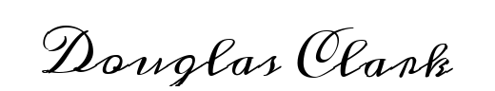
Husband's Signature: __________________________

Wife's Signature: __________________________

