IN THE CIRCUIT COURT OF THE [Judicial Circuit] JUDICIAL CIRCUIT, IN AND FOR [County] COUNTY, [State]
Case No.: 457762
Division: Family
PSC 6748, Box 1750, APO AA 64348
Court telephone No.: 001-388-620-4581x00275
Husband: Dylan Martin and Wife: Jenna Yu

PETITION FOR SIMPLIFIED DISSOLUTION OF MARRIAGE
We, Dylan Martin, Husband, and Jenna Yu, Wife, being sworn, certify that the following information is true:
1. We are both asking the Court for a dissolution of our marriage.
2. Husband lives at 125 Monica River Apt. 921, South Veronicaville, MN 47121. Wife lives at 21616 Gina Locks Apt. 480, New Kimberlymouth, FM 84493.
3. We were married on July 21, 2018 in the city of Lake Heatherport, Iowa.
4. Our marriage is irretrievably broken.
5. We do not have any minor or dependent children together, and the wife is not pregnant.
6. We have divided our assets and liabilities by agreement, and we are satisfied with the division.
[Check one only]
- ( ) Our marital settlement agreement is attached and was signed freely by both parties.
- ( ) We prefer to keep our financial agreements private.
Filed on: June 05, 2024
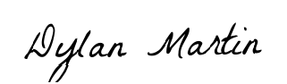
Husband's Signature: __________________________
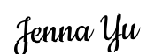
Wife's Signature: __________________________

