IN THE CIRCUIT COURT OF THE [Judicial Circuit] JUDICIAL CIRCUIT, IN AND FOR [County] COUNTY, [State]
Case No.: 612086
Division: Family
025 Oneill Drive Suite 156, Silvaville, WI 83758
Court telephone No.: 001-500-500-0984x876
Husband: Harold Salinas and Wife: Hannah Lynn

PETITION FOR SIMPLIFIED DISSOLUTION OF MARRIAGE
We, Harold Salinas, Husband, and Hannah Lynn, Wife, being sworn, certify that the following information is true:
1. We are both asking the Court for a dissolution of our marriage.
2. Husband lives at 828 Alexander Dam Apt. 975, South David, NM 55525. Wife lives at PSC 1662, Box 1178, APO AP 45572.
3. We were married on April 18, 2015 in the city of Ryantown, Missouri.
4. Our marriage is irretrievably broken.
5. We do not have any minor or dependent children together, and the wife is not pregnant.
6. We have divided our assets and liabilities by agreement, and we are satisfied with the division.
[Check one only]
- ( ) Our marital settlement agreement is attached and was signed freely by both parties.
- ( ) We prefer to keep our financial agreements private.
Filed on: February 16, 2024
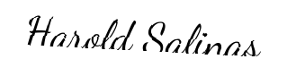
Husband's Signature: __________________________
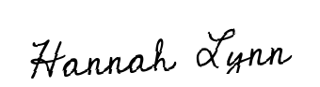
Wife's Signature: __________________________

