IN THE CIRCUIT COURT OF THE [Judicial Circuit] JUDICIAL CIRCUIT, IN AND FOR [County] COUNTY, [State]
Case No.: 880229
Division: Family
5593 Brian Fields Apt. 163, Lake Joshua, NJ 31902
Court telephone No.: 3206764437
Husband: Matthew Martinez and Wife: Shelby Lewis

PETITION FOR SIMPLIFIED DISSOLUTION OF MARRIAGE
We, Matthew Martinez, Husband, and Shelby Lewis, Wife, being sworn, certify that the following information is true:
1. We are both asking the Court for a dissolution of our marriage.
2. Husband lives at 338 Monica Port Suite 909, Simmonsberg, IL 12217. Wife lives at 48668 Sandra Creek Apt. 144, New Douglas, AL 02664.
3. We were married on December 14, 2017 in the city of West Jasonhaven, Arizona.
4. Our marriage is irretrievably broken.
5. We do not have any minor or dependent children together, and the wife is not pregnant.
6. We have divided our assets and liabilities by agreement, and we are satisfied with the division.
[Check one only]
- ( ) Our marital settlement agreement is attached and was signed freely by both parties.
- ( ) We prefer to keep our financial agreements private.
Filed on: October 08, 2024
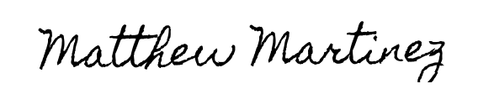
Husband's Signature: __________________________
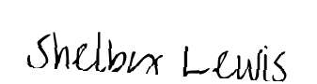
Wife's Signature: __________________________

