IN THE CIRCUIT COURT OF THE [Judicial Circuit] JUDICIAL CIRCUIT, IN AND FOR [County] COUNTY, [State]
Case No.: 281672
Division: Family
91856 Jordan Court Apt. 000, Gabrielaview, KS 15579
Court telephone No.: (552)474-1260x411
Husband: Michael Bell and Wife: Rebecca Boone

PETITION FOR SIMPLIFIED DISSOLUTION OF MARRIAGE
We, Michael Bell, Husband, and Rebecca Boone, Wife, being sworn, certify that the following information is true:
1. We are both asking the Court for a dissolution of our marriage.
2. Husband lives at 880 Erin Streets Apt. 604, Cynthiaview, AL 73384. Wife lives at 24616 Jacob Hill Apt. 239, Brucemouth, AZ 00697.
3. We were married on June 06, 2016 in the city of North Jeff, Alaska.
4. Our marriage is irretrievably broken.
5. We do not have any minor or dependent children together, and the wife is not pregnant.
6. We have divided our assets and liabilities by agreement, and we are satisfied with the division.
[Check one only]
- ( ) Our marital settlement agreement is attached and was signed freely by both parties.
- ( ) We prefer to keep our financial agreements private.
Filed on: October 24, 2024
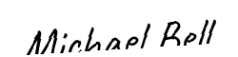
Husband's Signature: __________________________
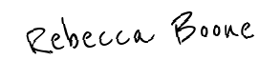
Wife's Signature: __________________________

