IN THE CIRCUIT COURT OF THE [Judicial Circuit] JUDICIAL CIRCUIT, IN AND FOR [County] COUNTY, [State]
Case No.: 911741
Division: Family
447 Jason Wall, East Julia, OR 06988
Court telephone No.: 749-211-0523x5190
Husband: Patrick Clark and Wife: Chelsey Bishop

PETITION FOR SIMPLIFIED DISSOLUTION OF MARRIAGE
We, Patrick Clark, Husband, and Chelsey Bishop, Wife, being sworn, certify that the following information is true:
1. We are both asking the Court for a dissolution of our marriage.
2. Husband lives at 95495 Allen Lock Apt. 649, Adamschester, AZ 67479. Wife lives at 047 Thomas Skyway, Elizabethside, GU 17808.
3. We were married on September 25, 2018 in the city of Davisfurt, Arkansas.
4. Our marriage is irretrievably broken.
5. We do not have any minor or dependent children together, and the wife is not pregnant.
6. We have divided our assets and liabilities by agreement, and we are satisfied with the division.
[Check one only]
- ( ) Our marital settlement agreement is attached and was signed freely by both parties.
- ( ) We prefer to keep our financial agreements private.
Filed on: May 05, 2024
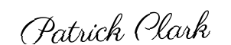
Husband's Signature: __________________________
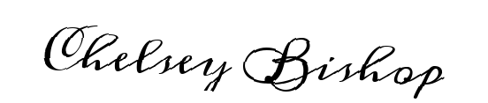
Wife's Signature: __________________________

