RESIDENTIAL LEASE AGREEMENT
1. THE PARTIES. This Residential Lease Agreement (“Agreement”) is made on February 04, 2025 by and between:
Landlord
Name: Jessica Jackson
Mailing Address: 5294 Farmer Square, New Kendra, VA 54052
Tenant
Name: Alexandra Johnson
Mailing Address: 9385 Fleming Ramp, South Nancyville, OK 68590
2. PROPERTY
Property Address: 68657 Willis Estate Suite 119, Robertton, NV 99622
Residence Type: Townhouse
Bedroom(s): 1 Bathroom(s): 3
3. TERM
Start Date: February 07, 2025
End Date: July 12, 2026
4. RENT
Monthly Rent: $2753
Due Date: 1st day of each month.
5. SECURITY DEPOSIT
Amount: $2075
IN WITNESS WHEREOF, the Parties have executed this Agreement as of the date first above written.
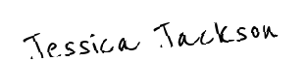
Landlord's Signature: __________________________
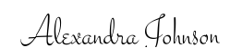
Tenant's Signature: __________________________

