RESIDENTIAL LEASE AGREEMENT
1. THE PARTIES. This Residential Lease Agreement (“Agreement”) is made on February 04, 2025 by and between:
Landlord
Name: Eric Davis
Mailing Address: USCGC Parker, FPO AA 07724
Tenant
Name: Amanda Beck
Mailing Address: 97541 Jordan Mews Suite 741, Kellyburgh, OK 35211
2. PROPERTY
Property Address: 38157 Brandon Summit, Jenniferport, CA 09560
Residence Type: Apartment
Bedroom(s): 5 Bathroom(s): 3
3. TERM
Start Date: March 03, 2025
End Date: July 20, 2026
4. RENT
Monthly Rent: $1659
Due Date: 1st day of each month.
5. SECURITY DEPOSIT
Amount: $1560
IN WITNESS WHEREOF, the Parties have executed this Agreement as of the date first above written.
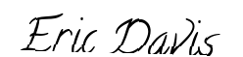
Landlord's Signature: __________________________
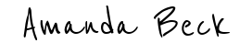
Tenant's Signature: __________________________

