RESIDENTIAL LEASE AGREEMENT
1. THE PARTIES. This Residential Lease Agreement (“Agreement”) is made on February 01, 2025 by and between:
Landlord
Name: Lawrence Williams
Mailing Address: 29067 Thomas Brooks, East Samuelview, OR 46252
Tenant
Name: Ashley Bender
Mailing Address: 15513 Nielsen Falls, Carrillotown, IA 38605
2. PROPERTY
Property Address: Unit 4046 Box 2198, DPO AE 96423
Residence Type: Townhouse
Bedroom(s): 4 Bathroom(s): 1
3. TERM
Start Date: March 04, 2025
End Date: April 30, 2026
4. RENT
Monthly Rent: $1796
Due Date: 1st day of each month.
5. SECURITY DEPOSIT
Amount: $1841
IN WITNESS WHEREOF, the Parties have executed this Agreement as of the date first above written.
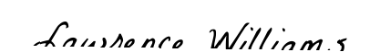
Landlord's Signature: __________________________
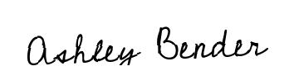
Tenant's Signature: __________________________

