RESIDENTIAL LEASE AGREEMENT
1. THE PARTIES. This Residential Lease Agreement (“Agreement”) is made on February 04, 2025 by and between:
Landlord
Name: Kristin Steele
Mailing Address: 9472 Roberts Crossing Suite 075, Stephensonfurt, AS 47346
Tenant
Name: Cody Bernard
Mailing Address: 800 Anderson View Apt. 184, West Phillip, SC 23438
2. PROPERTY
Property Address: 417 Tucker Corner Suite 035, Nicoleton, MH 62647
Residence Type: Townhouse
Bedroom(s): 2 Bathroom(s): 1
3. TERM
Start Date: February 26, 2025
End Date: September 09, 2026
4. RENT
Monthly Rent: $2504
Due Date: 1st day of each month.
5. SECURITY DEPOSIT
Amount: $2289
IN WITNESS WHEREOF, the Parties have executed this Agreement as of the date first above written.
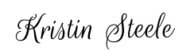
Landlord's Signature: __________________________
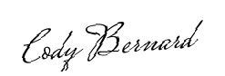
Tenant's Signature: __________________________

