RESIDENTIAL LEASE AGREEMENT
1. THE PARTIES. This Residential Lease Agreement (“Agreement”) is made on February 01, 2025 by and between:
Landlord
Name: Patrick Ferguson
Mailing Address: 4909 Ashley Pass Apt. 647, Harrisborough, AL 07701
Tenant
Name: Dalton Tran
Mailing Address: 33403 Macdonald Fords Apt. 434, New Rebecca, PW 34314
2. PROPERTY
Property Address: 652 Mcguire Square Apt. 354, New Vanessa, FM 16300
Residence Type: Townhouse
Bedroom(s): 5 Bathroom(s): 1
3. TERM
Start Date: February 12, 2025
End Date: January 13, 2027
4. RENT
Monthly Rent: $1624
Due Date: 1st day of each month.
5. SECURITY DEPOSIT
Amount: $3580
IN WITNESS WHEREOF, the Parties have executed this Agreement as of the date first above written.
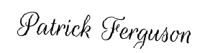
Landlord's Signature: __________________________
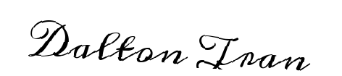
Tenant's Signature: __________________________

