RESIDENTIAL LEASE AGREEMENT
1. THE PARTIES. This Residential Lease Agreement (“Agreement”) is made on February 01, 2025 by and between:
Landlord
Name: Ashley Rodriguez
Mailing Address: PSC 0178, Box 6654, APO AA 36830
Tenant
Name: Daniel Davis
Mailing Address: 33198 Kimberly Landing Suite 481, Port Allison, MP 41050
2. PROPERTY
Property Address: 4137 Ryan Meadows, Vargasmouth, GU 66896
Residence Type: Apartment
Bedroom(s): 5 Bathroom(s): 3
3. TERM
Start Date: February 20, 2025
End Date: January 11, 2027
4. RENT
Monthly Rent: $2207
Due Date: 1st day of each month.
5. SECURITY DEPOSIT
Amount: $1780
IN WITNESS WHEREOF, the Parties have executed this Agreement as of the date first above written.
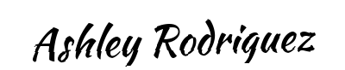
Landlord's Signature: __________________________
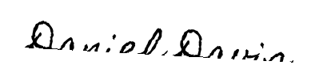
Tenant's Signature: __________________________

