RESIDENTIAL LEASE AGREEMENT
1. THE PARTIES. This Residential Lease Agreement (“Agreement”) is made on February 04, 2025 by and between:
Landlord
Name: Bruce Williams
Mailing Address: 82850 Scott Skyway, North Amyview, MP 49831
Tenant
Name: David Gray
Mailing Address: 489 Smith Row Apt. 511, North Jack, MN 93254
2. PROPERTY
Property Address: 68703 Vance Row, Larsonport, VT 03521
Residence Type: Townhouse
Bedroom(s): 2 Bathroom(s): 2
3. TERM
Start Date: February 06, 2025
End Date: November 28, 2026
4. RENT
Monthly Rent: $1423
Due Date: 1st day of each month.
5. SECURITY DEPOSIT
Amount: $4358
IN WITNESS WHEREOF, the Parties have executed this Agreement as of the date first above written.
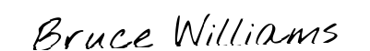
Landlord's Signature: __________________________
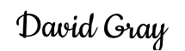
Tenant's Signature: __________________________

