RESIDENTIAL LEASE AGREEMENT
1. THE PARTIES. This Residential Lease Agreement (“Agreement”) is made on February 05, 2025 by and between:
Landlord
Name: Bryan Allen
Mailing Address: 16623 Fisher Cliff, North Ryan, NC 26256
Tenant
Name: David Wilkerson
Mailing Address: 7452 Hernandez Locks Apt. 935, South Janice, KY 99437
2. PROPERTY
Property Address: 8133 Lopez Gateway, Johnside, SD 03307
Residence Type: Apartment
Bedroom(s): 1 Bathroom(s): 3
3. TERM
Start Date: February 25, 2025
End Date: January 22, 2027
4. RENT
Monthly Rent: $2659
Due Date: 1st day of each month.
5. SECURITY DEPOSIT
Amount: $1651
IN WITNESS WHEREOF, the Parties have executed this Agreement as of the date first above written.
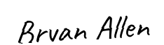
Landlord's Signature: __________________________
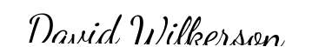
Tenant's Signature: __________________________

