RESIDENTIAL LEASE AGREEMENT
1. THE PARTIES. This Residential Lease Agreement (“Agreement”) is made on February 02, 2025 by and between:
Landlord
Name: Edward Cook
Mailing Address: 234 Anderson Motorway, New Brittney, VI 82946
Tenant
Name: Donald Heath
Mailing Address: 1914 Erica Canyon Apt. 303, Williamsside, ID 10795
2. PROPERTY
Property Address: 2062 Kevin Junction, Johnsonton, MD 37906
Residence Type: Condo
Bedroom(s): 4 Bathroom(s): 3
3. TERM
Start Date: February 27, 2025
End Date: April 14, 2026
4. RENT
Monthly Rent: $2985
Due Date: 1st day of each month.
5. SECURITY DEPOSIT
Amount: $2357
IN WITNESS WHEREOF, the Parties have executed this Agreement as of the date first above written.
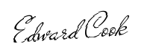
Landlord's Signature: __________________________
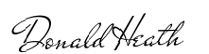
Tenant's Signature: __________________________

