RESIDENTIAL LEASE AGREEMENT
1. THE PARTIES. This Residential Lease Agreement (“Agreement”) is made on February 05, 2025 by and between:
Landlord
Name: Mrs. Barbara Parks
Mailing Address: 0427 Taylor Creek Suite 881, Port Jeffreyborough, TX 04218
Tenant
Name: Frank Fisher
Mailing Address: 4801 Robert Canyon, Jacksonmouth, UT 21767
2. PROPERTY
Property Address: 87258 Davis Vista Suite 519, East Andrewberg, MI 57890
Residence Type: Apartment
Bedroom(s): 2 Bathroom(s): 1
3. TERM
Start Date: March 04, 2025
End Date: November 25, 2026
4. RENT
Monthly Rent: $2092
Due Date: 1st day of each month.
5. SECURITY DEPOSIT
Amount: $3217
IN WITNESS WHEREOF, the Parties have executed this Agreement as of the date first above written.
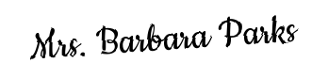
Landlord's Signature: __________________________
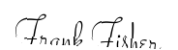
Tenant's Signature: __________________________

