RESIDENTIAL LEASE AGREEMENT
1. THE PARTIES. This Residential Lease Agreement (“Agreement”) is made on February 03, 2025 by and between:
Landlord
Name: Patricia Johnson
Mailing Address: 9792 John Views, East Melissa, ME 19228
Tenant
Name: Jamie Lee
Mailing Address: 71317 Ashlee Lodge, Shanemouth, AR 77605
2. PROPERTY
Property Address: 330 Joseph Brook, Willisfurt, WA 59099
Residence Type: Apartment
Bedroom(s): 3 Bathroom(s): 3
3. TERM
Start Date: February 10, 2025
End Date: December 28, 2026
4. RENT
Monthly Rent: $1646
Due Date: 1st day of each month.
5. SECURITY DEPOSIT
Amount: $3548
IN WITNESS WHEREOF, the Parties have executed this Agreement as of the date first above written.
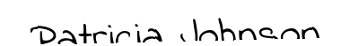
Landlord's Signature: __________________________
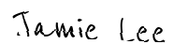
Tenant's Signature: __________________________

