RESIDENTIAL LEASE AGREEMENT
1. THE PARTIES. This Residential Lease Agreement (“Agreement”) is made on February 02, 2025 by and between:
Landlord
Name: Brianna Patrick
Mailing Address: 8538 Rachel Lake Apt. 602, East Jeffrey, DE 12311
Tenant
Name: Jason Allen
Mailing Address: 232 Rebecca Lane Suite 847, East Jonathan, MO 49273
2. PROPERTY
Property Address: 1479 Bradley Mission Suite 498, New Bryanton, WV 95357
Residence Type: House
Bedroom(s): 1 Bathroom(s): 1
3. TERM
Start Date: February 24, 2025
End Date: July 18, 2026
4. RENT
Monthly Rent: $1912
Due Date: 1st day of each month.
5. SECURITY DEPOSIT
Amount: $2479
IN WITNESS WHEREOF, the Parties have executed this Agreement as of the date first above written.
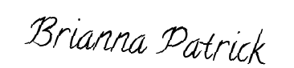
Landlord's Signature: __________________________

Tenant's Signature: __________________________

