RESIDENTIAL LEASE AGREEMENT
1. THE PARTIES. This Residential Lease Agreement (“Agreement”) is made on February 04, 2025 by and between:
Landlord
Name: Eric Santos
Mailing Address: Unit 9434 Box 4278, DPO AE 10362
Tenant
Name: Jeffrey Brown
Mailing Address: 3124 Mark Landing Suite 057, West Chaseland, SD 78660
2. PROPERTY
Property Address: 2703 Jessica Mountains Suite 152, East Kennethport, KS 93317
Residence Type: House
Bedroom(s): 2 Bathroom(s): 3
3. TERM
Start Date: February 08, 2025
End Date: July 13, 2026
4. RENT
Monthly Rent: $2616
Due Date: 1st day of each month.
5. SECURITY DEPOSIT
Amount: $3781
IN WITNESS WHEREOF, the Parties have executed this Agreement as of the date first above written.
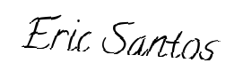
Landlord's Signature: __________________________
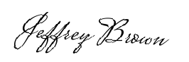
Tenant's Signature: __________________________

