RESIDENTIAL LEASE AGREEMENT
1. THE PARTIES. This Residential Lease Agreement (“Agreement”) is made on February 01, 2025 by and between:
Landlord
Name: Thomas Campbell
Mailing Address: Unit 4064 Box 3237, DPO AE 99622
Tenant
Name: Jennifer Williams
Mailing Address: 693 Velasquez Spring Suite 028, Mcdanielmouth, SD 14430
2. PROPERTY
Property Address: 020 Tracy Course Suite 526, Collinsfurt, PA 28534
Residence Type: Condo
Bedroom(s): 1 Bathroom(s): 3
3. TERM
Start Date: February 26, 2025
End Date: December 10, 2026
4. RENT
Monthly Rent: $1076
Due Date: 1st day of each month.
5. SECURITY DEPOSIT
Amount: $3601
IN WITNESS WHEREOF, the Parties have executed this Agreement as of the date first above written.
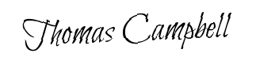
Landlord's Signature: __________________________
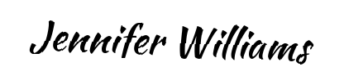
Tenant's Signature: __________________________

