RESIDENTIAL LEASE AGREEMENT
1. THE PARTIES. This Residential Lease Agreement (“Agreement”) is made on February 02, 2025 by and between:
Landlord
Name: Bradley Brown
Mailing Address: 12676 Conrad Fork, Port Jennifer, ID 98057
Tenant
Name: Jessica Walker
Mailing Address: 350 Richardson Wall Apt. 228, Gillton, NY 87108
2. PROPERTY
Property Address: 371 Young Point Suite 006, South Donna, OK 28441
Residence Type: Condo
Bedroom(s): 2 Bathroom(s): 1
3. TERM
Start Date: February 17, 2025
End Date: April 30, 2026
4. RENT
Monthly Rent: $1690
Due Date: 1st day of each month.
5. SECURITY DEPOSIT
Amount: $3522
IN WITNESS WHEREOF, the Parties have executed this Agreement as of the date first above written.
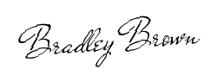
Landlord's Signature: __________________________
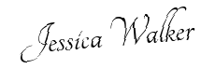
Tenant's Signature: __________________________

