RESIDENTIAL LEASE AGREEMENT
1. THE PARTIES. This Residential Lease Agreement (“Agreement”) is made on February 01, 2025 by and between:
Landlord
Name: Caitlin Collins
Mailing Address: 71259 Raymond Canyon, Port Ashleyside, DC 51993
Tenant
Name: Joel Horton
Mailing Address: 0467 Friedman Ridges Apt. 968, Lake Jacob, NM 05109
2. PROPERTY
Property Address: Unit 6611 Box 0183, DPO AA 92748
Residence Type: Townhouse
Bedroom(s): 5 Bathroom(s): 2
3. TERM
Start Date: February 07, 2025
End Date: May 05, 2026
4. RENT
Monthly Rent: $1260
Due Date: 1st day of each month.
5. SECURITY DEPOSIT
Amount: $4242
IN WITNESS WHEREOF, the Parties have executed this Agreement as of the date first above written.
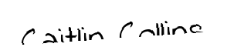
Landlord's Signature: __________________________
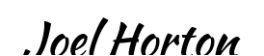
Tenant's Signature: __________________________

