RESIDENTIAL LEASE AGREEMENT
1. THE PARTIES. This Residential Lease Agreement (“Agreement”) is made on February 04, 2025 by and between:
Landlord
Name: Manuel Murphy
Mailing Address: 51731 Graves Mountains, New Jennifer, MI 43162
Tenant
Name: John English
Mailing Address: 3917 Joseph Points Suite 667, East Jessica, FM 47417
2. PROPERTY
Property Address: 180 Davis Lights Apt. 986, New Aaronburgh, CO 71841
Residence Type: House
Bedroom(s): 4 Bathroom(s): 3
3. TERM
Start Date: March 05, 2025
End Date: August 28, 2026
4. RENT
Monthly Rent: $1898
Due Date: 1st day of each month.
5. SECURITY DEPOSIT
Amount: $4386
IN WITNESS WHEREOF, the Parties have executed this Agreement as of the date first above written.
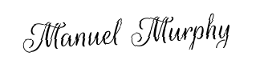
Landlord's Signature: __________________________
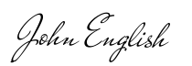
Tenant's Signature: __________________________

