RESIDENTIAL LEASE AGREEMENT
1. THE PARTIES. This Residential Lease Agreement (“Agreement”) is made on February 05, 2025 by and between:
Landlord
Name: Gabriella Benton
Mailing Address: USNV Watson, FPO AP 12976
Tenant
Name: Joshua James
Mailing Address: 179 Benjamin Gateway Apt. 364, Port Stephen, MS 04227
2. PROPERTY
Property Address: 775 April Way, West Audrey, PR 99816
Residence Type: Apartment
Bedroom(s): 3 Bathroom(s): 3
3. TERM
Start Date: February 21, 2025
End Date: July 31, 2026
4. RENT
Monthly Rent: $2216
Due Date: 1st day of each month.
5. SECURITY DEPOSIT
Amount: $3654
IN WITNESS WHEREOF, the Parties have executed this Agreement as of the date first above written.
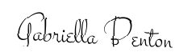
Landlord's Signature: __________________________
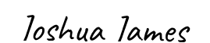
Tenant's Signature: __________________________

