RESIDENTIAL LEASE AGREEMENT
1. THE PARTIES. This Residential Lease Agreement (“Agreement”) is made on February 01, 2025 by and between:
Landlord
Name: Jacqueline Hoffman
Mailing Address: 791 Evan Gateway Suite 367, North Kyle, WI 89037
Tenant
Name: Kendra Boyd
Mailing Address: 121 Jackson Flat, Port Paula, KS 69562
2. PROPERTY
Property Address: 1566 Rhodes Grove, West Desireestad, WI 53184
Residence Type: Apartment
Bedroom(s): 1 Bathroom(s): 2
3. TERM
Start Date: February 14, 2025
End Date: November 03, 2026
4. RENT
Monthly Rent: $1015
Due Date: 1st day of each month.
5. SECURITY DEPOSIT
Amount: $3242
IN WITNESS WHEREOF, the Parties have executed this Agreement as of the date first above written.
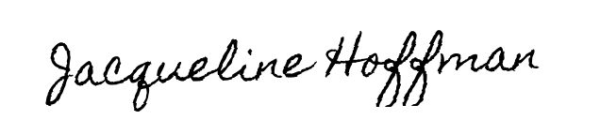
Landlord's Signature: __________________________
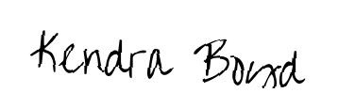
Tenant's Signature: __________________________

