RESIDENTIAL LEASE AGREEMENT
1. THE PARTIES. This Residential Lease Agreement (“Agreement”) is made on February 02, 2025 by and between:
Landlord
Name: Paul Davis
Mailing Address: 088 Holt Dam Suite 215, East Theresa, UT 22871
Tenant
Name: Matthew White
Mailing Address: 53025 Williams Mills Suite 283, West Daniel, VI 94599
2. PROPERTY
Property Address: 81327 Thomas Plains Apt. 244, Collinsstad, IA 41904
Residence Type: Townhouse
Bedroom(s): 2 Bathroom(s): 3
3. TERM
Start Date: February 11, 2025
End Date: March 09, 2026
4. RENT
Monthly Rent: $2340
Due Date: 1st day of each month.
5. SECURITY DEPOSIT
Amount: $3626
IN WITNESS WHEREOF, the Parties have executed this Agreement as of the date first above written.
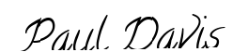
Landlord's Signature: __________________________
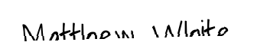
Tenant's Signature: __________________________

