RESIDENTIAL LEASE AGREEMENT
1. THE PARTIES. This Residential Lease Agreement (“Agreement”) is made on February 02, 2025 by and between:
Landlord
Name: Steven Taylor
Mailing Address: PSC 3700, Box 3125, APO AE 62475
Tenant
Name: Michelle Schwartz
Mailing Address: 950 Ronald Court Apt. 615, Edwardsport, DE 71489
2. PROPERTY
Property Address: 33968 John Path, Franklinville, WA 47202
Residence Type: Townhouse
Bedroom(s): 5 Bathroom(s): 1
3. TERM
Start Date: March 02, 2025
End Date: March 11, 2026
4. RENT
Monthly Rent: $1098
Due Date: 1st day of each month.
5. SECURITY DEPOSIT
Amount: $2179
IN WITNESS WHEREOF, the Parties have executed this Agreement as of the date first above written.
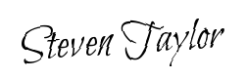
Landlord's Signature: __________________________
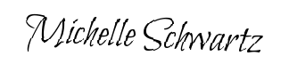
Tenant's Signature: __________________________

