RESIDENTIAL LEASE AGREEMENT
1. THE PARTIES. This Residential Lease Agreement (“Agreement”) is made on February 03, 2025 by and between:
Landlord
Name: Chloe Johnston
Mailing Address: 347 Meyer Parks, Rosalesfort, PA 11318
Tenant
Name: Nathan Mendoza
Mailing Address: 68237 Horne Pike Suite 520, New Elizabethport, NM 84946
2. PROPERTY
Property Address: Unit 2192 Box 7761, DPO AP 50939
Residence Type: Apartment
Bedroom(s): 3 Bathroom(s): 3
3. TERM
Start Date: March 03, 2025
End Date: January 17, 2027
4. RENT
Monthly Rent: $1687
Due Date: 1st day of each month.
5. SECURITY DEPOSIT
Amount: $1561
IN WITNESS WHEREOF, the Parties have executed this Agreement as of the date first above written.
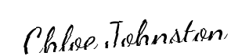
Landlord's Signature: __________________________
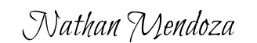
Tenant's Signature: __________________________

