RESIDENTIAL LEASE AGREEMENT
1. THE PARTIES. This Residential Lease Agreement (“Agreement”) is made on February 02, 2025 by and between:
Landlord
Name: Dr. Theresa Simpson DVM
Mailing Address: 015 Susan Ville, South Cody, PR 82821
Tenant
Name: Nicole Martinez
Mailing Address: 705 Williams Gateway Suite 576, Samanthaview, IL 71747
2. PROPERTY
Property Address: 111 Simpson Junctions, Emilytown, MI 83716
Residence Type: House
Bedroom(s): 4 Bathroom(s): 3
3. TERM
Start Date: February 12, 2025
End Date: March 06, 2026
4. RENT
Monthly Rent: $2671
Due Date: 1st day of each month.
5. SECURITY DEPOSIT
Amount: $1781
IN WITNESS WHEREOF, the Parties have executed this Agreement as of the date first above written.
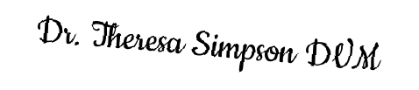
Landlord's Signature: __________________________

Tenant's Signature: __________________________

