RESIDENTIAL LEASE AGREEMENT
1. THE PARTIES. This Residential Lease Agreement (“Agreement”) is made on February 05, 2025 by and between:
Landlord
Name: Christine Nelson
Mailing Address: 56645 Michael Ports, North Jessicaburgh, WI 34632
Tenant
Name: Samuel Gonzales
Mailing Address: 9616 Jacqueline Crescent, Brownhaven, MP 05299
2. PROPERTY
Property Address: 987 Stephanie Extensions, New Jenniferville, LA 23482
Residence Type: House
Bedroom(s): 4 Bathroom(s): 3
3. TERM
Start Date: March 01, 2025
End Date: May 14, 2026
4. RENT
Monthly Rent: $1005
Due Date: 1st day of each month.
5. SECURITY DEPOSIT
Amount: $4116
IN WITNESS WHEREOF, the Parties have executed this Agreement as of the date first above written.
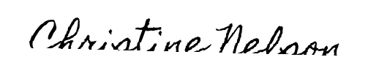
Landlord's Signature: __________________________
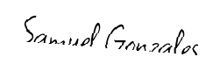
Tenant's Signature: __________________________

