RESIDENTIAL LEASE AGREEMENT
1. THE PARTIES. This Residential Lease Agreement (“Agreement”) is made on February 03, 2025 by and between:
Landlord
Name: Wesley Maldonado
Mailing Address: 632 Sosa Valleys, Garciaburgh, TX 81209
Tenant
Name: Todd Bennett
Mailing Address: 526 Shane Pass, South Douglas, MH 64448
2. PROPERTY
Property Address: 24164 Amanda Corners, Fryemouth, NM 91534
Residence Type: House
Bedroom(s): 2 Bathroom(s): 3
3. TERM
Start Date: February 11, 2025
End Date: October 23, 2026
4. RENT
Monthly Rent: $2128
Due Date: 1st day of each month.
5. SECURITY DEPOSIT
Amount: $2398
IN WITNESS WHEREOF, the Parties have executed this Agreement as of the date first above written.
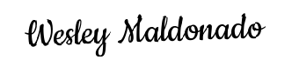
Landlord's Signature: __________________________
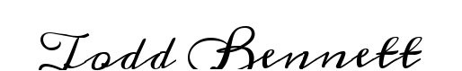
Tenant's Signature: __________________________

