PARTNERSHIP AGREEMENT
This PARTNERSHIP AGREEMENT ("Agreement") is made this July 11, 2024 by and between the following individuals:
Partner 1: Derek Butler
Address: 446 Cole Oval, New Heatherview, OK 07809
Partner 2: Christina Carney
Address: 7077 Kathleen Crossing, North Michaelmouth, KS 06024
1. Nature of Business: The partners listed above agree to form a partnership for the purpose of conducting the following business: Optional holistic instruction set.
2. Name of the Partnership: The partnership shall operate under the name 'Brady-Howard' and maintain offices at [ADDRESS].
3. Day-To-Day Operations: The partners shall devote their full time and best efforts to the business. All partners will have equal management rights unless otherwise agreed upon.
4. Capital Contributions: Each partner agrees to contribute the following capital to the partnership:
- Derek Butler: $10,000 (50% Share)
- Christina Carney: $10,000 (50% Share)
5. Profits and Losses: Profits and losses shall be divided according to the capital contributions of each partner unless otherwise agreed.
6. Termination: The partnership may be terminated upon mutual agreement. Upon termination, assets will be distributed based on each partner's share.
7. Governing Law: This Agreement shall be governed by the laws of the state of Alaska.
IN WITNESS WHEREOF, the parties have executed this Agreement as of the date first written above.
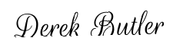
Partner 1's Signature: __________________________
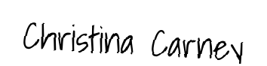
Partner 2's Signature: __________________________

