PARTNERSHIP AGREEMENT
This PARTNERSHIP AGREEMENT ("Agreement") is made this September 21, 2024 by and between the following individuals:
Partner 1: Lisa Mason
Address: 27269 Keith Rest, East Ericville, SD 23641
Partner 2: Thomas Carlson
Address: 10220 Alicia Isle Apt. 999, North Scott, NJ 58099
1. Nature of Business: The partners listed above agree to form a partnership for the purpose of conducting the following business: Integrated multi-state initiative.
2. Name of the Partnership: The partnership shall operate under the name 'Fuentes-Lewis' and maintain offices at [ADDRESS].
3. Day-To-Day Operations: The partners shall devote their full time and best efforts to the business. All partners will have equal management rights unless otherwise agreed upon.
4. Capital Contributions: Each partner agrees to contribute the following capital to the partnership:
- Lisa Mason: $10,000 (50% Share)
- Thomas Carlson: $10,000 (50% Share)
5. Profits and Losses: Profits and losses shall be divided according to the capital contributions of each partner unless otherwise agreed.
6. Termination: The partnership may be terminated upon mutual agreement. Upon termination, assets will be distributed based on each partner's share.
7. Governing Law: This Agreement shall be governed by the laws of the state of Florida.
IN WITNESS WHEREOF, the parties have executed this Agreement as of the date first written above.
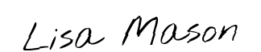
Partner 1's Signature: __________________________
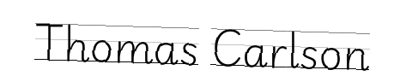
Partner 2's Signature: __________________________

