

**UVM Medical Center**

PO BOX 1968  
Atlanta, GA 49743  
RETURN SERVICE REQUESTED

**PATIENT NAME:** David Reed  
**DATE OF BIRTH:** 1912-01-10  
**GENDER:** Other  
**ADDRESS:** 6681 Boyd Stream, Cookmouth, DC 66901  
**ACCOUNT #:** 63433656  
**INSURANCE INFORMATION ON FILE:** Aetna

**BILLING QUESTIONS:**TEL: 395-442-1904 | TOLL-FREE: 210-230-8724

**STATEMENT DATE:** 08/12/2023  
**DUE DATE:** 08/18/2023

|  |  |  |  |  |  |
| --- | --- | --- | --- | --- | --- |
| ADMIT DATE OF SERVICE | VISIT NUMBER / PROCEDURE CODE | TYPE OF SERVICE | BILLED CHARGES | PAID BY PLAN / ADJUSTMENT | PATIENT PAYMENT DUE |
| 07/07/2022 | 66027554 899 | Vaccination | $177.53 | -$112.95 | $64.58 |
| 11/03/2021 | 24477254 227 | X-Ray | $140.29 | -$62.07 | $78.22 |
| 11/22/2021 | 10744544 739 | Ultrasound | $54.91 | -$32.82 | $22.09 |
| 12/03/2021 | 86139463 850 | Ultrasound | $267.79 | -$26.9 | $240.89 |

**ACCOUNT TOTAL DUE FROM YOU: $405.78**

**IMPORTANT MESSAGE:**Thank you for selecting UVM Medical Center as your healthcare provider. Please pay the amount due by the due date shown on your statement.

**MAKE CHECKS PAYABLE TO:**

UVM Medical Center  
Financial Services  
PO BOX 1968  
Atlanta, GA 49743

**Authorized Signature: ___________________________**Date: ______________

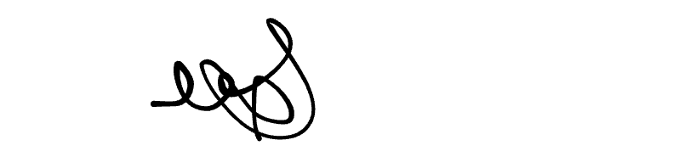

Page 2 of 2