

**Northern Lights Medical Center**

PO BOX 5581  
Miami, FL 79591  
RETURN SERVICE REQUESTED

**PATIENT NAME:** Tara Petersen  
**DATE OF BIRTH:** 1962-06-25  
**GENDER:** Non-binary  
**ADDRESS:** 68688 Hannah Loop, North Jenniferfurt, MD 24033  
**ACCOUNT #:** 23022486  
**INSURANCE INFORMATION ON FILE:** Molina Healthcare

**BILLING QUESTIONS:**TEL: 706-119-7599 | TOLL-FREE: 241-740-2326

**STATEMENT DATE:** 03/05/2021  
**DUE DATE:** 03/21/2021

|  |  |  |  |  |  |
| --- | --- | --- | --- | --- | --- |
| ADMIT DATE OF SERVICE | VISIT NUMBER / PROCEDURE CODE | TYPE OF SERVICE | BILLED CHARGES | PAID BY PLAN / ADJUSTMENT | PATIENT PAYMENT DUE |
| 10/01/2023 | 49864679 944 | Dialysis | $170.44 | -$36.03 | $134.41 |
| 07/17/2023 | 5763227 426 | Emergency Room Visit | $61.71 | -$34.45 | $27.26 |
| 04/21/2024 | 35352942 499 | Ultrasound | $204.2 | -$176.34 | $27.86 |
| 03/11/2022 | 7250300 988 | Skin Biopsy | $193.35 | -$102.75 | $90.6 |

**ACCOUNT TOTAL DUE FROM YOU: $280.13**

**IMPORTANT MESSAGE:**Thank you for selecting Northern Lights Medical Center as your healthcare provider. Please pay the amount due by the due date shown on your statement.

**MAKE CHECKS PAYABLE TO:**

Northern Lights Medical Center  
Financial Services  
PO BOX 5581  
Miami, FL 79591

**Authorized Signature: ___________________________**Date: ______________

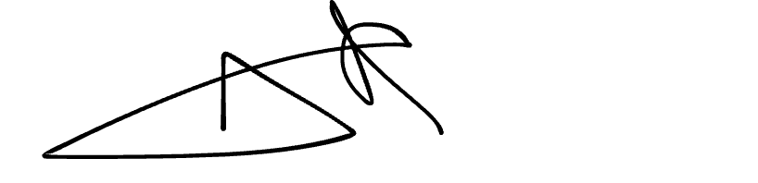

Page 2 of 2