Nigeria overall

* Typical cluster is 1.5km radius and 4K people. Larger clusters may be 100K+ with similar density
* Have excluded all areas with light on DMSP (>.1) or VIIRS (>.6)
* areas with light are in purple, pink, grey (respectively dmsp only, viirs only, both)
* clusters with 4000 people and no electricity are in green
* clusters are nationwide but very dense around Kano and North East of Port Harcourt

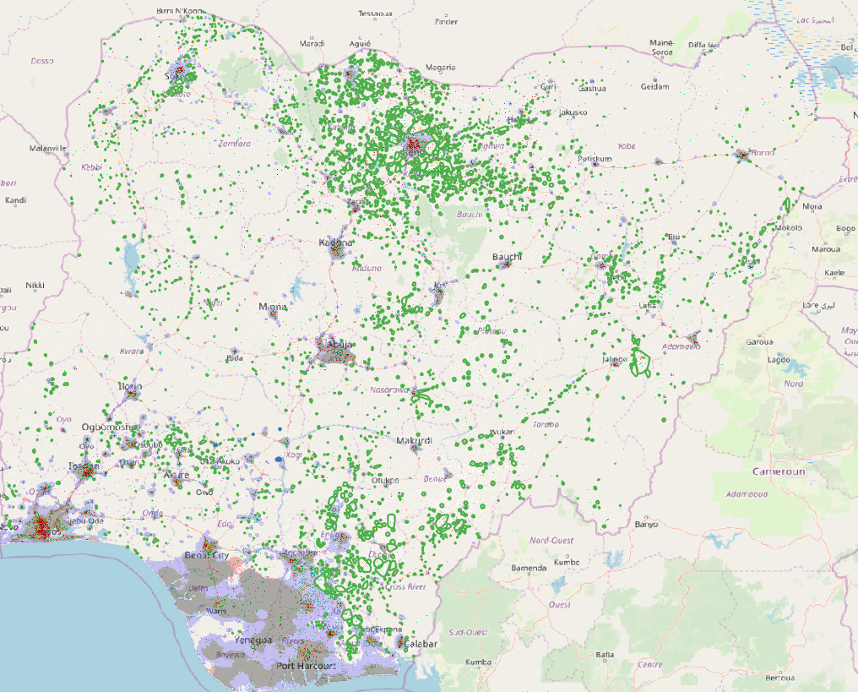

Known towns are all as expected

Ajaokuta is grey so lit on DMSP and VIIRS Omuo is purple so lit on DMSP but not VIIRS. It had electricity but it stopped working

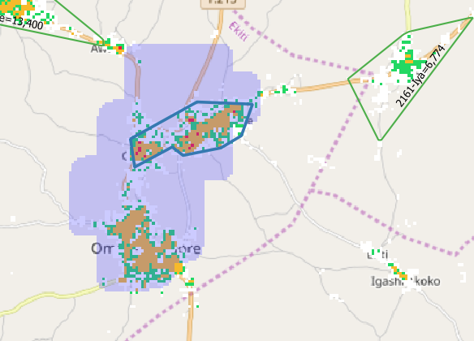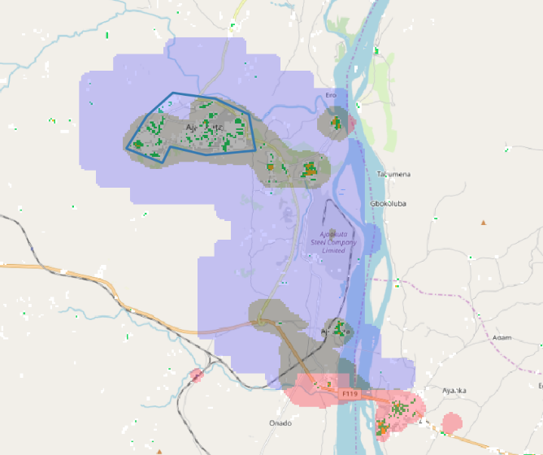

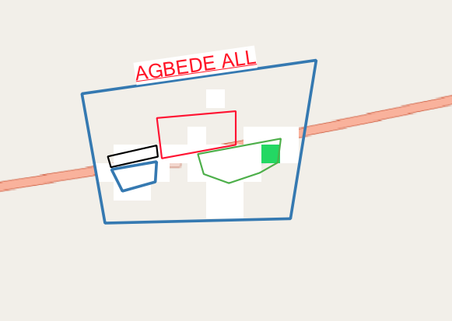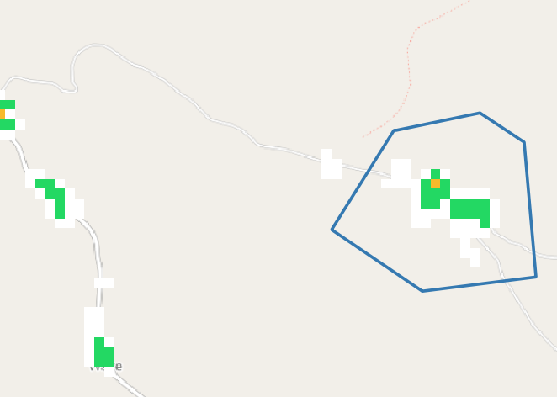Agbede is unlit Agbaja is unlit

Example clusters. Typical cluster is 3km across (1.5km radius) with 4K people

