* DMSP is 2014; 19:30pm; stray light filtering. VIIRS is 2019; twice the resolution; 1:30am. Does everywhere with lights have street lights on at night?
* On DMSP only 21% have any light. On VIIRS 100% have some light. 21% have more than .59. World Bank says 59%.
* Possible issue is definitions. Can be connected to grid but it does not work; or only the village is connected not the houses.
* Also %connected depends on estimates of population and population distribution. The data sources are not consistent.

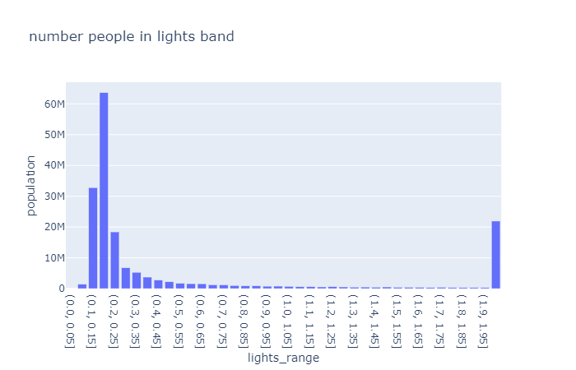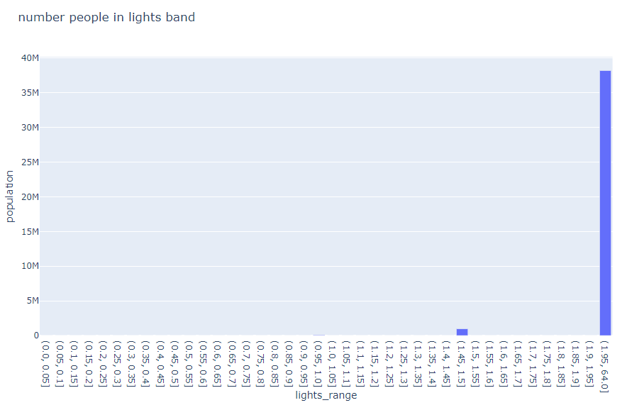

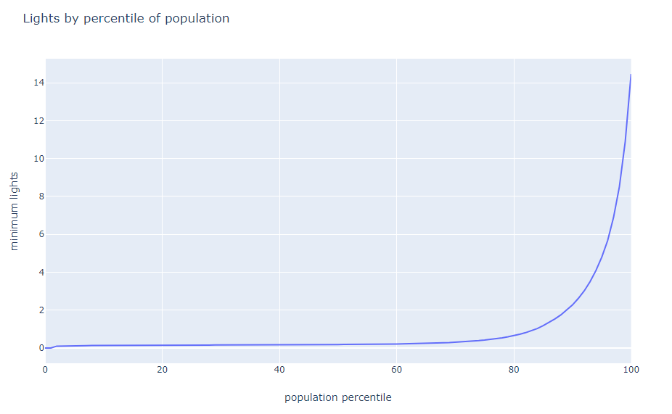

* This shows DMSP versus VIIRS lighting. Legend grey is .2 to 1 and black is 1+
* In general the pattern is the same despite the time of day (19:30 versus 01:30)
* At cut-off .2 VIIRS is picking up roads plus a slightly bigger area around towns.
* Tried various cut-offs and there is no way to exclude the roads without removing much of Lagos area.
* Therefore the DMSP data looks 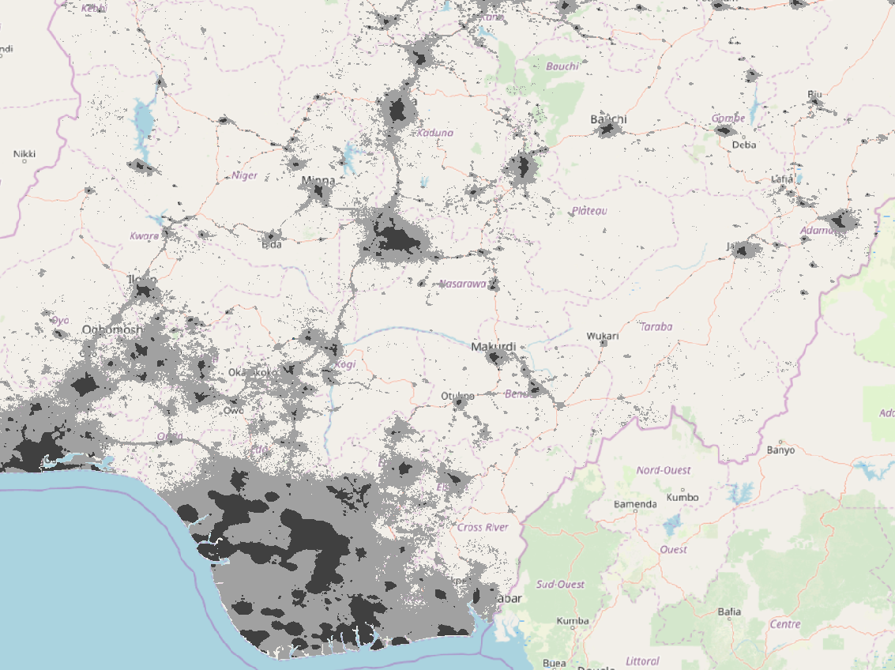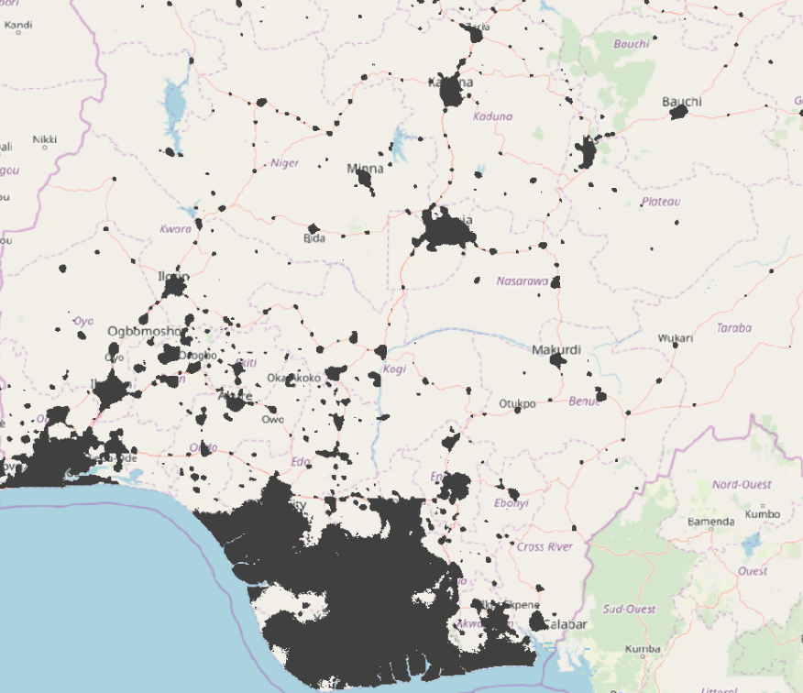more suitable despite being from 2014 and lower resolution……..unless better sources can be found!