* Worldpop and Grid3 both produced by the same people and are the two most credible sources so far.
* Worldpop spreads the census. Grid3 is bottom up using mini-census of local areas to predict others.
* Worldpop map versus Grid3 maps. Both have 25 % of the population in each of the red, orange, green and white areas. Blank areas are zeros.
* Worldpop has no zeros. Grid3 is mostly zeros as it allocates people to settlements. Each colored pixel has a lot more people.
* Grid3 does not use the census and has been validated locally via the vaccination programme. Probably more reliable.

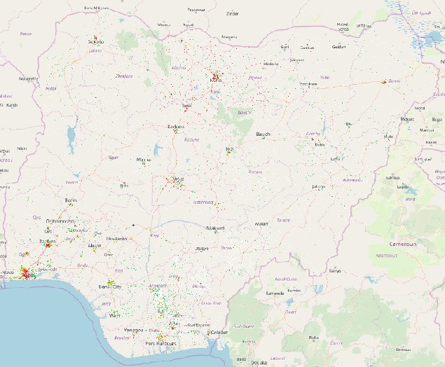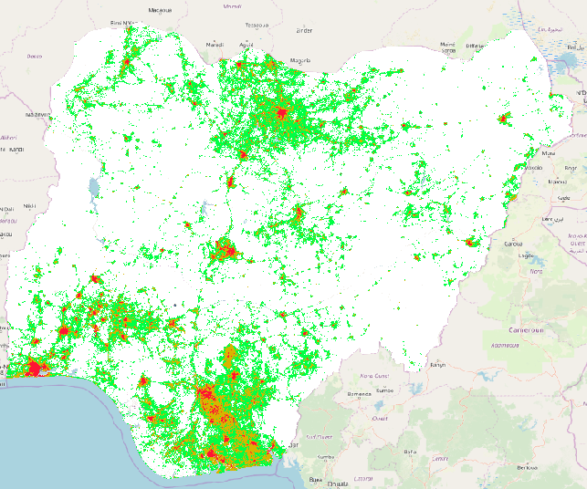

* This zooms in on Agbedde (from which I have cut four polygons plus one for the area)
* Both pick up the main centres of population
* Worldpop is all white as there are no zero pixels
* Grid3 has few white patches and each has many more people. Note especially the villages to the south west.

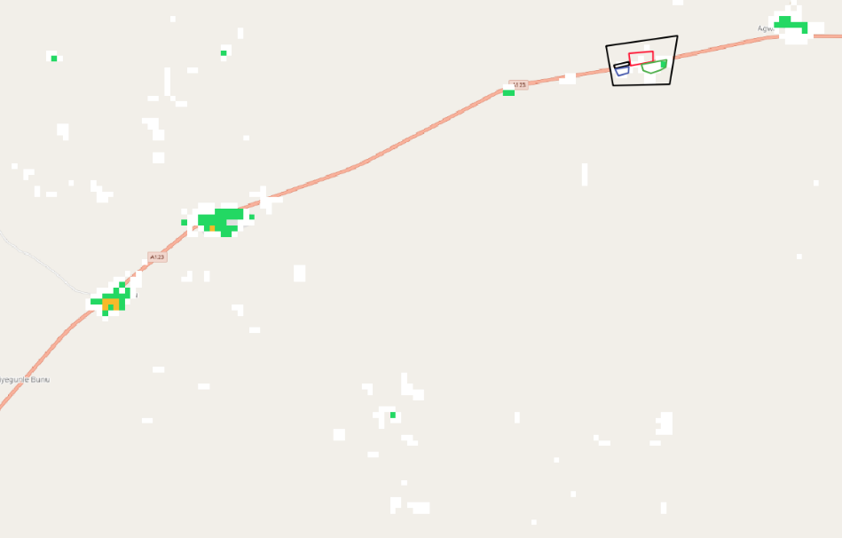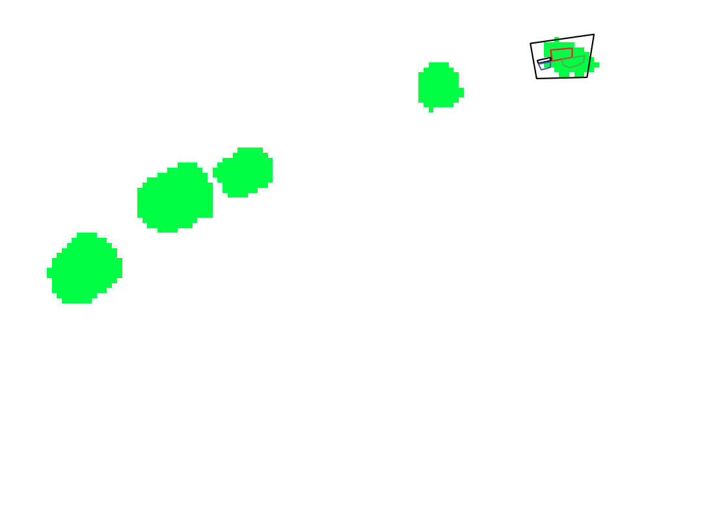

* This is the area to the south west where grid3 has people. Definitely a settlement. Another polygon.

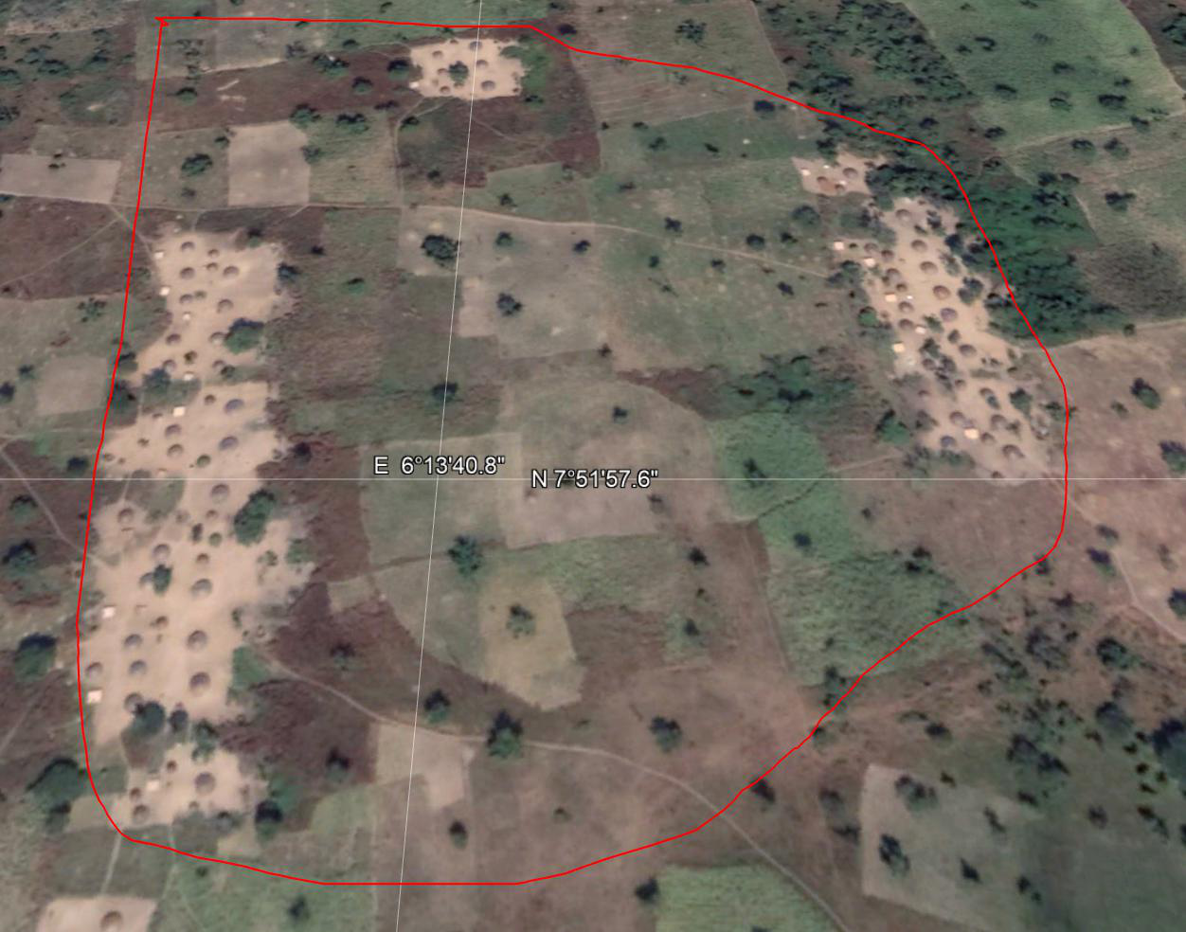

* 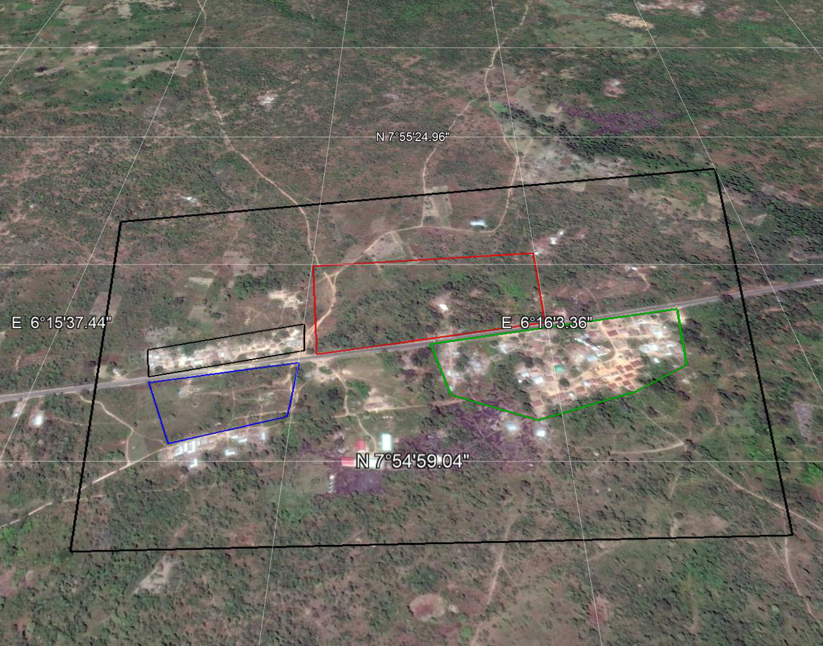This is Agbedde village itself. You can see polygons with houses and others without houses.
* These are the stats for Worldpop versus Grid3 for 4 Agbedde polygons; All Agbedde; unnamed village. I estimated houses by hand
* Grid3 is based on microsurveys and bottom up prediction. Worldpop is census data split using random forest. Former totals 30m fewer people.
* The grid3 numbers look and feel more realistic e.g. 168 in the unnamed village versus 2. Worldpop probably has the 168 in the area if you draw a big enough rectangle.

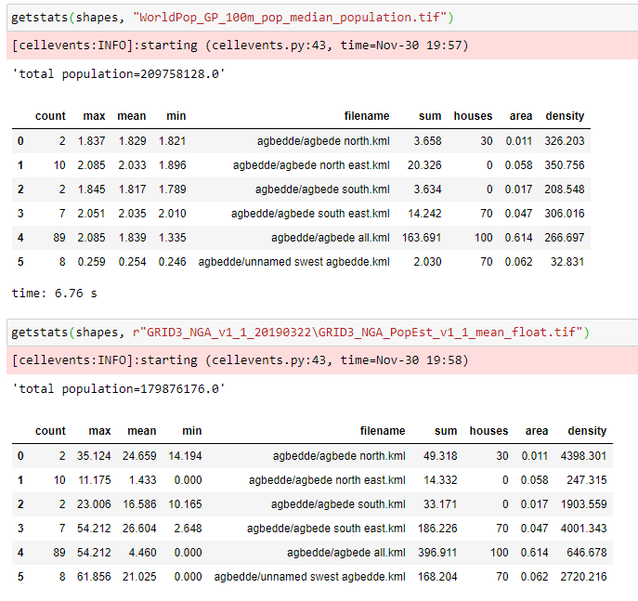

* 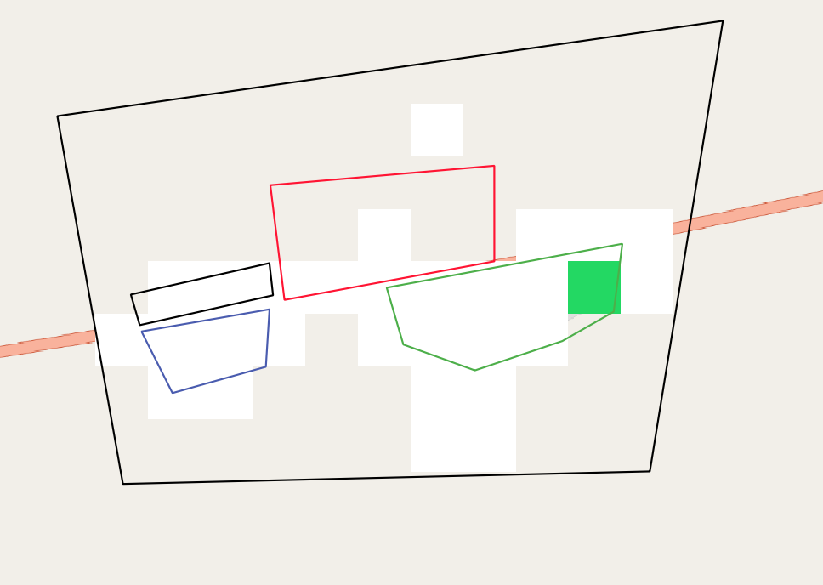This is grid3 view of Agbedde. Not perfect but quite realistic. White is bottom quartile density but up to 41 people per pixel.