CSS Basics

DEADLINE: 12/04/2020

FOLDER STRUCTURE
FL13_HW2/* ** - required
├─ task/** ** - restricted (no need to submit)
├─ examples/**
└─ homework/*
└─ css/*
└─ bootstrap.min.css*
└─ general.css*
└─ style.css*
└─ img/*
└─ index.html*

TASK
1) Open index.html. You are provided with a mark-up of a web-page, print preview mode of which looks as follows (see Figure 1):
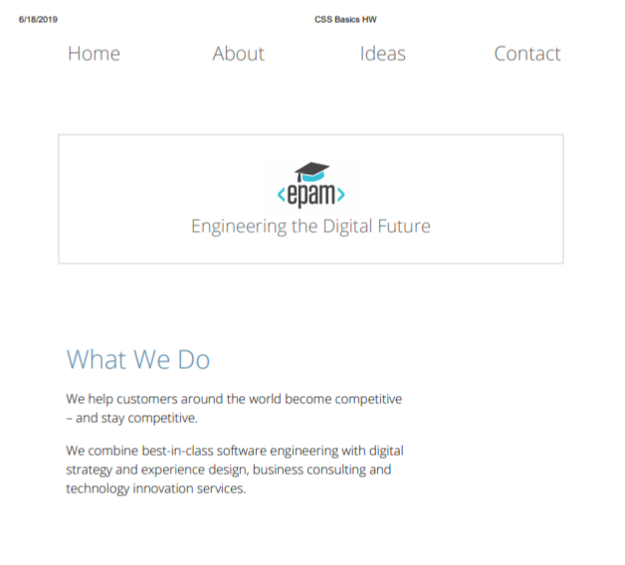
Figure 1 — Print version

Apply your custom CSS styles to modify the page print view. The result should look close (not pixel perfect) to the example provided in Figure 2.
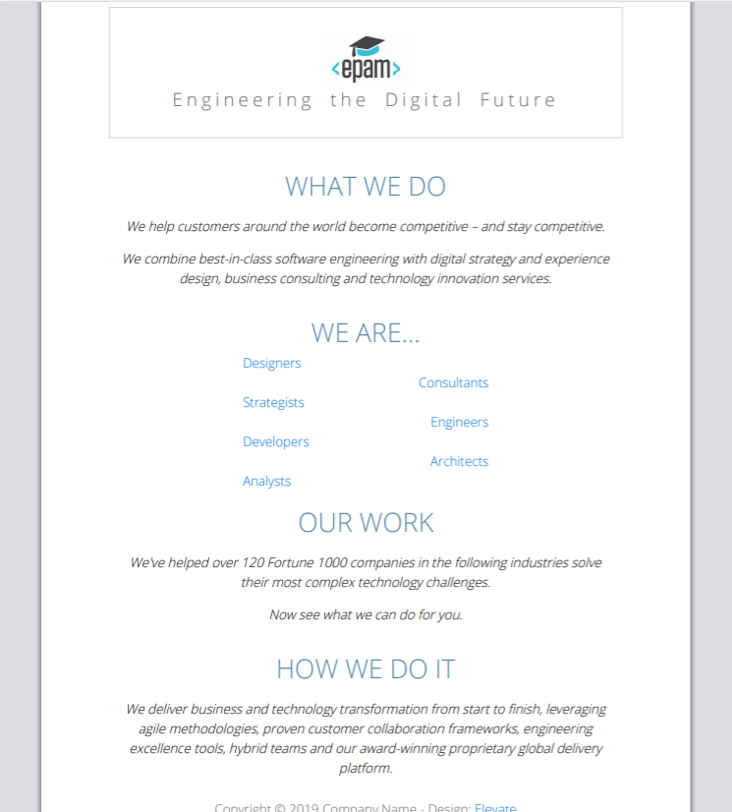

Figure 2 — Print version (mockup)

2) Add a hover effect for the navigation items (background color – lightskyblue , text color - #fff). (see Figure 2).

Figure 2 – Navigation hover effect(mockup).
3) Add gradient from “lightskyblue” color to “burlywood “color for the banner.( see Figure 3)
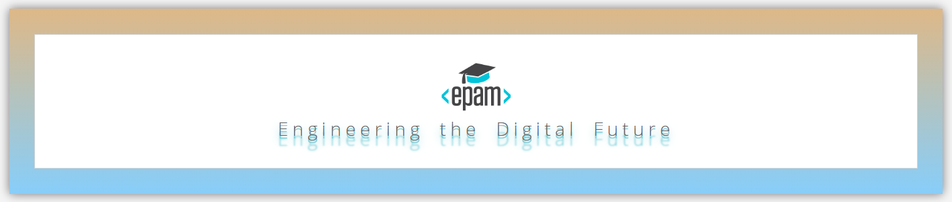Figure 3 – Banner(mockup).
4) Add shadow for banner text and spacing between words and letters. ( see Figure 3)

5) Add a box-shadow to navigation and to each content block (color - rgba(61, 55, 61, 0.7)). Change banner’s background-color to #76cdd7. Add text-shadow, letter-spacing and word-spacing to the banner (see Figure 4 for reference).
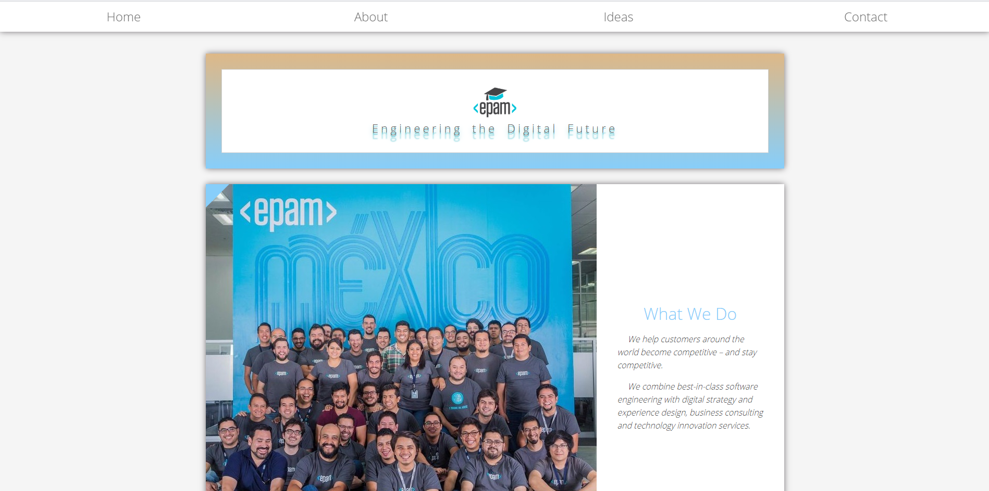

Figure 4 — Blocks shadow and banner’s styling (mockup)
6) Add animation to the banners text. Make it move from 45 degree to 0.
(see examples/animation.gif).

7) Add styles to make picture from the left side and text in center of section. Text should be styled as on the picture.(see Figure 4)
8) There is a gallery section in the markup. Please add a hover effect to it as shown in Figure 5.
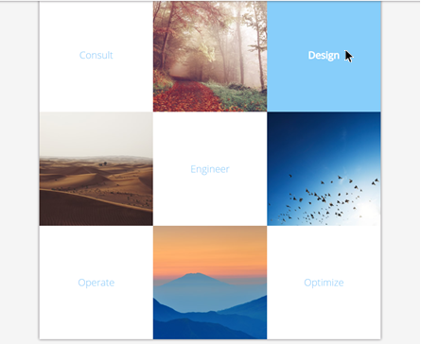

Figure 5 — Gallery block (mockup)

9) Make use of pseudo-elements to add a blue triangle to each section of the page (see top left corner in Figure 6).
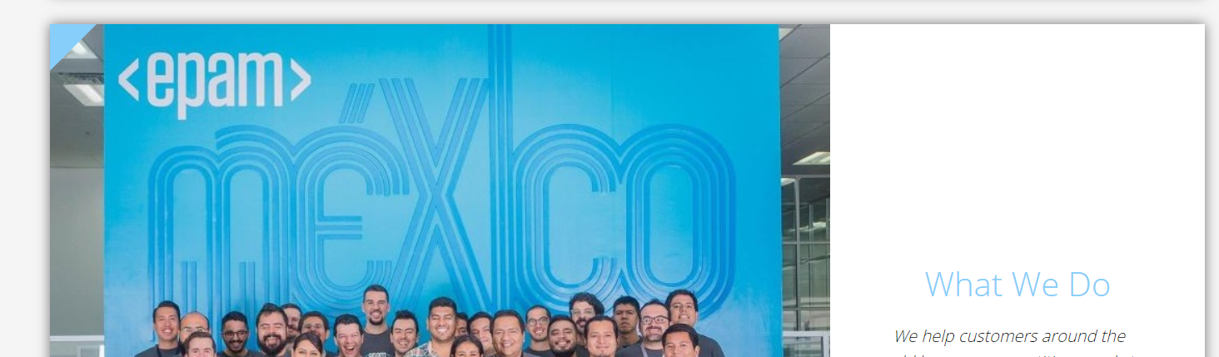

Figure 6 —Triangle (mockup)
10) Add styling to the “We are…” section (see Figure 7 for reference):
- add styling to section header;
- change list type to decimal-leading-zero;
- the hovered links should look like “Architects” item (red);
- add “New” label to the end of “Designers” and “Strategists” list items; change their font-variant and boldness.

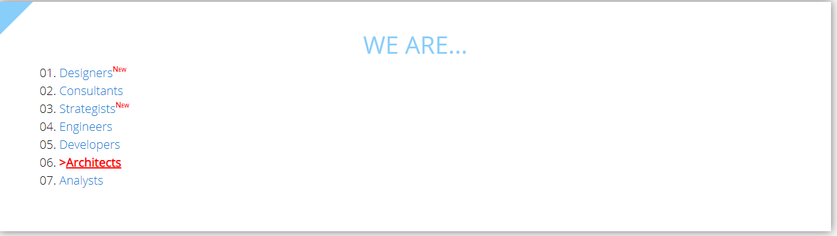
Figure 7 —List styling (mockup)

11) Every first paragraph that immediately follows <h2> should be italicized and formatted in such a way (see Figure 8 for reference):
- vertical space between lines should be increased;
- some extra space at the start of the first line should be added.

Figure 8 —Formated section (mockup)

12) Style the following block as shown in Figure 9.
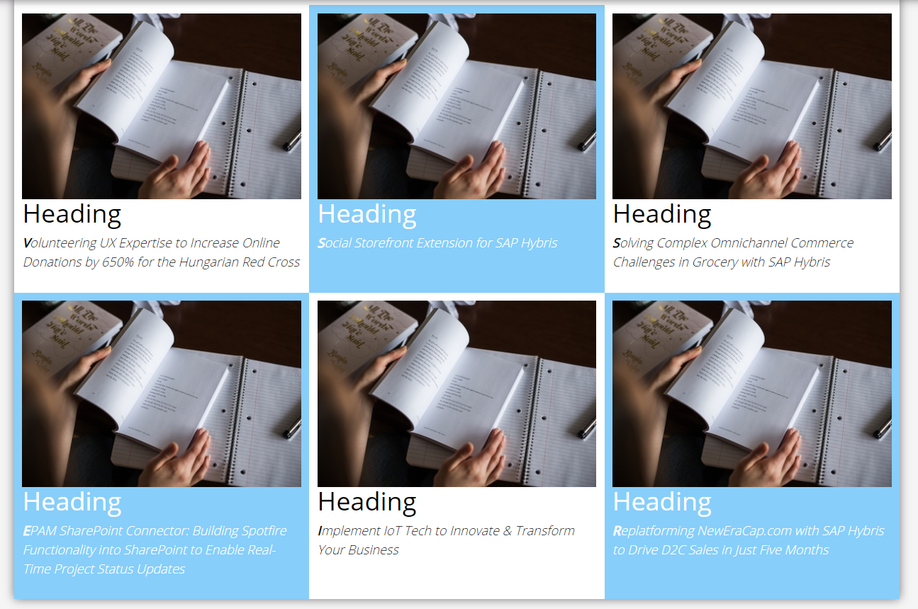
Figure 9 —Block styling (mockup)

13) Style form elements as shown in Figure 10. Note that subject field contains an image (img/search-icon.png).All fields have focus (Figure 11).
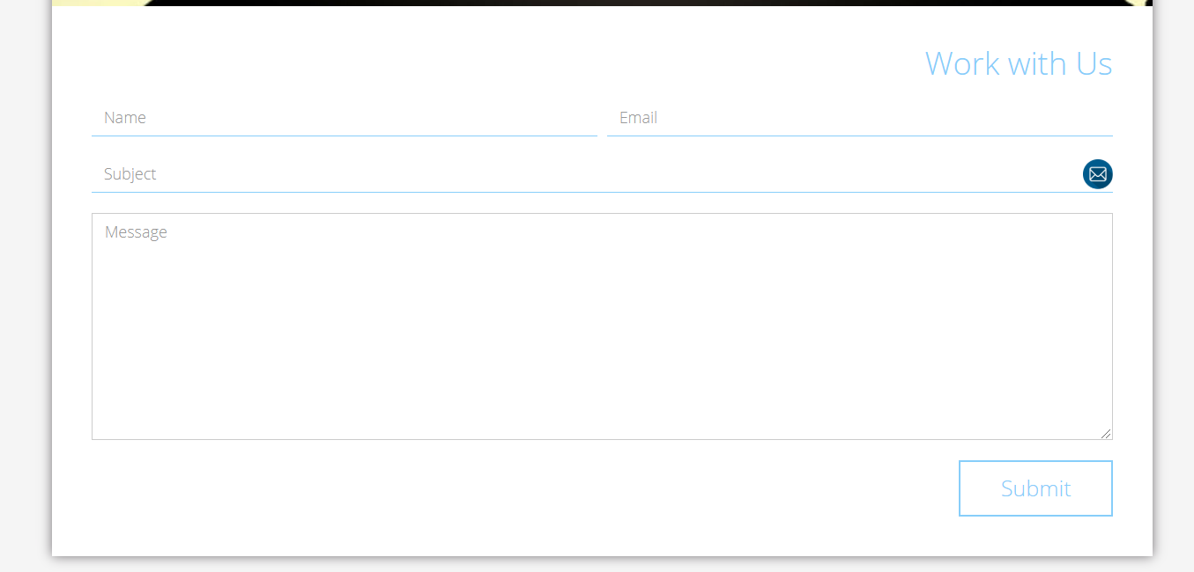
Figure 10 —Work with Us form (mockup)
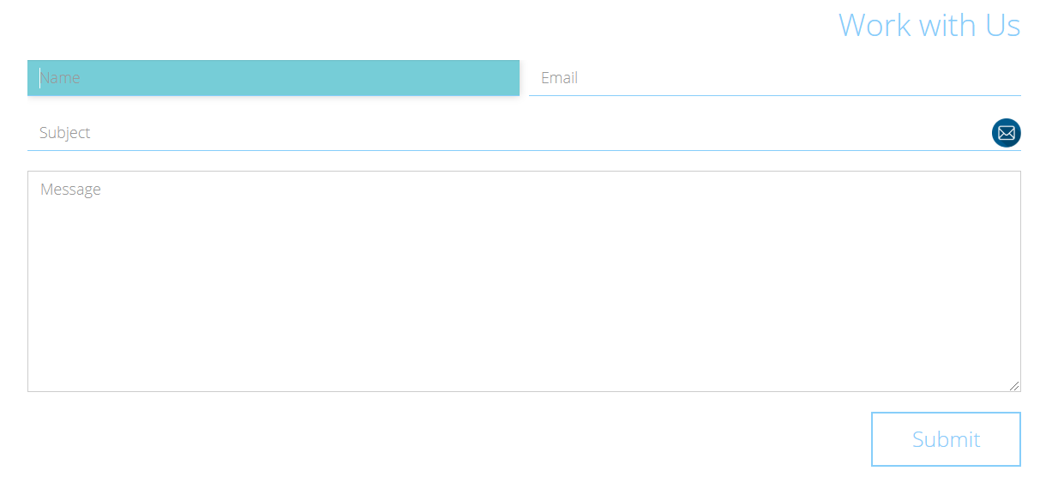
Figure 11 —Work with Us form (mockup)

The submit button should have a hover effect (see Figure 12).

Figure 12 —Submit button in hover state (mockup)

RESTRICTIONS
- Adding/editing styles in the general.css and bootstrap.min.css file is forbidden;
- Usage of JavaScript is forbidden;
- Adding anything to index.html is forbidden;
- Adding task/ and example/ folders is forbidden. Do not push it to repository (only homework/ folder should be pushed);
- No requirements for browser support (should work properly in Google Chrome last version).

BEFORE SUBMIT
- Read requirements and compare to your homework result;
- Format the code (remove unnecessary lines of code);
- Make sure your GitHub folder structure meets the required one (without task and examples folders);
- Validate your CSS (https://jigsaw.w3.org/css-validator/).

SUBMIT
- The FL13_HW2 folder should be uploaded to GitHub repository “FL-13” into master branch

USEFUL LINKS
- https://www.smashingmagazine.com/2007/07/css-specificity-things-you-should-know/
- https://dev.to/doppelmutzi/understand-how-css-styles-are-applied-to-html-elements-by-learning-the-fundamentals-precedence-specificity-cascade-de4
- http://specificity.keegan.st/
- https://vegibit.com/css-selectors-tutorial/
- https://www.sitepoint.com/css-printer-friendly-pages/

To see print preview mode, open index.html file in a browser and press ctrl+p (or cmd+P for Mac).

