Nepali Village Adventures

http://www.photos-voyages.com/nepal/images/nepal14_large.jpg

Summary

Our story, Nepali Village Adventures focuses on two main characters one in the mountainous northern region and the other in the tropical south region of Nepal, who each go on an exciting adventure through the area.

Featuring exciting scenery from each region, the viewer is taken on an exciting cultural journey and learns details about Nepal as the video progresses. Local wildlife, architecture and cultural artifacts such as Prayer Flags and a Yeti all make appearances throughout the characters travels.

Animation will be used to accentuate the atmosphere of each area by animating not just the characters, but their surroundings as well. Our goal is that by the end of the presentation, viewers will have gathered some knowledge about the cultural atmosphere of Nepal and its diverse regions.

Storyboard

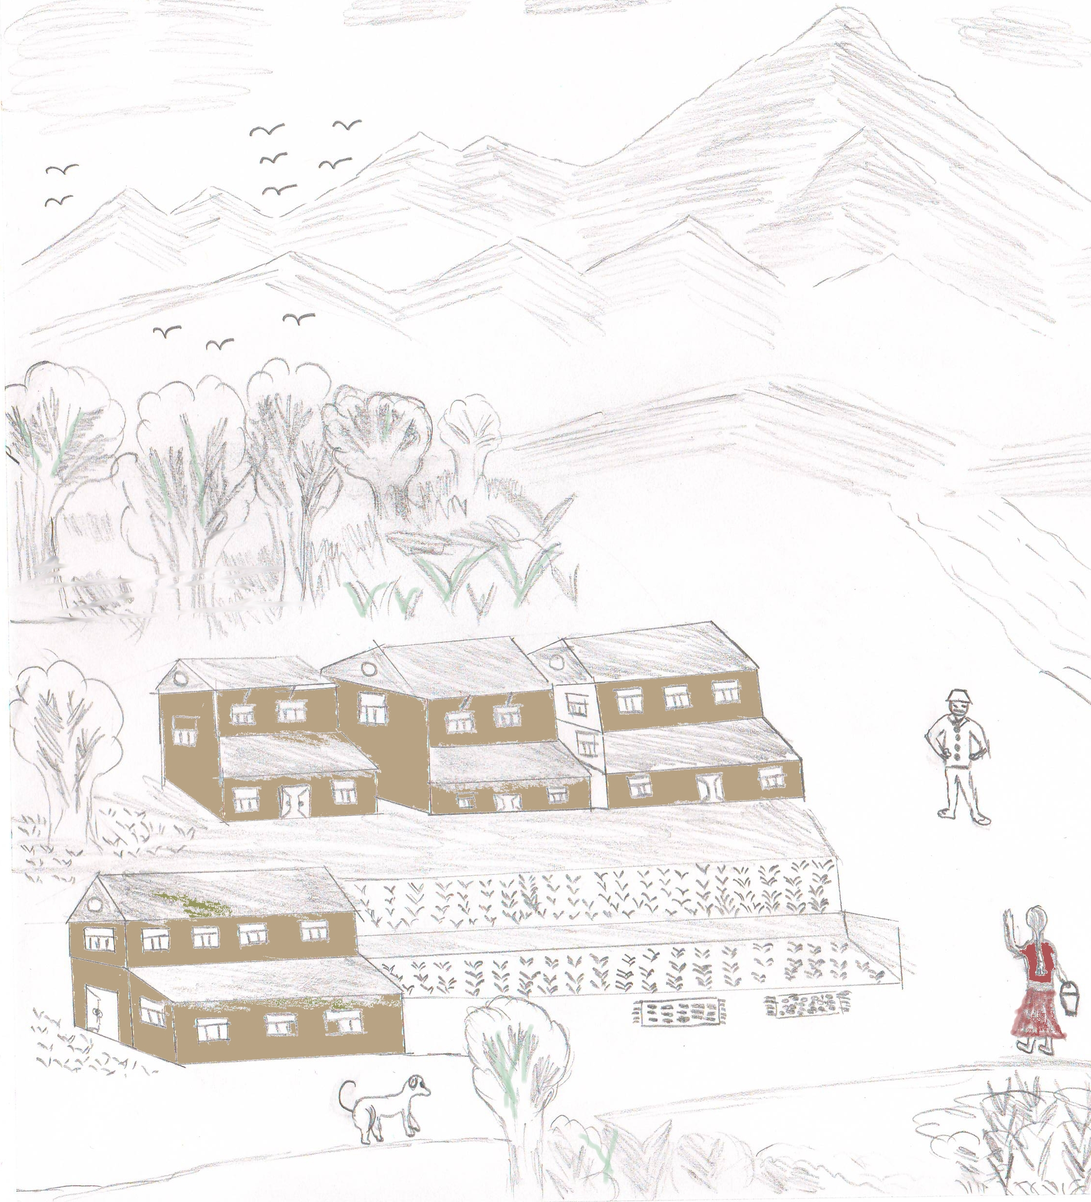
Scene 1: The story begins in a village in northern Nepal under the Himalayan mountains. Our main character, a village girl named Pasang lives here.
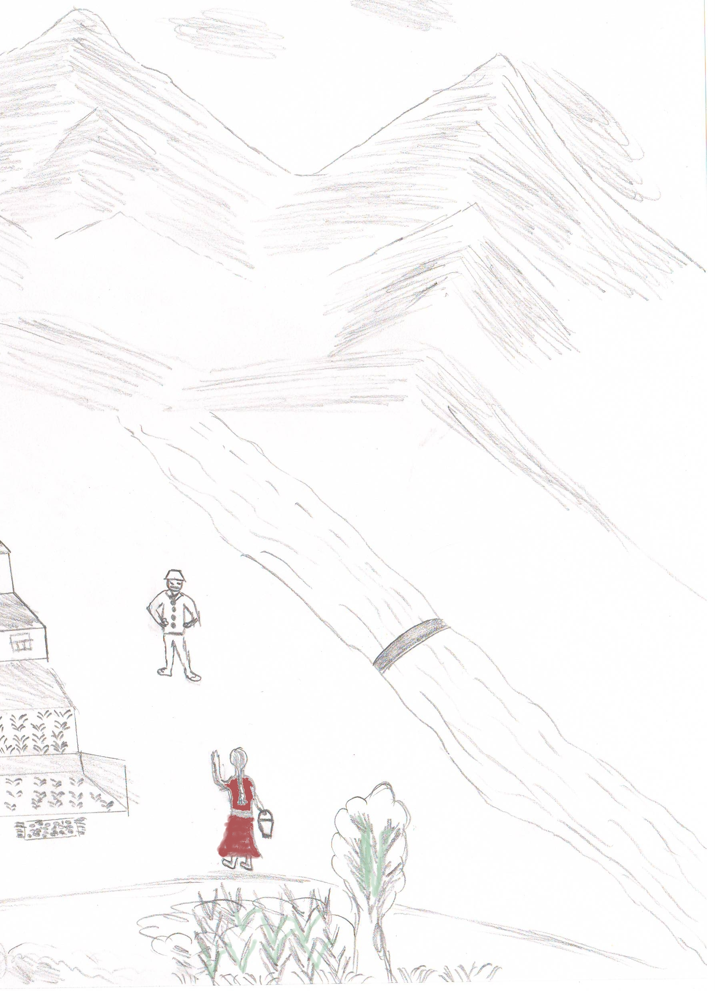
Scene 2: Pasang then goes to the river to fetch water for her family. She makes her way through mountainous terrain to perform her everyday tasks.
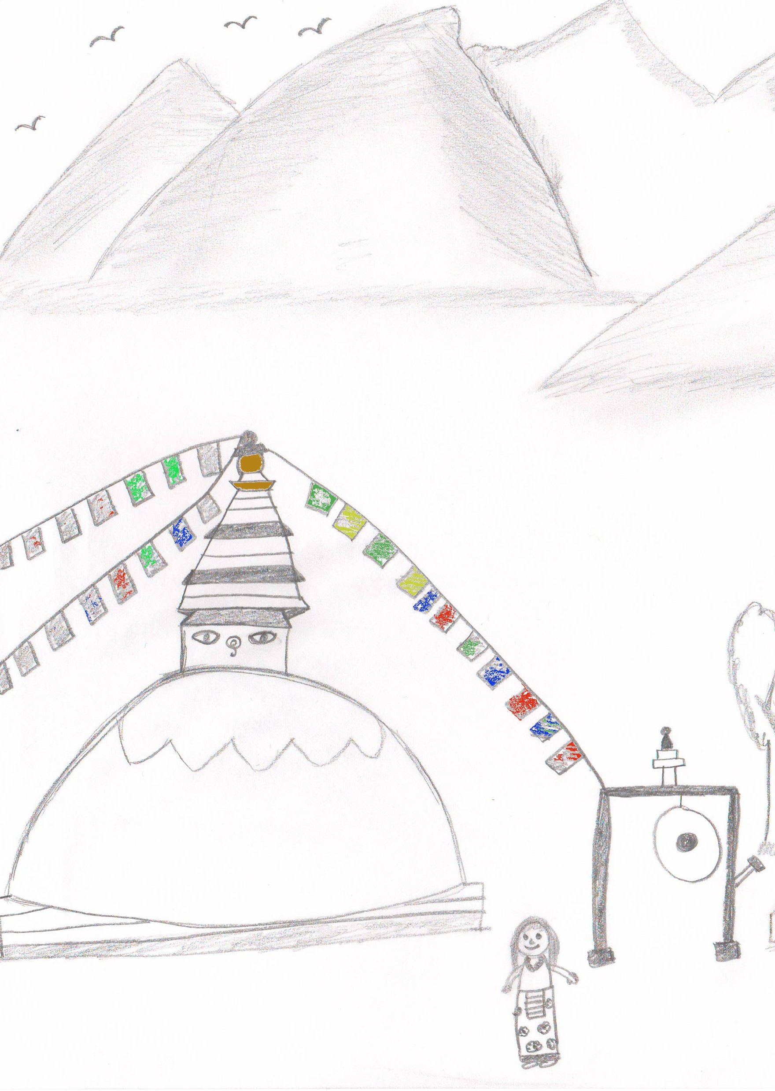

Scene 3: She then goes to the Buddhist Stupa to pray. The Stupa has bells and the traditional prayer flags.
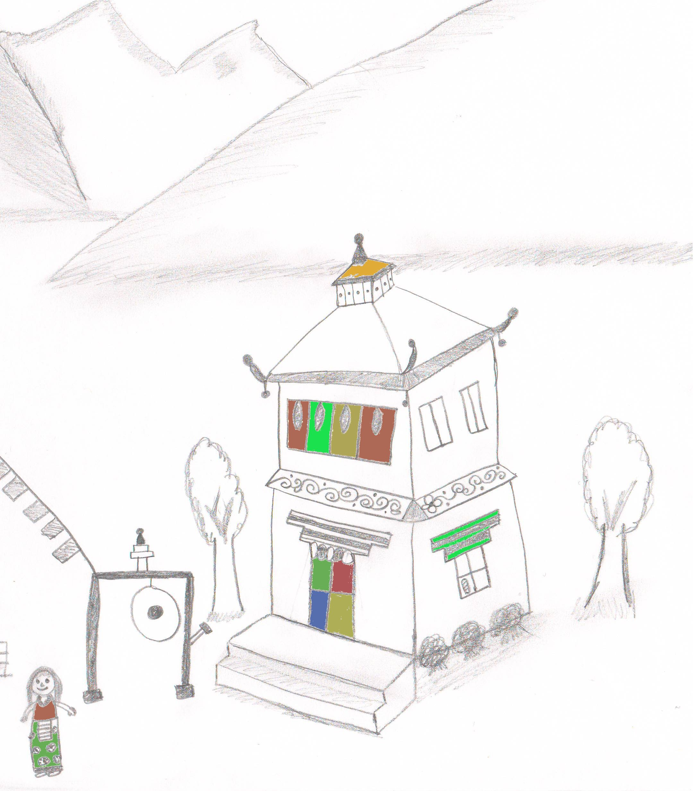

Scene 4: She then goes to the Monastery nearby to meditate, a common practice in Buddhist traditions. Monasteries are found in various places across Northern Nepal.
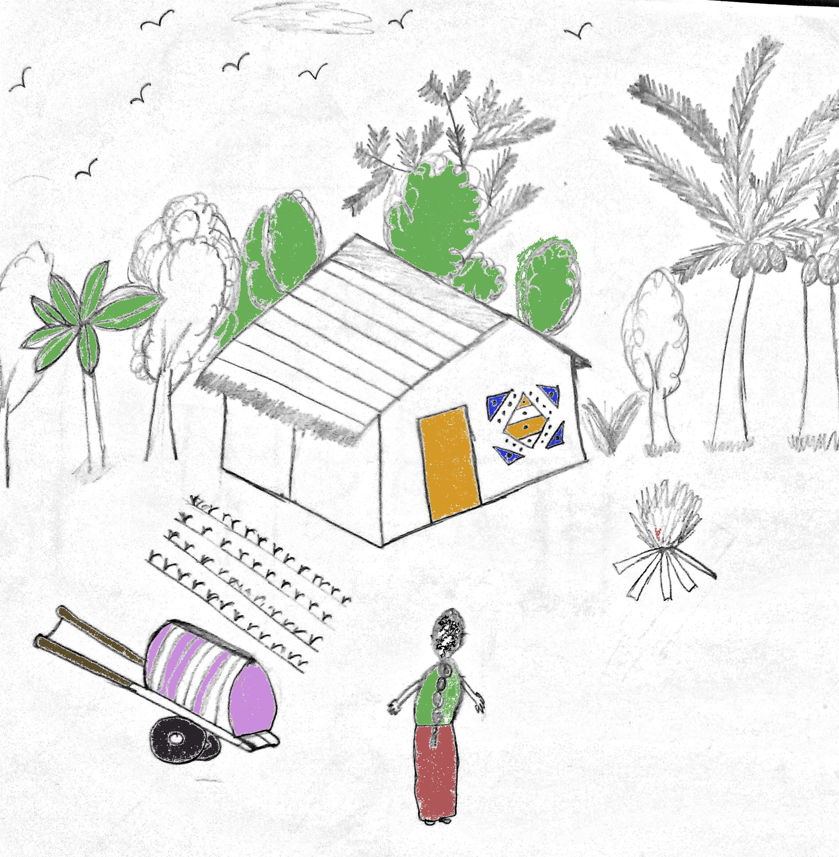
Scene 5: Our story next goes to a village in Subtropical southern Nepal. A very different terrain than North Nepal. We can see the traditional houses and our other main character, Mina in her village.
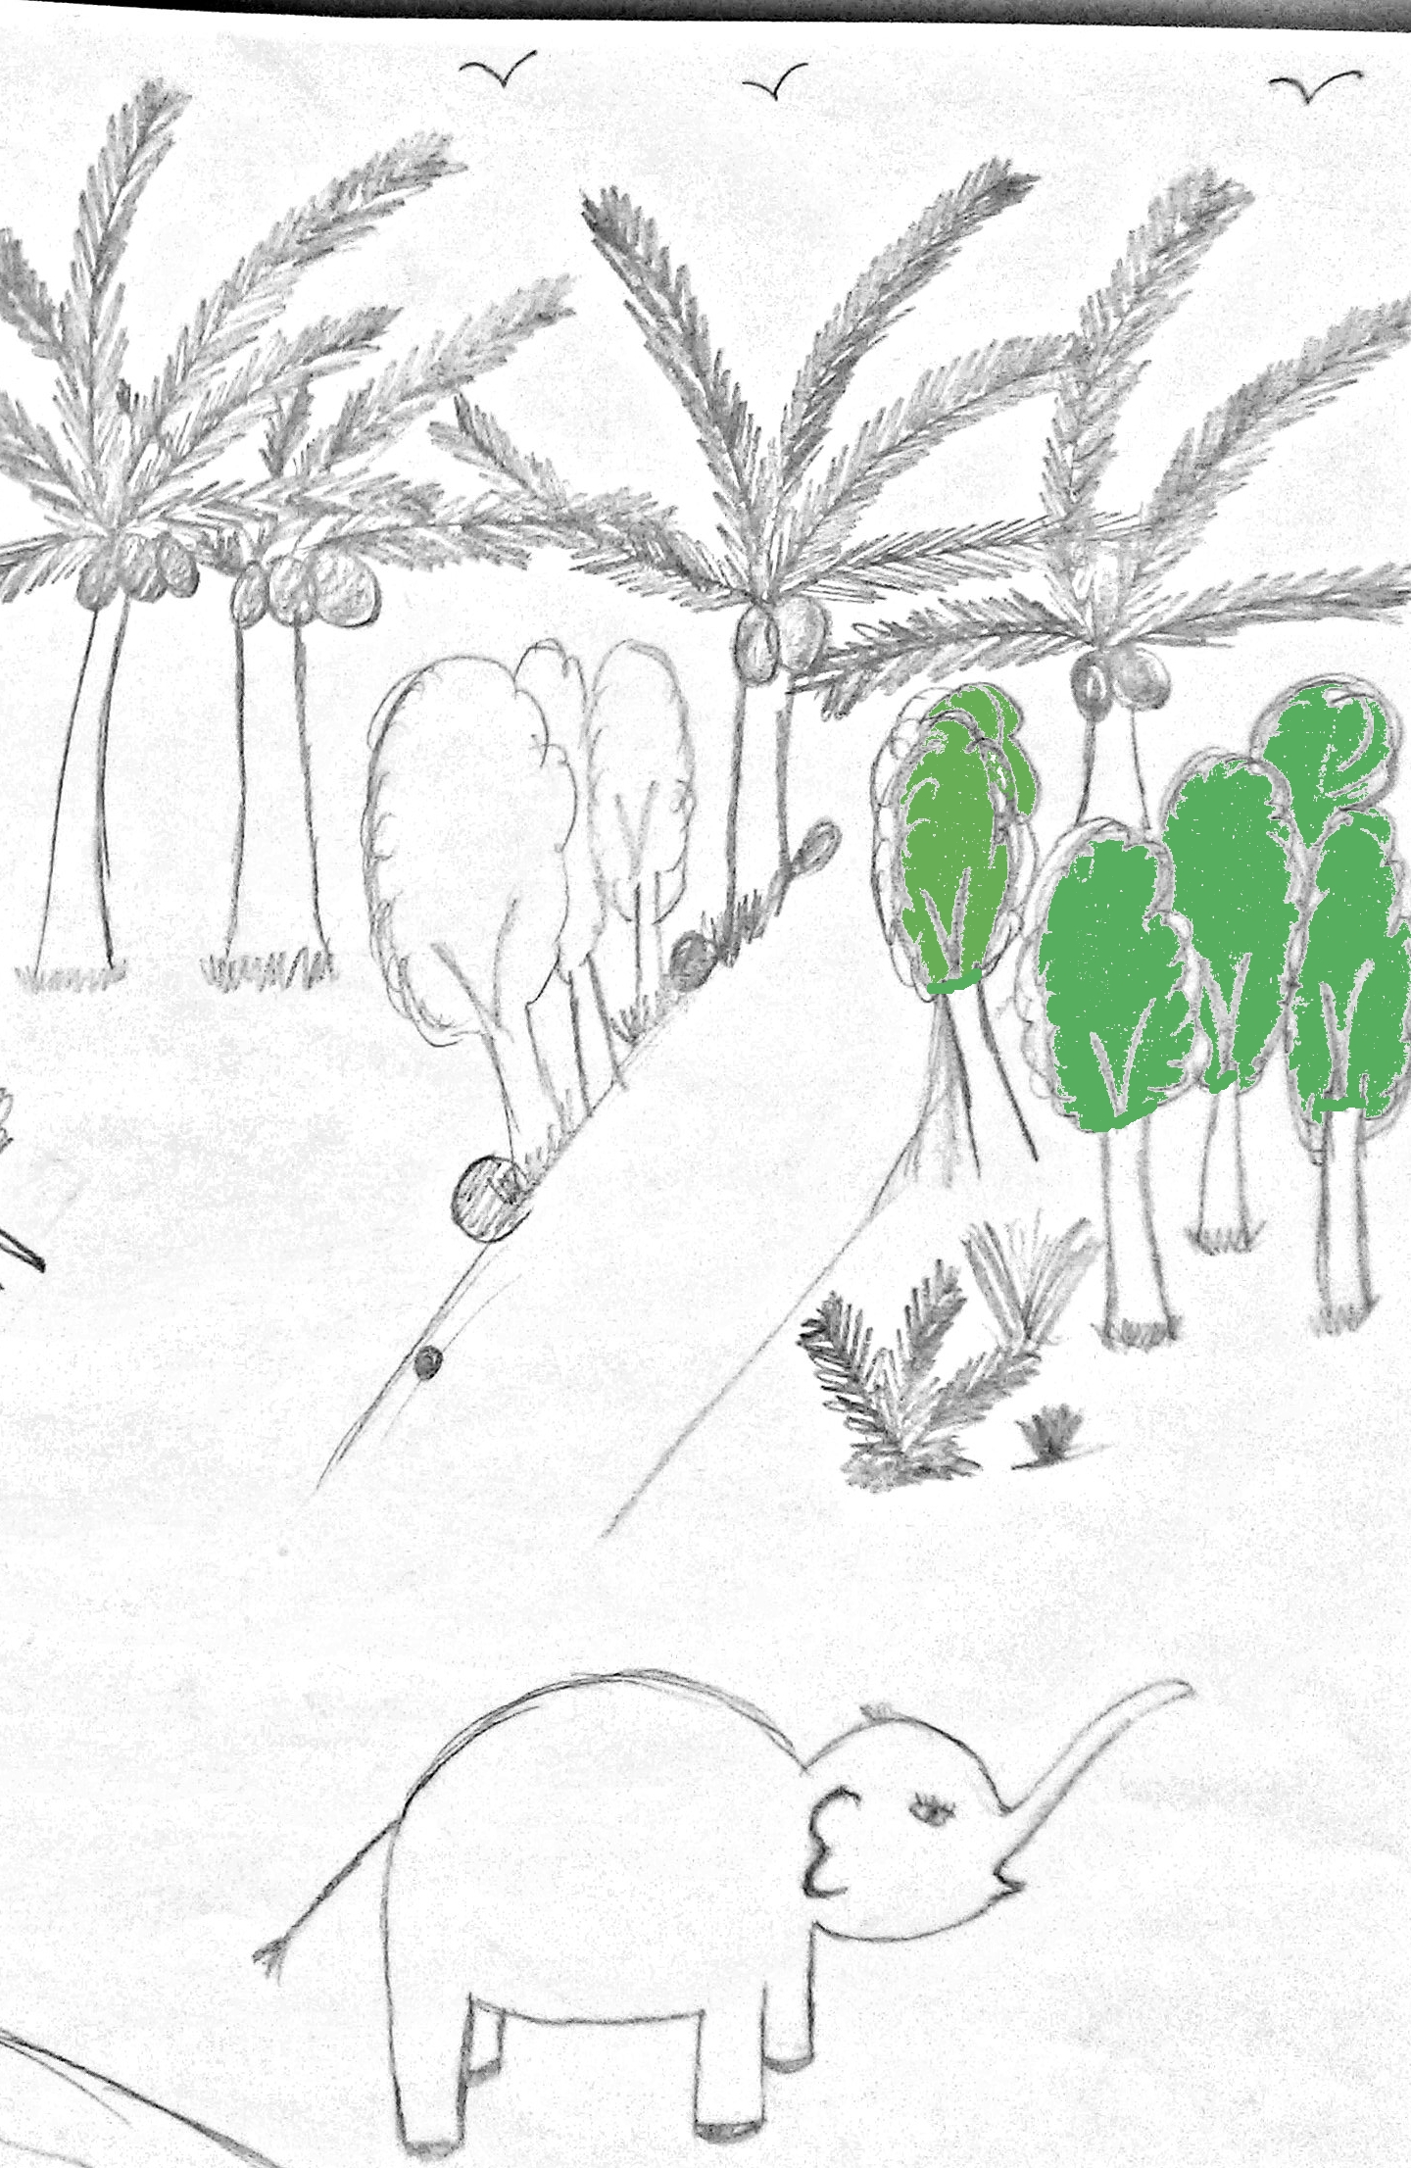

Scene 6: Mina then goes into the jungle on her pet elephant to get some firewood for her home. The tropical jungle is found in southern Nepal, and elephants are common in these jungles.
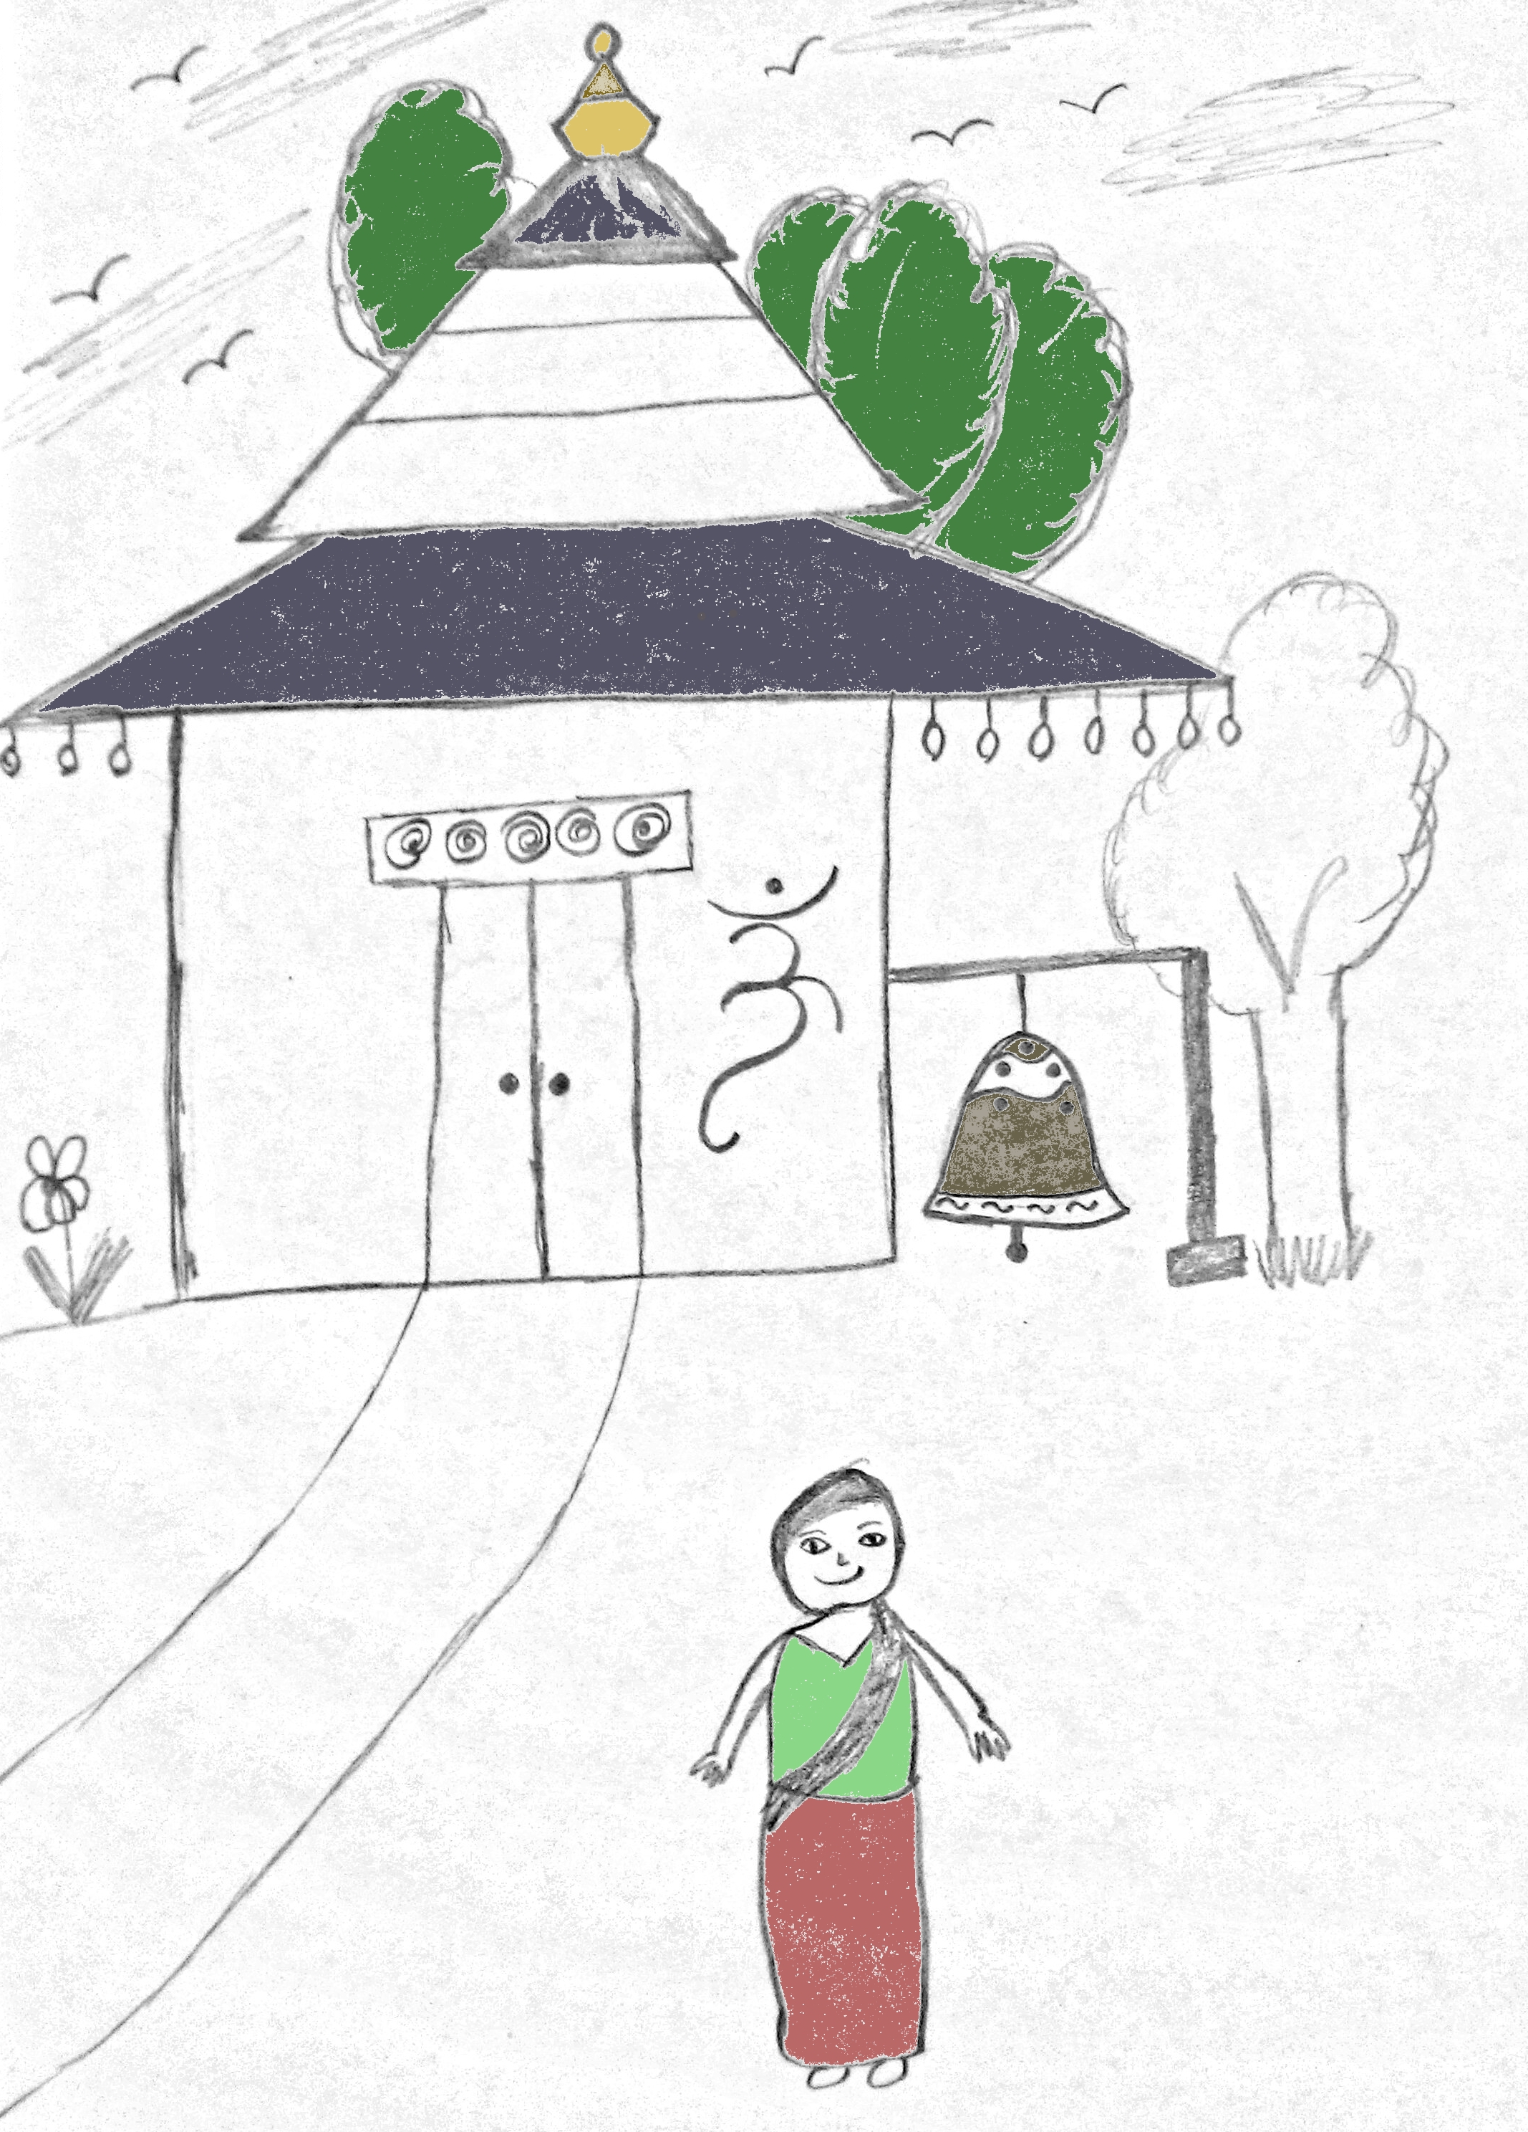

Scene 7: Mina then goes to a Hindu temple to pray. The temple has a pagoda architecture and bells around it. These are common cultural features of Nepal.
Group Meeting Schedule

Our team intends to meet minimum once per week on Tuesdays at 12:30PM. We will use GitHub for version controlling our project, and keeping track of bugs and each others work as well as issuing tasks. We will divide up work dynamically, based on each others strengths and the needs of our project as scenes develop.

Git Repo: https://github.com/SuperSheep18/307project

Guidelines for Project Initial Proposal

 | Aedan | Pranjali | Aaron | Cole
1st coordinator | x
2nd coordinator |  | x
3rd coordinator |  |  | x
4th coordinator |  |  |  | x
Story/message creation | x | x | x | x
Proposal write-up | x | x | x | x
Modelling & Texture | x | x | x | x
Animation | x | x | x | x
Special effects | x | x | x | x
Rendering | x |  | x | x
Final Video | x | x | x | x
Final Report | x | x |  | x

Time Allocation Graph

 | Wk5 | Wk6 | Wk7 | Wk8 | Wk9 | Wk10 | Wk11 | Wk12 | Wk13
Aedan | 8hr | 8hr | 8hr | 8hr | 8hr | 8hr | 8hr | 8hr | 8hr
Pranjali | 8hr | 8hr | 8hr | 8hr | 8hr | 8hr | 8hr | 8hr | 8hr
Cole | 8hr | 8hr | 8hr | 8hr | 8hr | 8hr | 8hr | 8hr | 8hr
Aaron | 8hr | 8hr | 8hr | 8hr | 8hr | 8hr | 8hr | 8hr | 8hr

