Web Programming Assignment - Individual Assignment #2

# Student Details

Full Name: Justin Brown

ID#: 1502670

Email: 1502670@utech.edu.jm

Module Code: CIT2011

Assignment: Individual Assignment #2

Day/Time of Class: Friday 11am-1pm

# Storyboard

# Login Page

# 

# Product Page

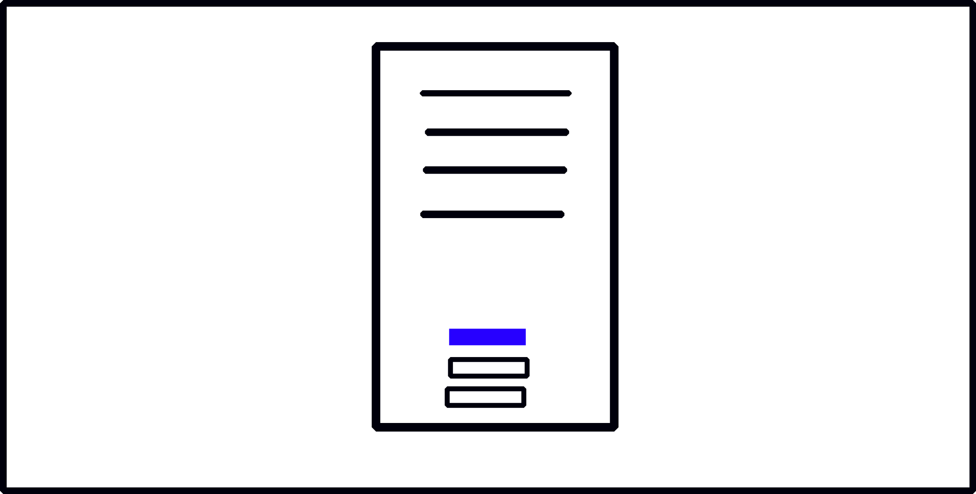

# Invoice Page

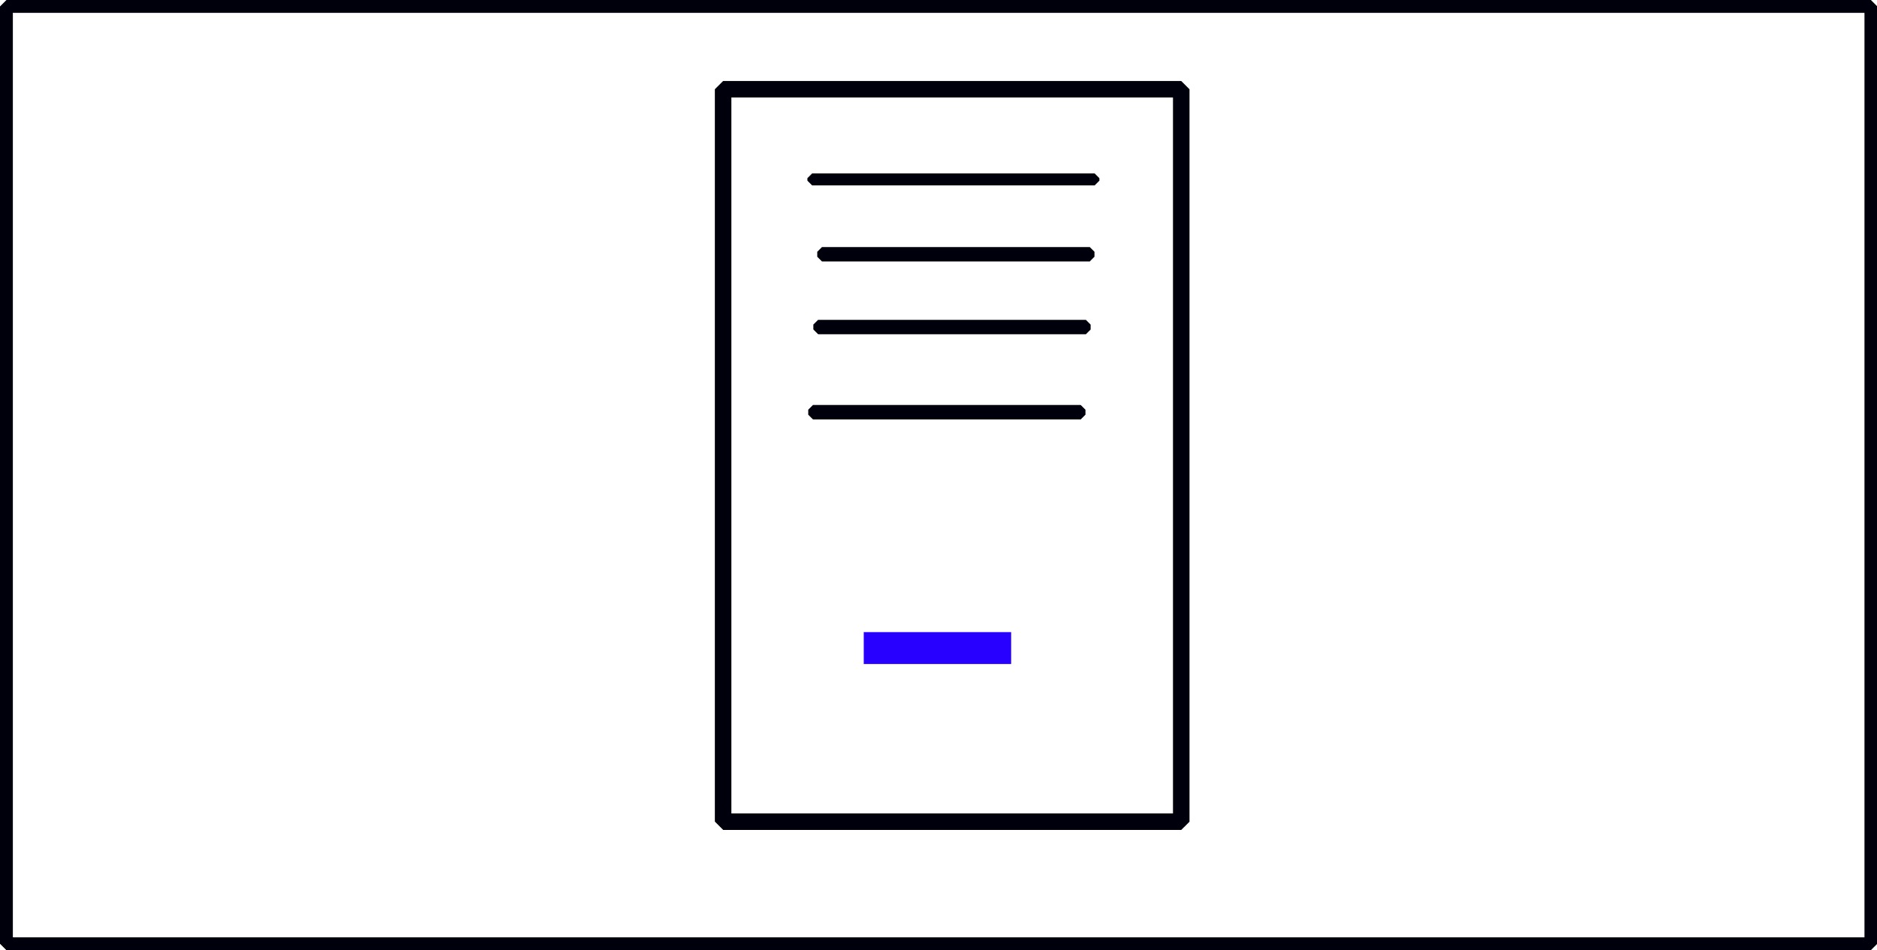

# 2. Business Description

## Business Name: Auto Parts Dealer

## Slogan

Your Trusted Auto Parts Source

## Mission Statement

To provide high-quality auto parts at affordable prices.

## Vision Statement

To be the leading supplier of automotive parts nationwide.

# 3. Justification of Color Palette

The color palette consists of a combination of blue and white. Blue represents trust and professionalism and white provides a neutral, clean background. These colors are often used in automotive branding to inspire confidence and reliability.

# 4. Intended Audience

The intended audience includes car owners, auto mechanics, and repair shops who are looking for high-quality, reliable auto parts.

# 5. References

No external sources were used.

# 6. Free Hosting Link

https://omegasolice.github.io/Web-Prog-Assignment-2/