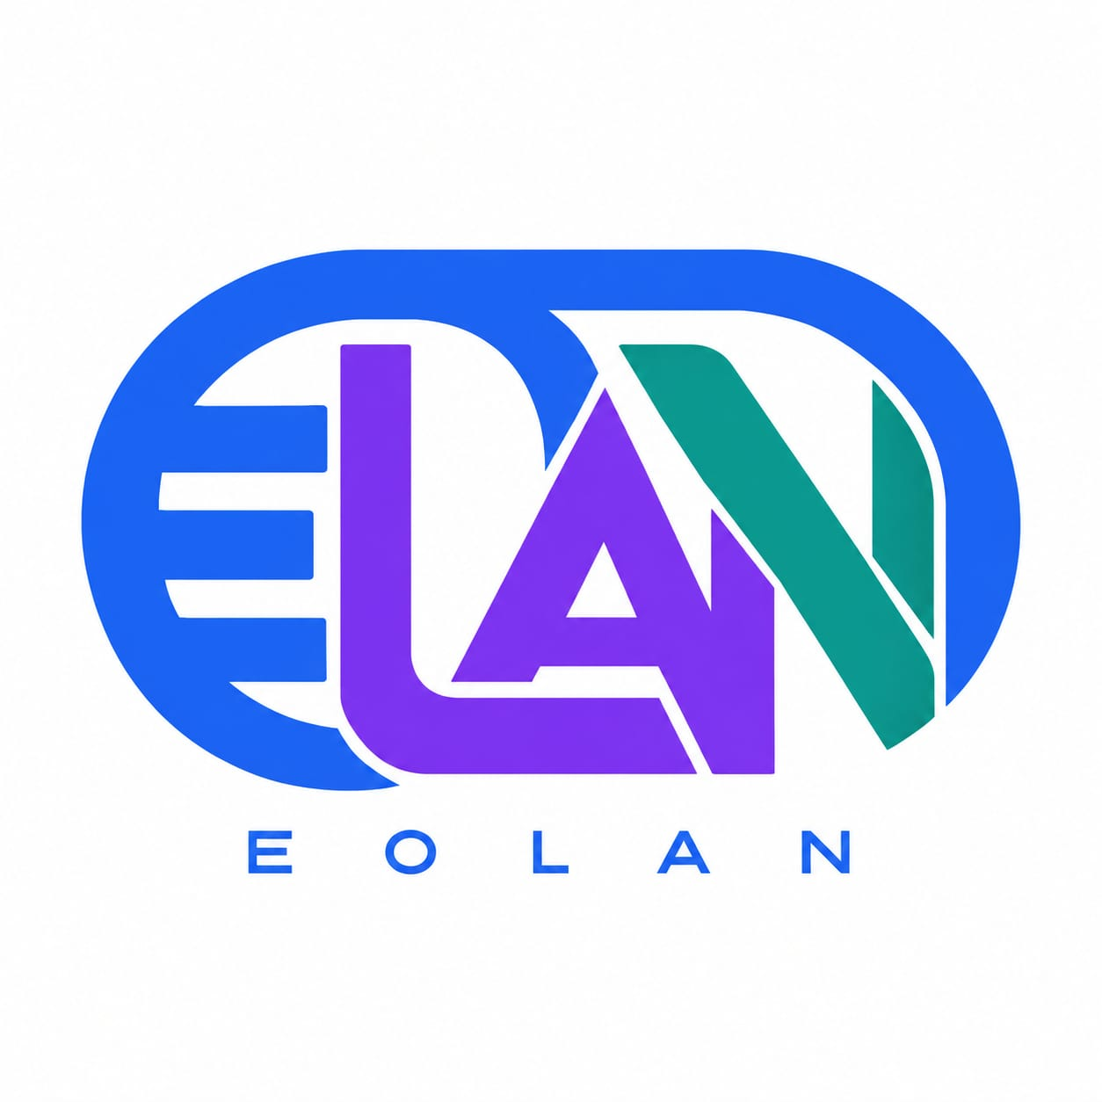

Full-Stack Developer Portfolio
EOLAN DiGITAL | PRD VERSION 2.1 | 21 OCTOBER 2026
Prepared for Egbedayo Olanrewaju • Dark-themed multi-page portfolio • Audience: employers and freelance clients
BRAND ASSETS | Approved EOLAN logo supplied. Primary colors: royal blue, purple and teal (approximate image samples; exact hex codes TBD). Use the original logo artwork without recoloring.

1. Brand and project overview
Brand | EOLAN DiGITAL
Owner / developer | Egbedayo Olanrewaju
Hero headline | Building Digital Experience
Purpose | Showcase credible full-stack work, attract hiring opportunities, and generate freelance enquiries.
Design direction | Premium dark navy interface; EOLAN royal blue, purple and teal accents; responsive and accessible.
Logo | Approved EOLAN logo received; use supplied original artwork.
Profile photo | Yes — final photo asset TBD.
CV | Later phase; no download link until a CV is supplied.

Approved professional introduction
I am a passionate Full Stack Web Developer focused on building modern, responsive, and user-friendly web applications. I specialize in React, JavaScript, TypeScript, Node.js, Express, MongoDB and MySQL, developing everything from engaging frontend interfaces to secure and scalable backend systems.
I enjoy turning ideas into practical digital solutions that solve real-world problems. My goal is to help businesses and individuals bring their ideas to life through clean code, thoughtful design and reliable technology.

2. Contact and public profiles
Professional email | Egbedayoolanrewaju@gmail.com
GitHub | https://github.com/Omegacarlos1
LinkedIn | https://www.linkedin.com/in/egbedayo-olanrewaju-671730243/
Domain | TBD — domain choice, registration and ownership
Hosting | TBD — final provider and monthly budget; recommendations in section 9

3. Site map and page requirements
- Home — Hero headline and bio excerpt, photo, featured projects, technology preview, services preview, contact call to action.
- About — Full biography, development approach, photo, verified background and social links; CV placeholder until supplied.
- Projects — Project gallery with status labels and technology filters; do not imply unfinished work is live.
- Project detail — Project goal, role, features, screenshots, technology, challenges, status, demo/repository links when available.
- Skills — Frontend, backend, database, testing and tooling; reflect demonstrable experience.
- Services — Six approved services with brief descriptions and enquiry calls to action.
- Experience — Only verified work, education and achievements; missing entries can remain unpublished.
- Contact — Accessible enquiry form, public email, GitHub and LinkedIn.

4. Portfolio content and services

Projects — status must be confirmed
- Ahoden Elite Clean — TBD: completion status, screenshots, responsibilities, demo and repository.
- Playrush Gaming Platform — TBD: completion status, screenshots, responsibilities, demo and repository.
- Figma BYC design — TBD: design ownership, scope, screenshots, Figma link and implementation status.

Services
- Full-stack web development
- Frontend development
- Backend / API development
- Database design
- E-commerce development
- Website maintenance

5. Technology and architecture
Frontend | React, TypeScript, JavaScript, Redux Toolkit for shared state, React Router; responsive styling (Tailwind CSS recommended).
Backend | Node.js, Express REST API, Socket.IO for an approved real-time feature in a later phase.
Databases | MySQL for live production and local development through XAMPP/phpMyAdmin. MongoDB is listed in personal skills, not required as a project database.
Testing | Jest for frontend/unit tests; Mocha with Chai/Supertest for backend/API tests.
Development tools | VS Code, Git, GitHub, environment configuration, linting and formatting.
Architecture: React + Redux client → HTTPS Express API → MySQL. Socket.IO is deferred unless an authenticated live-notification requirement is approved.

6. Functional requirements
- Responsive navigation, working internal links, keyboard access and dark branded design.
- Project cards and individual case studies, with clear In Development / Completed status.
- Contact form: name, email, message, optional project type/budget; validate inputs and show submission feedback.
- POST /api/contact: validate and save enquiries to MySQL, then send a notification to the owner email.
- GET /api/health: simple health check for deployment monitoring.
- Use server-side email delivery credentials, spam prevention, rate limiting and safe error handling.
- Admin dashboard: later phase only; no public admin route in MVP.
- Socket.IO: retained in stack plan but no MVP feature unless a real-time use case is approved.

7. Database and local environment

Local — XAMPP
- Run local MySQL using XAMPP and administer it via phpMyAdmin.
- Create a portfolio database, a dedicated application account, and versioned SQL schema/migrations.
- Keep secrets in .env files excluded from Git; use test records only in development.

Production — MySQL
- Use managed or secured production MySQL; do not deploy XAMPP to production.
- Restrict database access, configure backups and restore checks, and enable encryption where supported.
- Initial contact_messages table: id, name, email, project_type, budget_range, message, status, created_at.
- Define retention period and privacy notice before collecting visitor information (TBD).

8. Testing, security and launch criteria
Jest | Render/navigation tests, project filtering, form validation and UI states.
Mocha | API success/failure tests, malformed input, email failures, DB errors and rate limiting.
Manual QA | Responsive devices, accessibility, browser compatibility, SEO, image optimization and link checks.
Security | HTTPS, server-side validation, parameterized SQL, CORS allowlist, safe secrets and abuse protection.
MVP acceptance | All pages load; projects show truthful status; enquiries persist in MySQL and trigger email; tests pass; live domain has HTTPS.

9. Domain and hosting recommendations
- Frontend: Vercel or Netlify for React static assets and deployment previews.
- Backend: Node.js-compatible hosting such as Render or Railway; choose a plan with reliable outbound email and WebSocket support if Socket.IO is later enabled.
- Database: managed MySQL compatible with the chosen backend and backup requirements.
- DNS/domain: choose a domain (TBD), verify availability and pricing, retain account ownership, configure HTTPS and renewal reminders.
- TBD: preferred provider, hosting budget, domain extension, email delivery provider, monitoring and backup retention.

10. Milestones and delivery scope
M1 — Planning | Confirm logo, photo, project assets, domain preferences, page content and design tokens.
M2 — Frontend | Build responsive React/TypeScript pages, Redux setup, project views and contact UI.
M3 — Backend | Express API, XAMPP schema, production MySQL configuration, email workflow.
M4 — Quality | Jest and Mocha tests, accessibility, SEO, performance and security review.
M5 — Deployment | Publish frontend/backend, migrate MySQL, configure DNS/HTTPS, smoke-test contact flow.
Later phase | Authenticated admin dashboard, Socket.IO notifications and CV download when ready.

11. Open decisions / TBD register
- Existing EOLAN DiGITAL logo file (SVG/PNG) and official brand palette.
- Professional photo and any photo-use preferences.
- Final project status, images, contributions, repositories and demo URLs for all three projects.
- Domain name, hosting budget, hosting provider and email service.
- Public experience/education details, testimonials (if verified), and CV file.
- Privacy policy text, enquiry retention period, and whether project budget is a required form field.
Scope note: The MVP excludes payments, public chat, CMS, authenticated admin dashboard and real-time notifications. These require separate approval.

