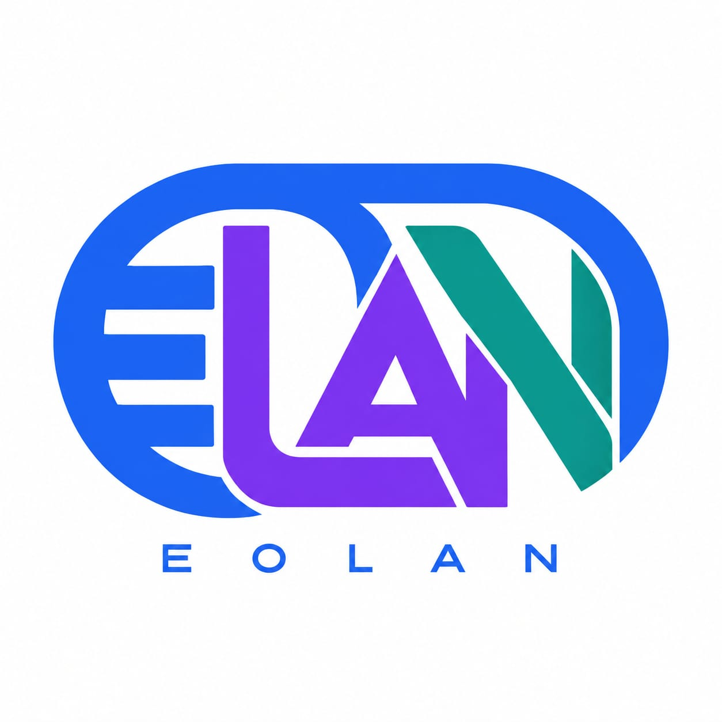

Frontend Development Milestones
  - EOLAN DiGITAL | Full-Stack Developer Portfolio | Version 1.0
Objective: Build a polished, accessible, responsive, dark multi-page portfolio for both employers and freelance clients. Frontend-first delivery, with backend integration in a later phase.

Project guardrails
- Brand: use the supplied EOLAN logo and its blue, purple and teal palette; dark navy UI. Do not recreate or distort the logo.
- Stack: React + TypeScript + Redux Toolkit + React Router; use reusable components. Backend later: Node.js, Express, Socket.IO and MySQL; XAMPP for local database; Mocha and Jest for testing.
- Content: Egbedayo Olanrewaju; brand EOLAN DiGITAL; hero headline “Building Digital Experience”. Do not invent employment, project completion, testimonials or metrics.
- Projects: Ahoden Elite Clean, Playrush Gaming Platform, Figma BYC Design; label completion status TBD until verified. CV, domain and admin dashboard remain TBD/later.

M1 — Foundation & architecture
Build: Initialize Vite React/TypeScript app, Redux Toolkit, routing, linting, test configuration, design tokens and common layout.
Acceptance: App boots locally; routes render; shared header/footer work; lint/build/tests pass.
Deliverables: React TS project, Redux store, routes, design tokens, README, AGENTS.md.

M2 — Branding & responsive shell
Build: Apply dark navy theme and EOLAN colors/logo; build accessible navigation, footer, responsive spacing, typography, buttons and cards.
Acceptance: No horizontal overflow at mobile/tablet/desktop; keyboard navigation works; logo is legible.
Deliverables: UI components, responsive navigation, theme styles, component tests.

M3 — Core pages
Build: Implement Home, About, Skills, Services, Experience and Contact; include clear CTAs and professional introduction.
Acceptance: All links and routes work; content matches PRD; no invented claims; contact form is frontend-only until API exists.
Deliverables: Page components, copy, form UI/validation, page tests.

M4 — Project showcase
Build: Build Projects index with categories and three project entries; project detail route with status, role, stack, challenges, images and links when verified.
Acceptance: Project details are data-driven; missing demos/screenshots are labeled TBD, not broken links.
Deliverables: Typed project dataset, cards, filters, detail template, tests.

M5 — Polish, accessibility & SEO
Build: Add restrained animation, reduced-motion support, semantic metadata, image optimization, keyboard/focus states and error/404 pages.
Acceptance: WCAG-conscious contrast and labels; no console errors; metadata unique per page; Lighthouse review completed.
Deliverables: SEO configuration, accessibility fixes, responsive QA report.

M6 — Frontend integration readiness
Build: Document API contracts for contact form; create configurable API client and mocked states; verify build for hosting.
Acceptance: Mock success/error/loading states work; no secrets in frontend; production build passes.
Deliverables: API integration specification, environment example, deployment checklist.

M7 — Backend integration (later)
Build: Implement Express contact API, MySQL storage, email notifications and optional Socket.IO real-time notifications only if approved.
Acceptance: Validated messages saved securely; email delivery tested; API tests pass; optional sockets scoped separately.
Deliverables: Express API, migrations/schema, Mocha tests, integration notes.

Codex workflow for every milestone
- Read the branded PRD and AGENTS.md before modifying files.
- Implement only the current milestone; do not add unapproved features.
- Run install/build/lint/tests available in the repo; fix failures, or report exact blockers.
- At the end provide changed files, commands/results, acceptance checklist, unresolved TODOs and recommended next step.
- Update AGENTS.md with confirmed conventions and architecture decisions, not speculative details.

Decisions / assets still needed
Professional photo (file); exact logo asset in frontend; project status, screenshots and repository/demo URLs; domain and hosting budget; CV later; approval before real-time Socket.IO or admin dashboard.

