**Bug Report**

|  |  |
| --- | --- |
| ID number | Defect 1 |
| Name | Incorrect calculation of VAT and Total when selling Apple product |
| Reporter | Prashant Mundepi |
| Submit Date | 30/01/2017 |
| Summary | When Apple product is bought and sold, VAT and Total are not updated correctly which lead to test case failure |
| URL | http://hoff.is/store/index.html |
| Screenshot | See below |
| Platform | - |
| Operating System | MAC OS |
| Browser | Chrome driver |
| Severity | Major |
| Assigned to |  |
| Priority | High |

**Description**

The calculation of VAT is incorrect when selling an Apple product, VAT and Total are not updated correctly. Please see the below screenshot for more details.

**Steps to reproduce**

> Select the product Apple

> Provide the correct Amount and click “Buy” button.

> Go to the receipt, click Sell button.

> “VAT” and “Total” is not updated which is responsible for test case failure.

**Expected result**

“VAT” and “Total” should be 0 after sold.

**Actual result**

“VAT” is 0.25 and “Total” is 1 after sold.

**Screenshots**

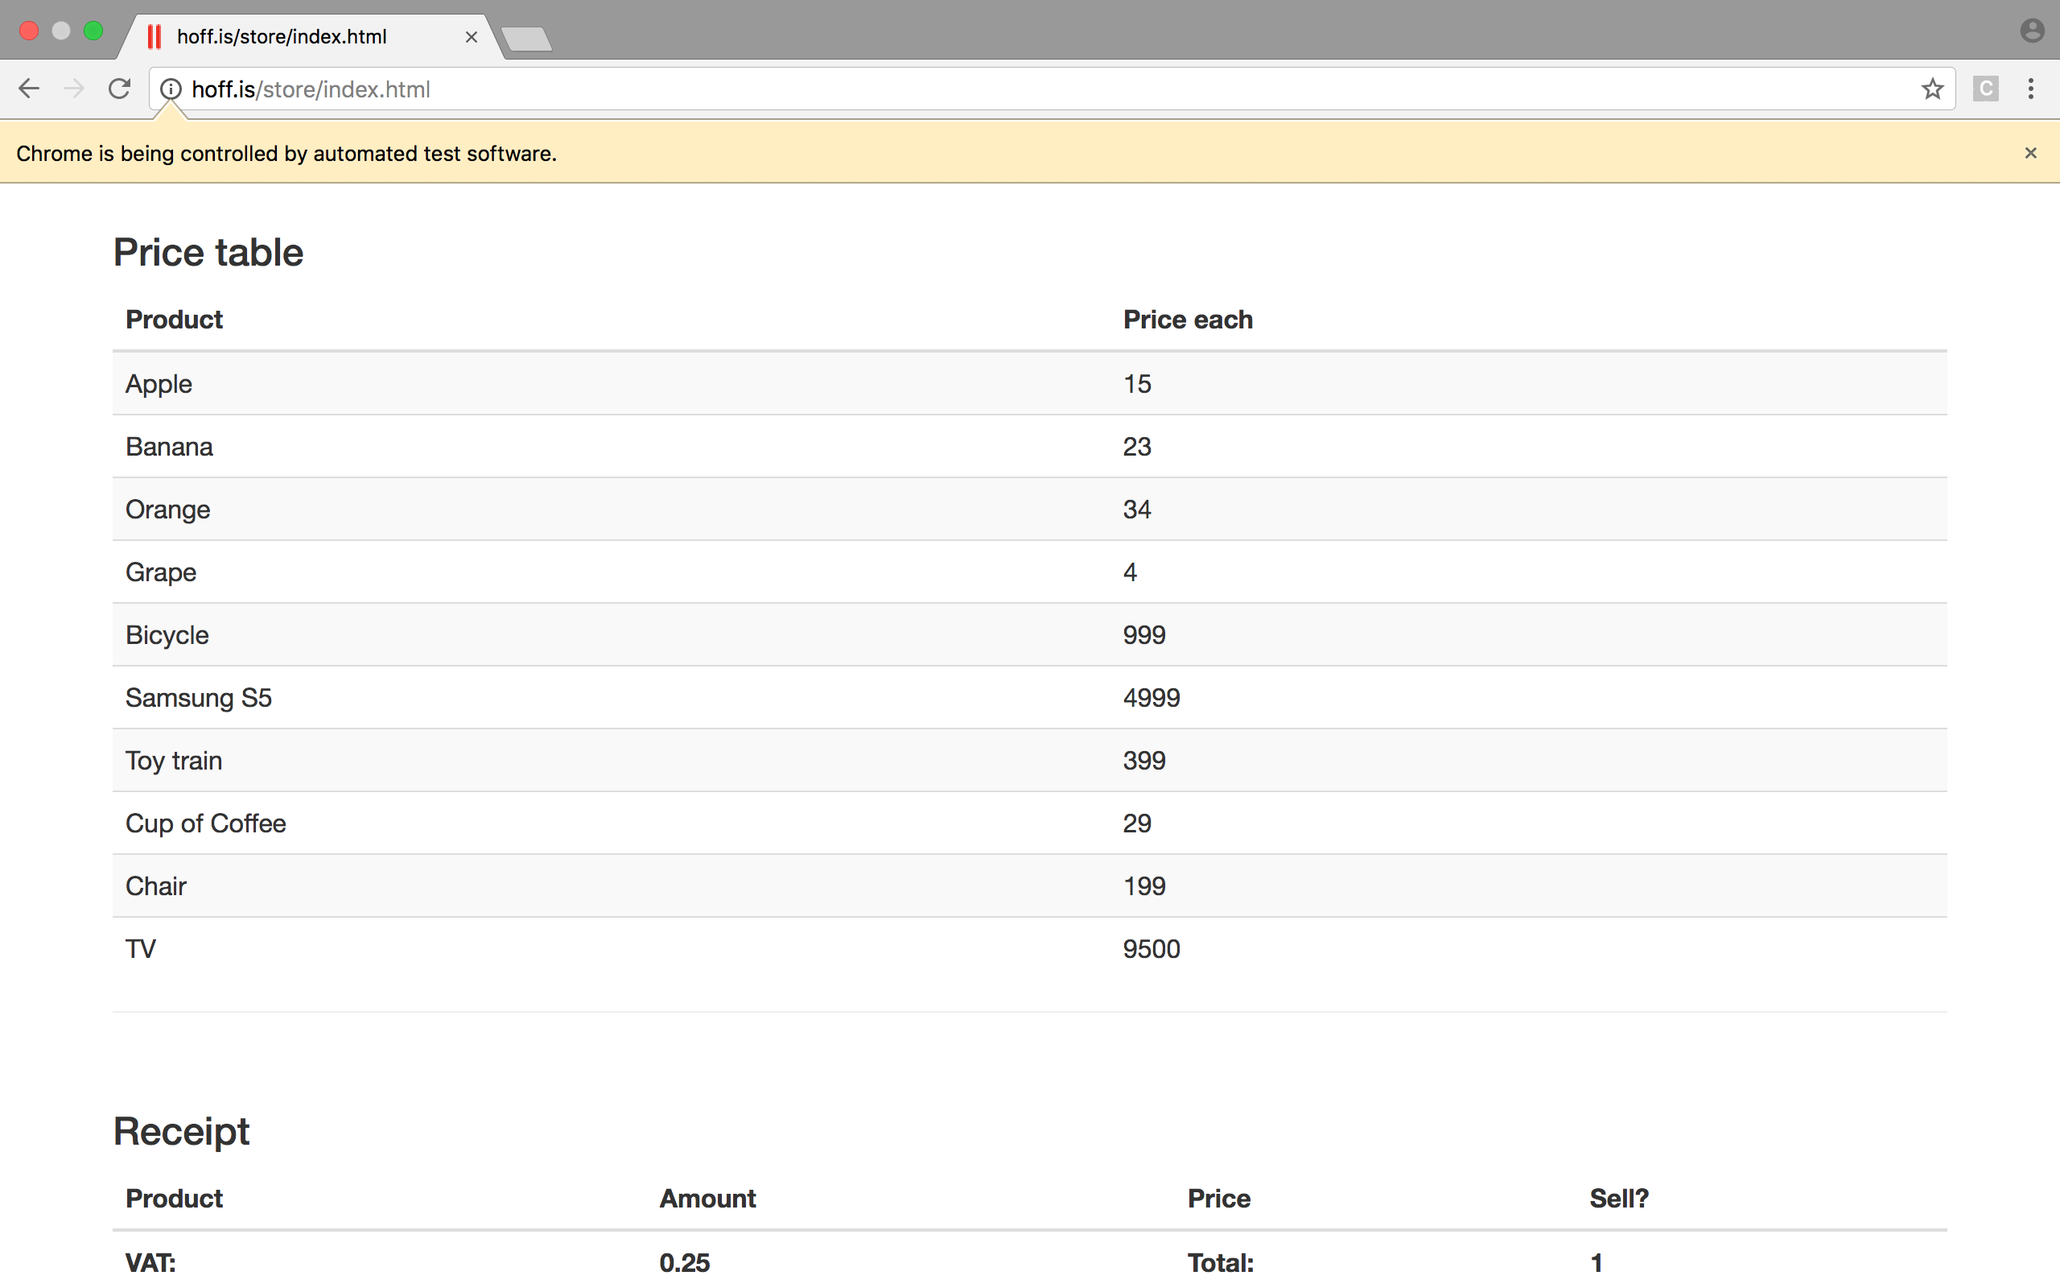

**Report Generation via TEST NG**

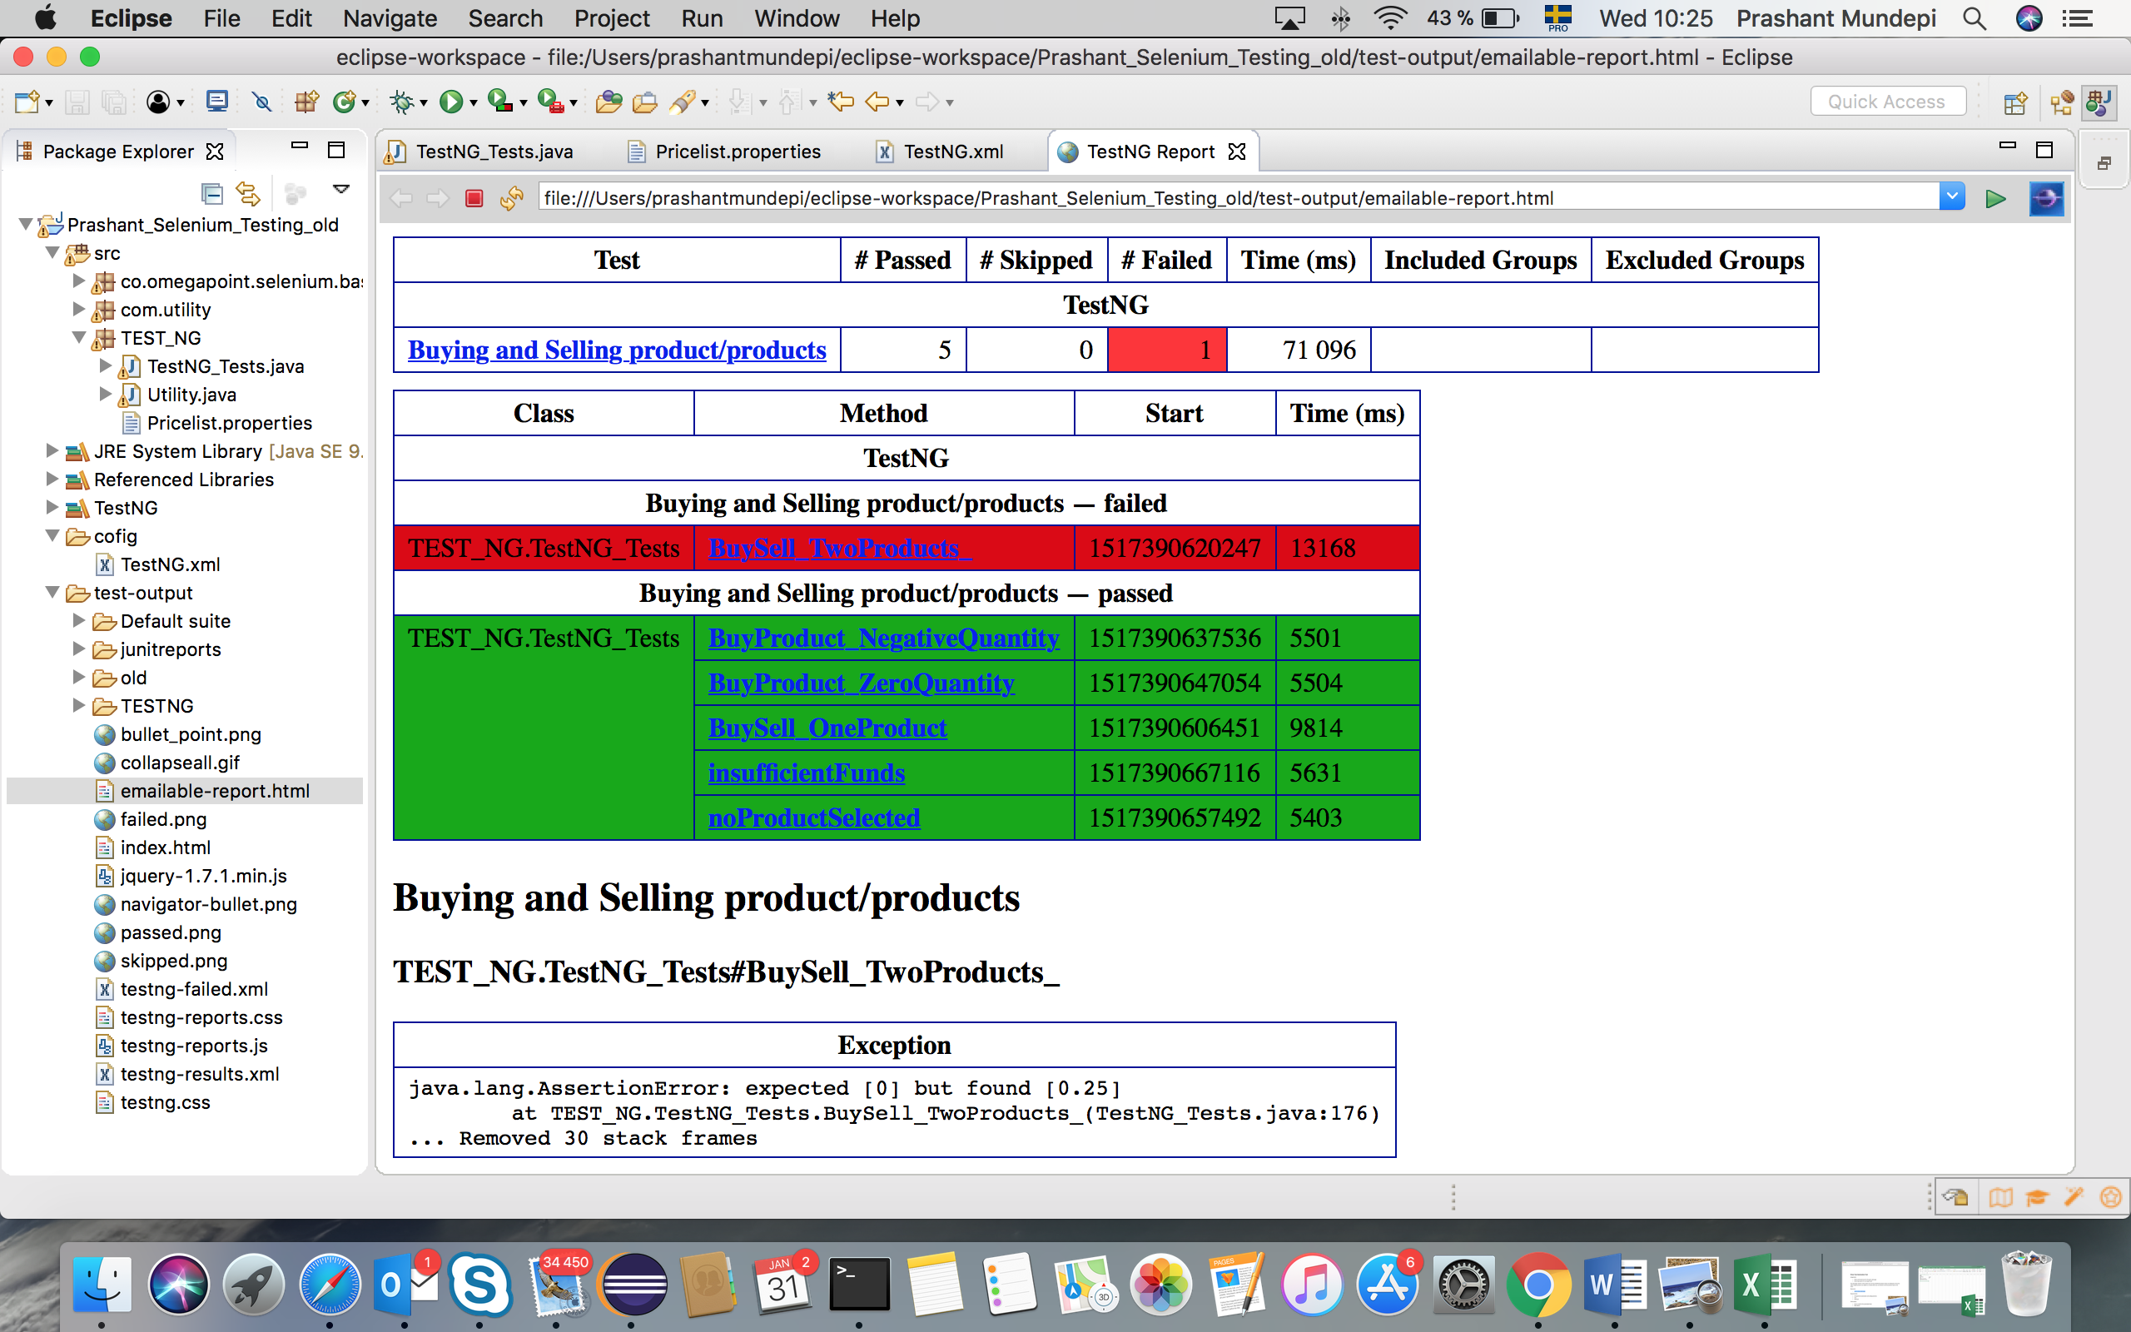

|  |  |
| --- | --- |
| ID number | Defect 2 |
| Name | Incorrect buying price for Bicycle |
| Reporter | Prashant Mundepi |
| Submit Date | 30/01/2017 |
| Summary | When Bicycle is bought incorrect price is calculated |
| URL | http://hoff.is/store/index.html |
| Screenshot | See below |
| Platform | - |
| Operating System | MAC OS |
| Browser | Chrome driver |
| Severity | Major |
| Assigned to |  |
| Priority | High |

**Description**

The calculation of price for Bicycle is incorrectly calculated.

**Steps to reproduce**

> Select the product Bicycle

> Provide the correct Amount for example 1 and click “Buy” button.

> Check message.

**Expected result**

Message: You bought 1 x Bicycle for a total of 999

**Actual result**

Message: You bought 1 x Bicycle for a total of 899.

**Screenshots**

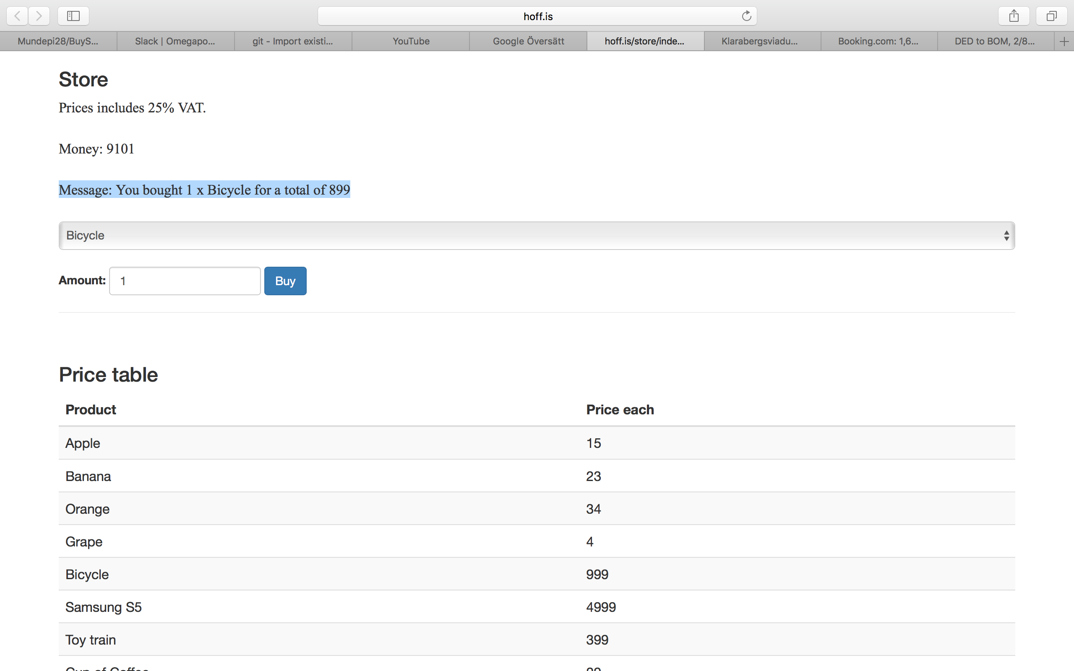

|  |  |
| --- | --- |
| ID number | Defect 3 |
| Name | Incorrect Amount for Cup of Coffee |
| Reporter | Prashant Mundepi |
| Submit Date | 30/01/2017 |
| Summary | When Cup of Coffee is bought incorrect amount is displayed |
| URL | http://hoff.is/store/index.html |
| Screenshot | See below |
| Platform | - |
| Operating System | MAC OS |
| Browser | Chrome driver |
| Severity | Major |
| Assigned to |  |
| Priority | High |

**Description**

The calculation of Amount in web page for Cup of Coffee is incorrect.

**Steps to reproduce**

> Select the product Cup of Coffee

> Provide the correct Amount for example 1 and click “Buy” button.

> Check message.

**Expected result**

Message: You bought 1 x Cup of Coffee for a total of 29

**Actual result**

Message: You bought 2 x Bicycle for a total of 29

**Screenshots**

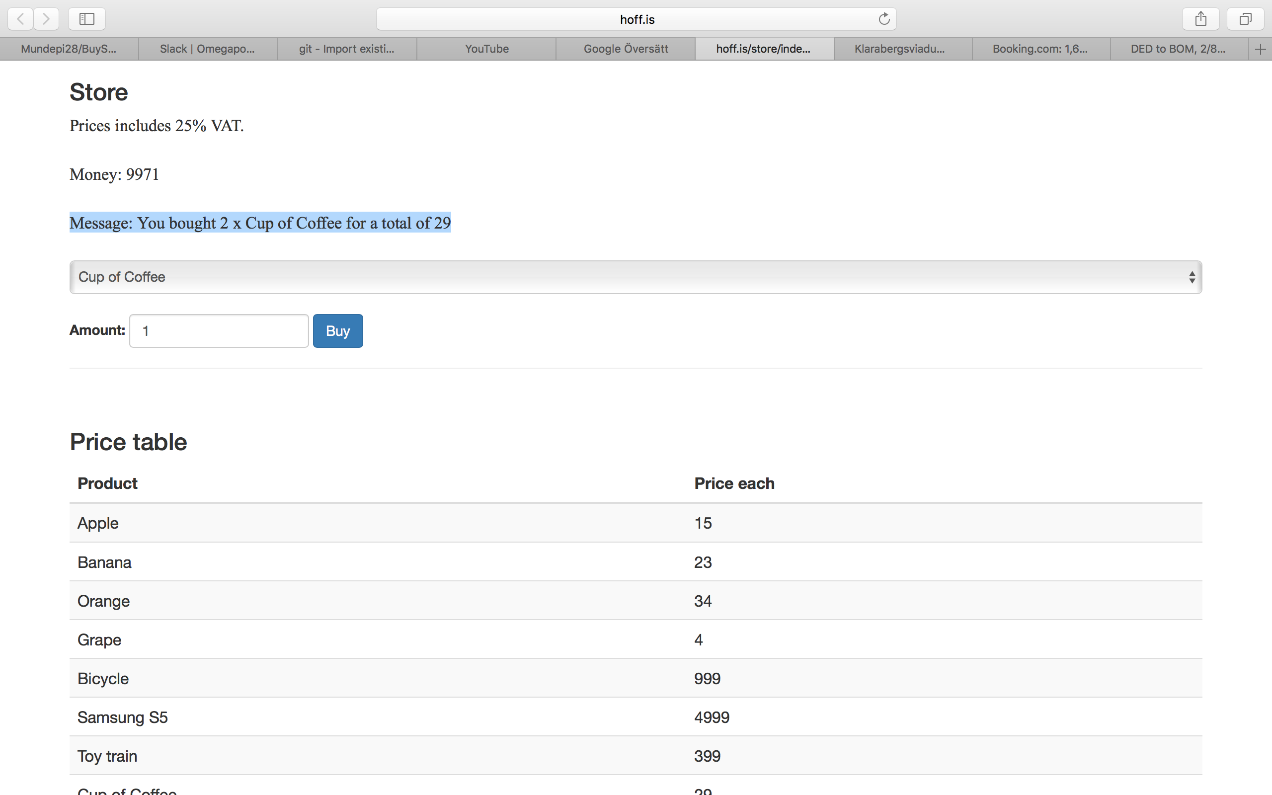

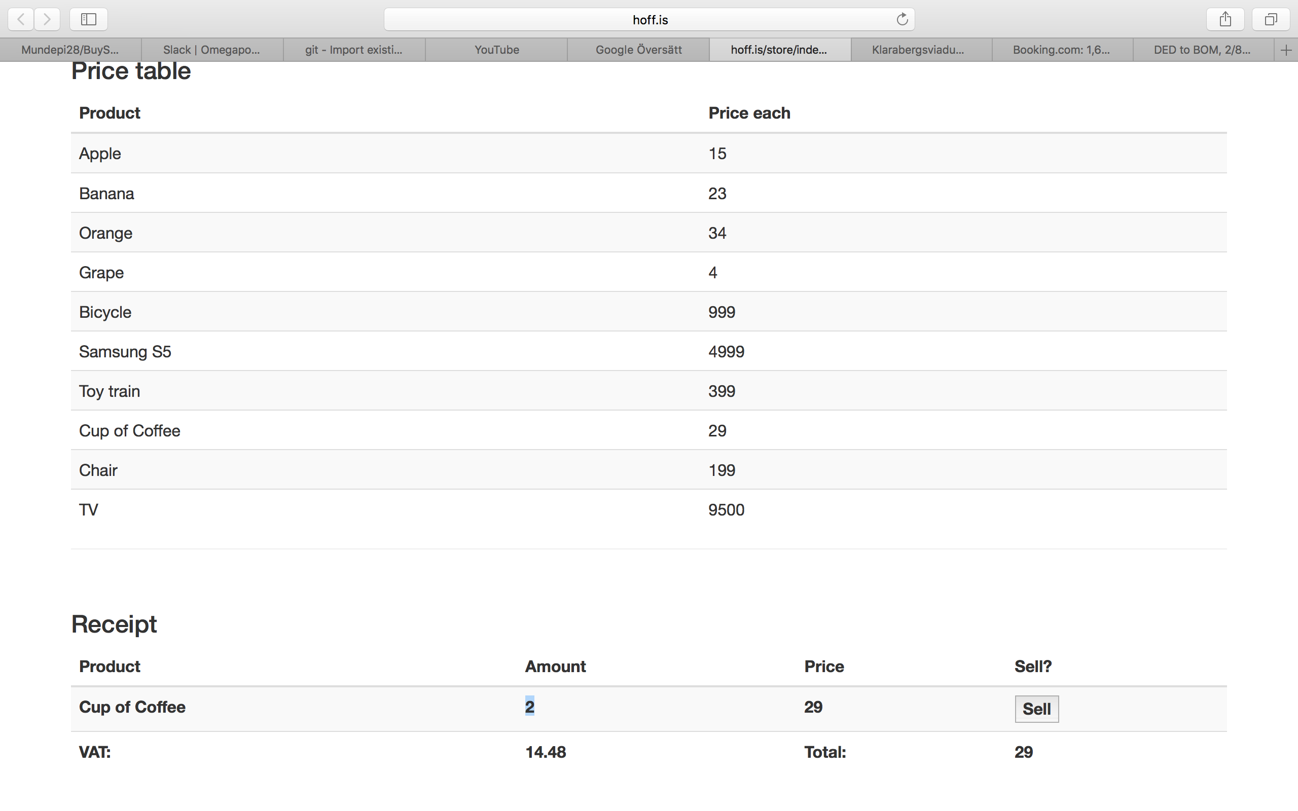

|  |  |
| --- | --- |
| ID number | Defect 4 |
| Name | Incorrect buying price for Chair |
| Reporter | Prashant Mundepi |
| Submit Date | 30/01/2017 |
| Summary | When Chair is bought incorrect price is calculated |
| URL | http://hoff.is/store/index.html |
| Screenshot | See below |
| Platform | - |
| Operating System | MAC OS |
| Browser | Chrome driver |
| Severity | Major |
| Assigned to |  |
| Priority | High |

**Description**

The calculation of price for Chair is incorrectly calculated.

**Steps to reproduce**

> Select the product Chair

> Provide the correct Amount for example 1 and click “Buy” button.

> Check message.

**Expected result**

Message: You bought 1 x Chair for a total of 199

**Actual result**

Message: You bought 1 x Chair for a total of 299

**Screenshots**

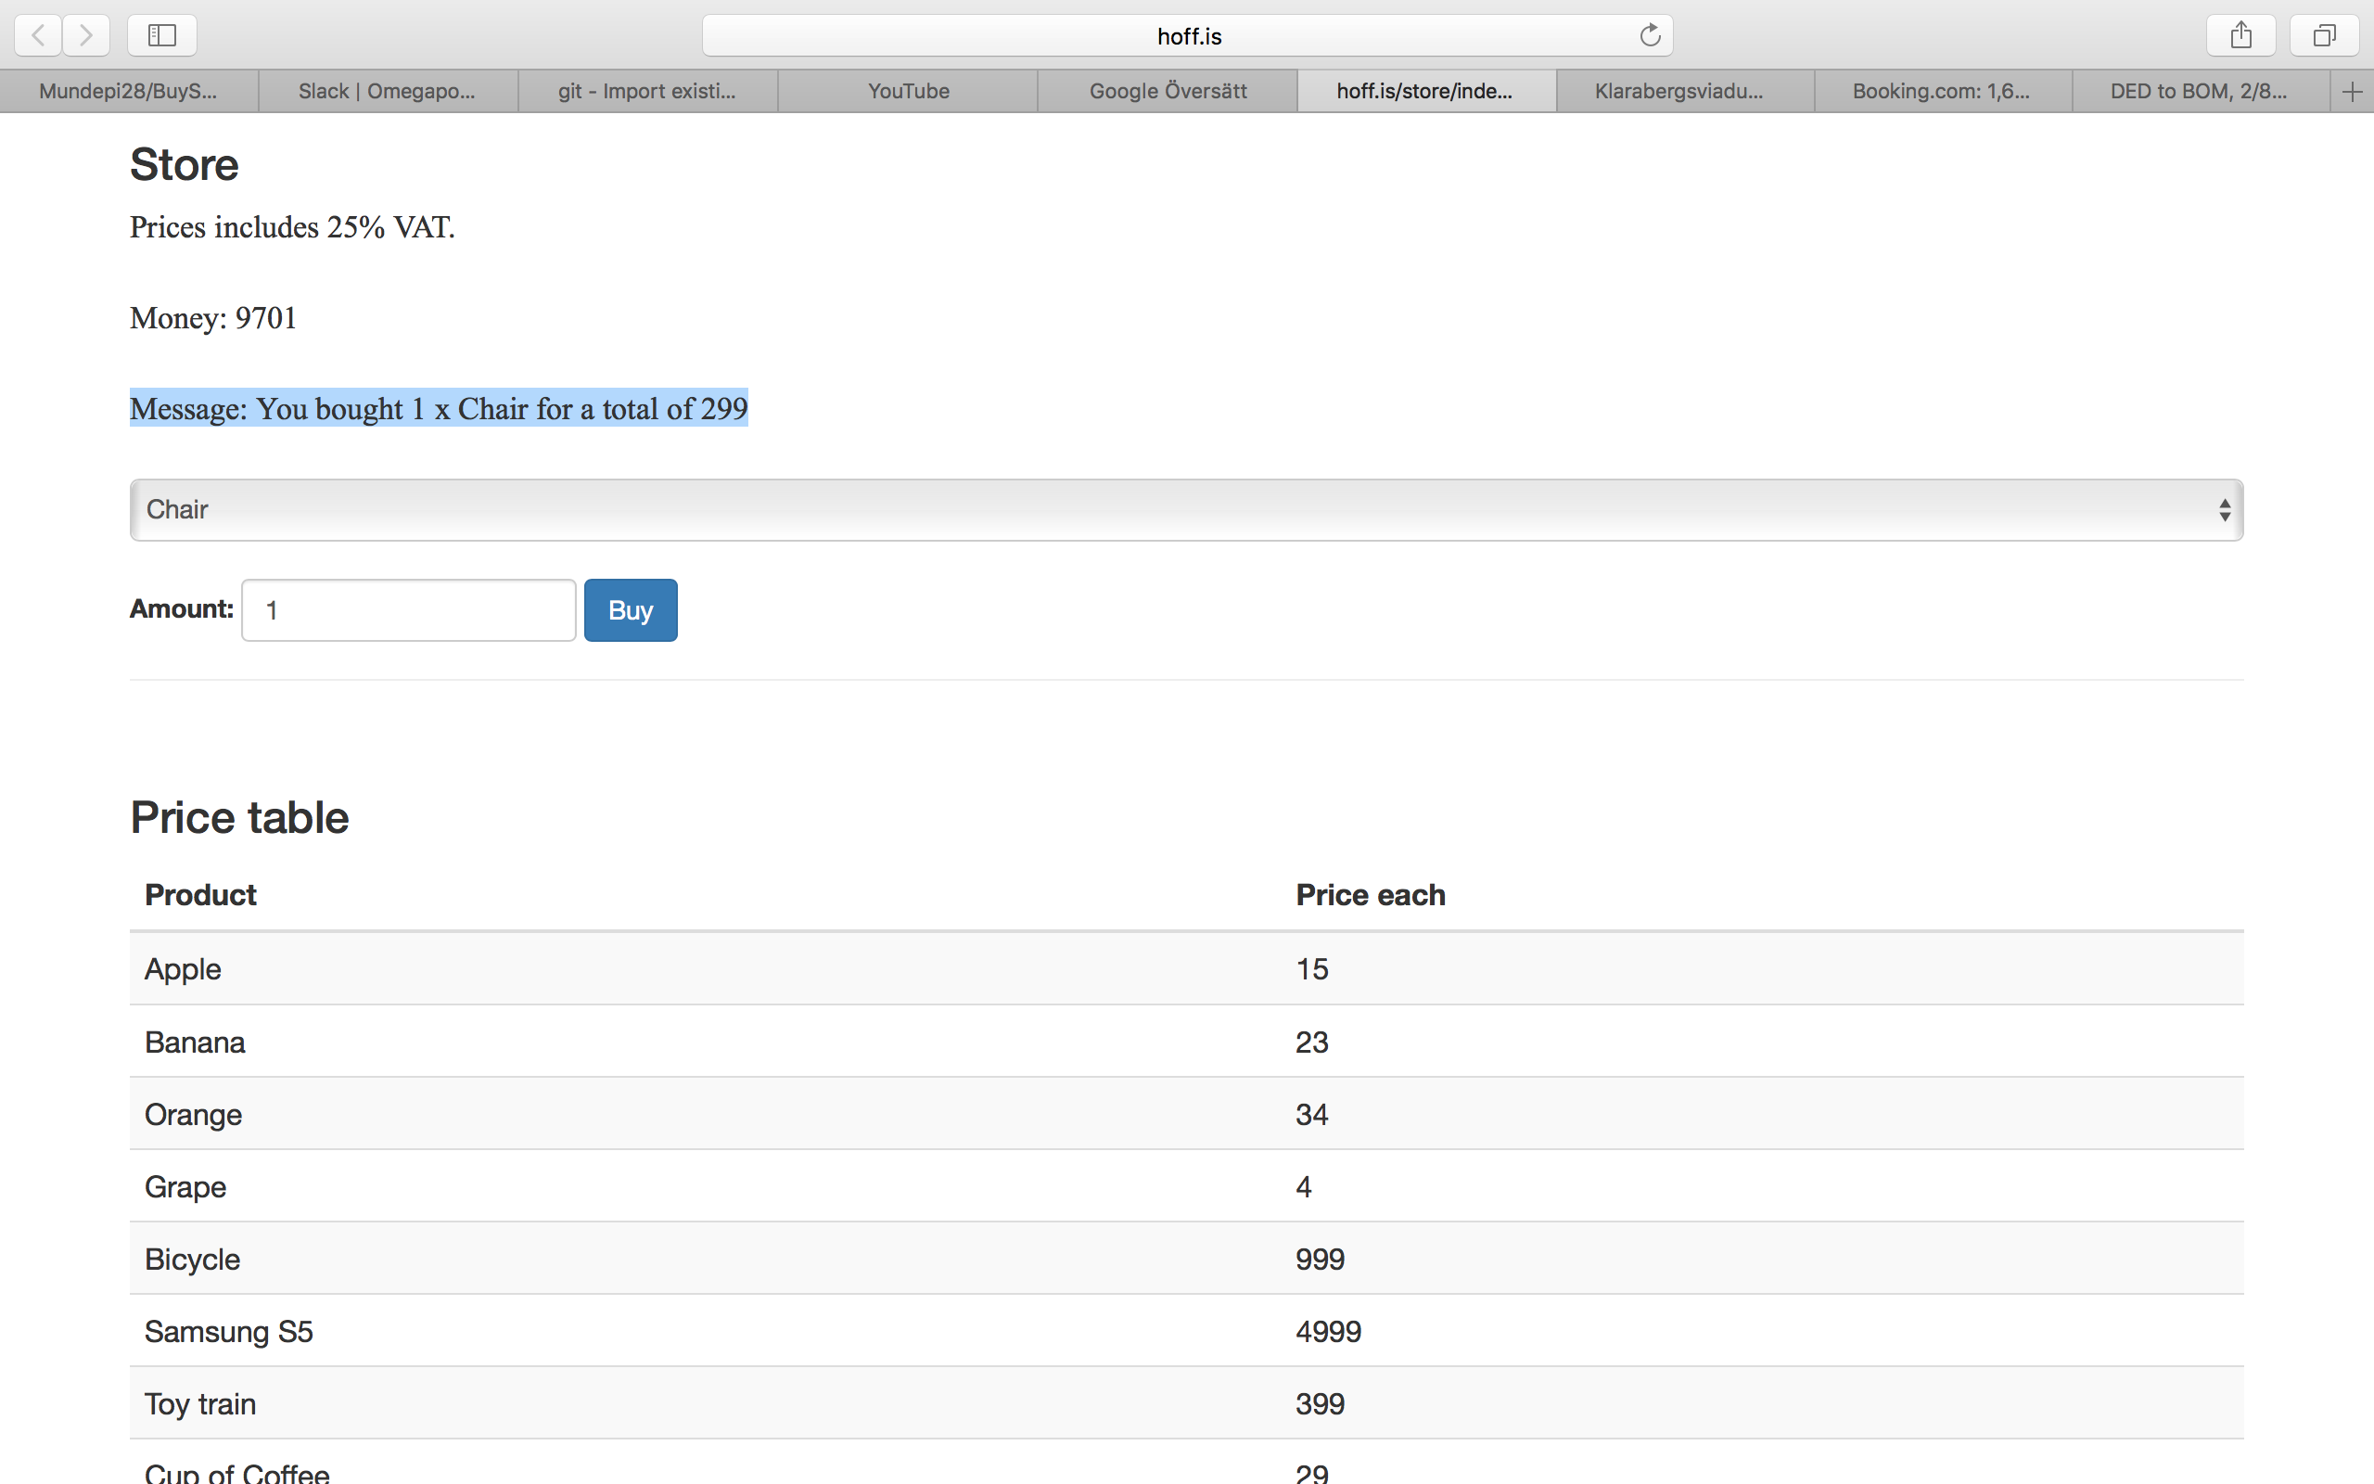

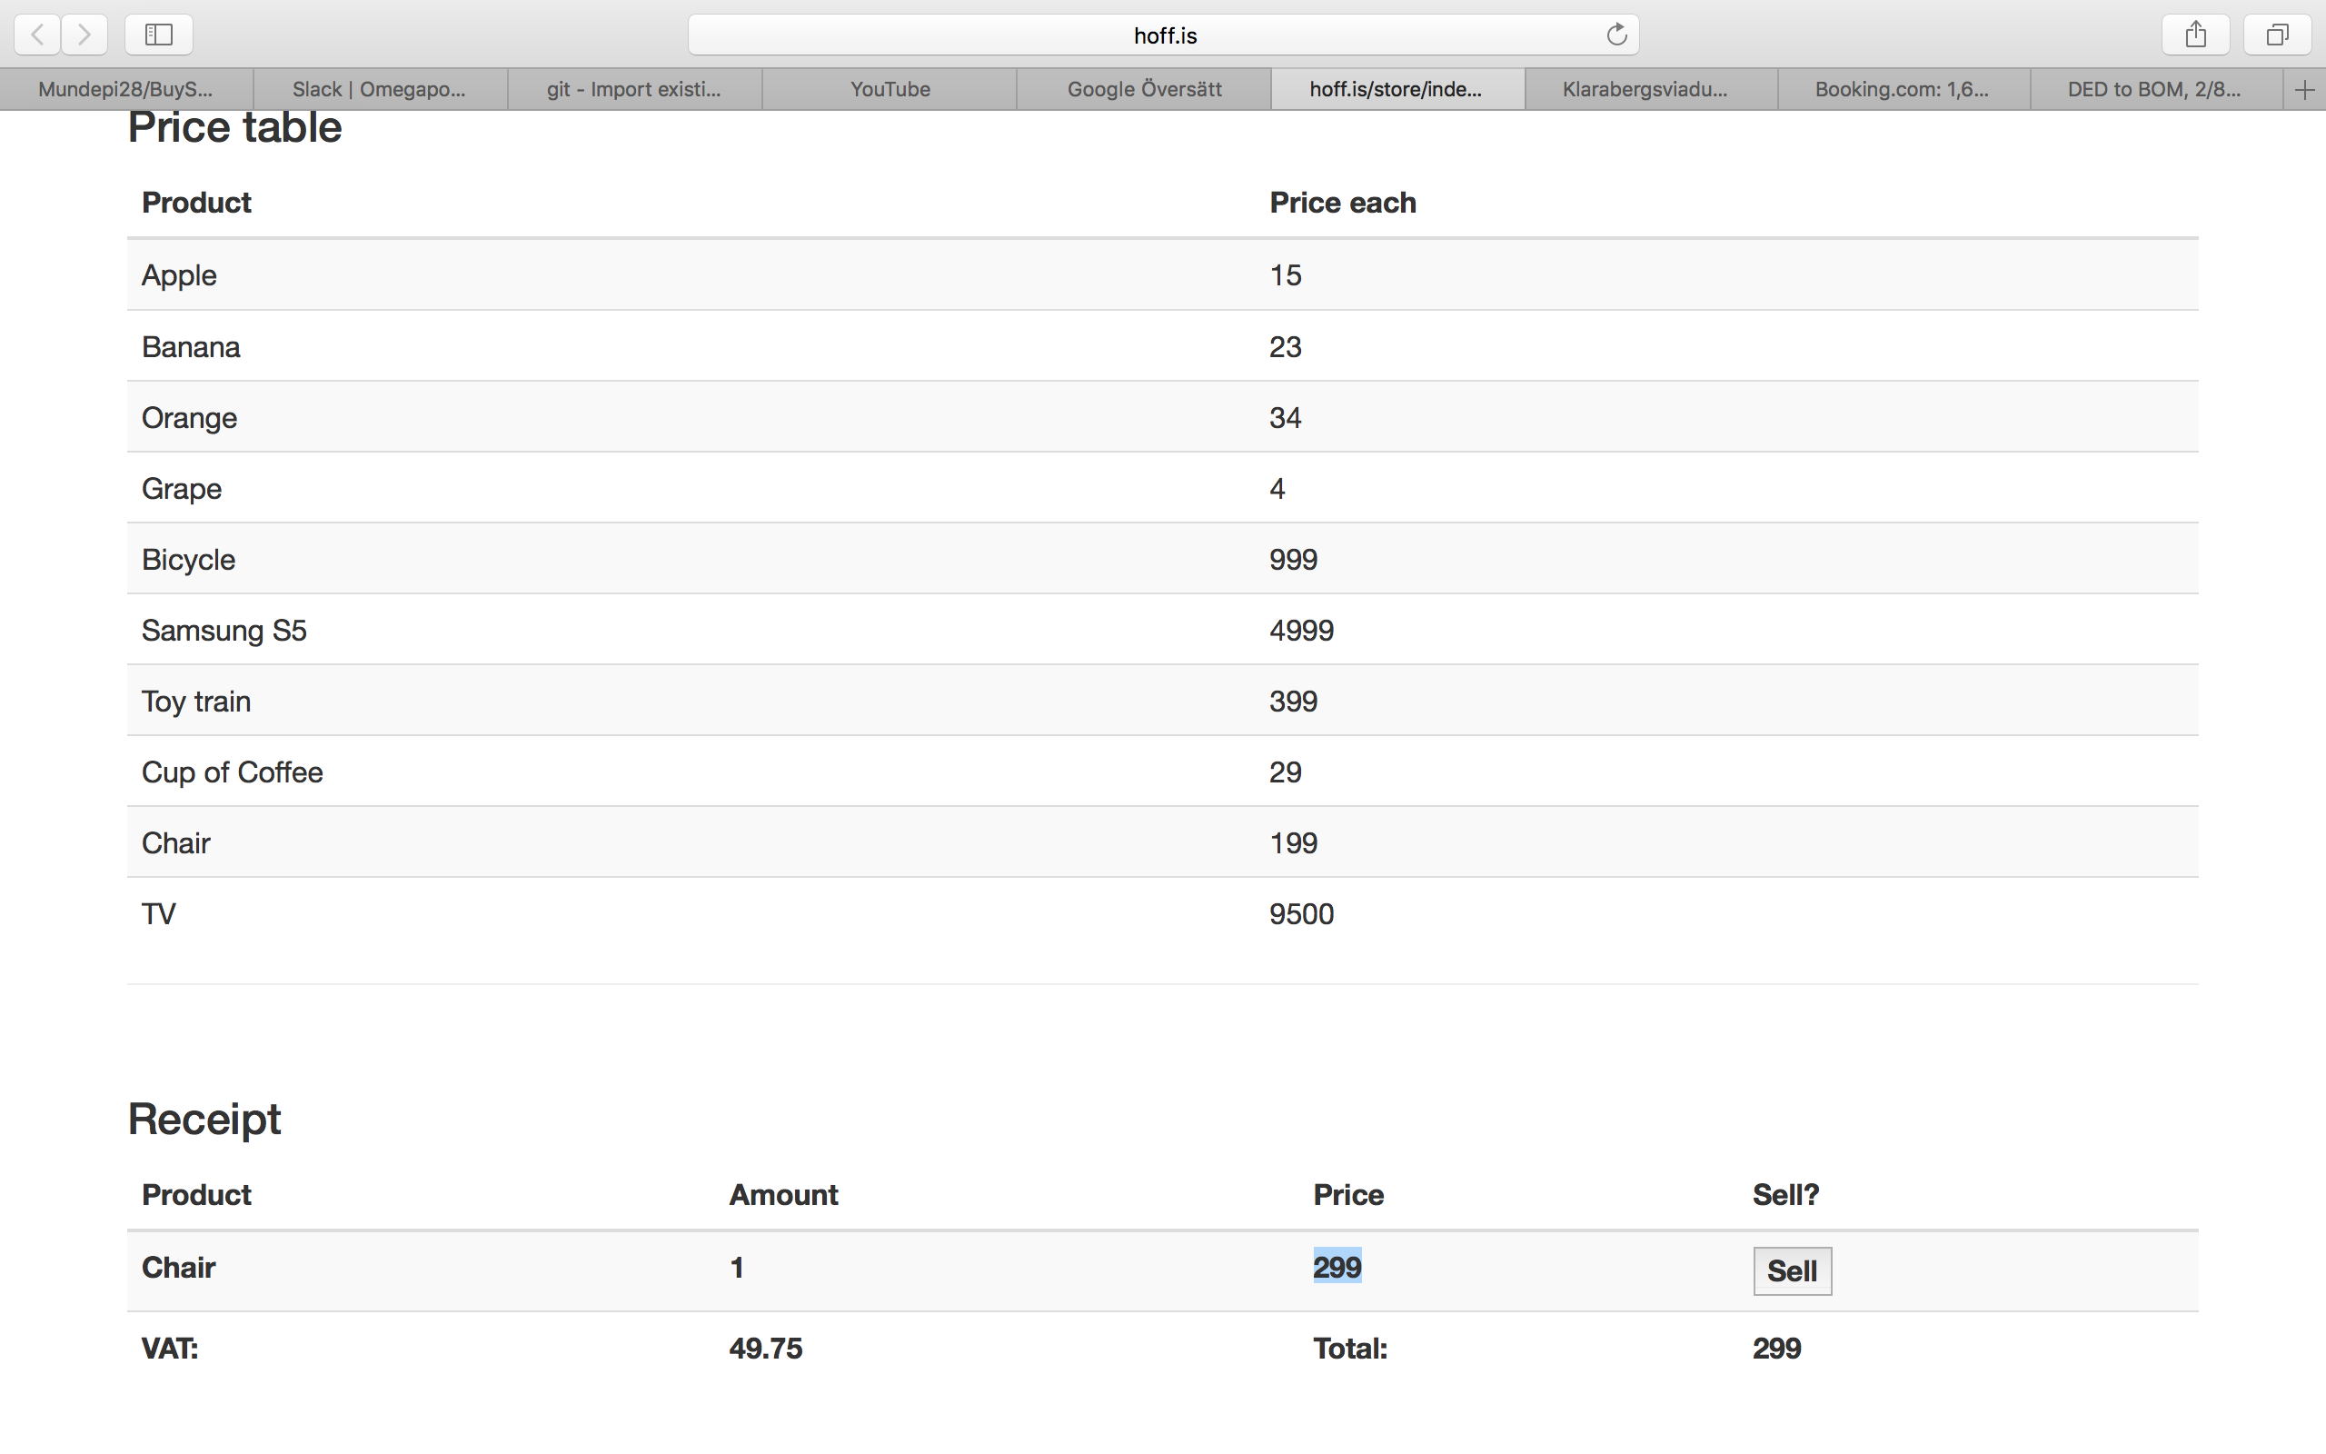

|  |  |
| --- | --- |
| ID number | Defect 5 |
| Name | Amount more than 100 |
| Reporter | Prashant Mundepi |
| Submit Date | 30/01/2017 |
| Summary | Incorrect display of amount when amount entered is more than 100 |
| URL | http://hoff.is/store/index.html |
| Screenshot | See below |
| Platform | - |
| Operating System | MAC OS |
| Browser | Chrome driver |
| Severity | Major |
| Assigned to |  |
| Priority | High |

**Description**

The calculation of amount is incorrect when amount of more than 100 is entered

**Steps to reproduce**

> Select any product for example Apple

> Enter the amount more than 100 and click “Buy” button.

> Check message.

**Expected result**

Message: You bought 101 x Apple for a total of 1515

**Actual result**

Message: You bought 100 x Apple for a total of 1515

**Screenshots**

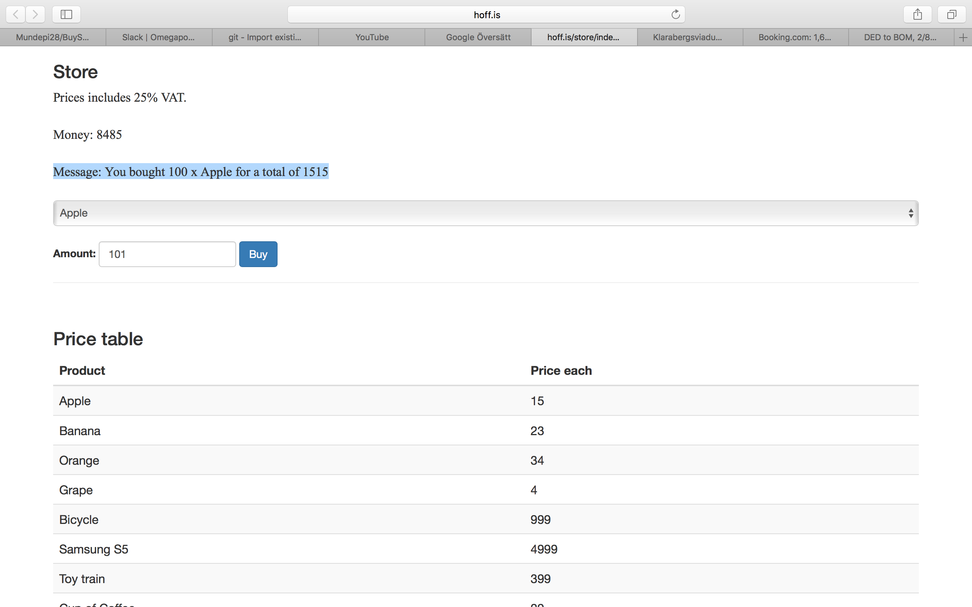

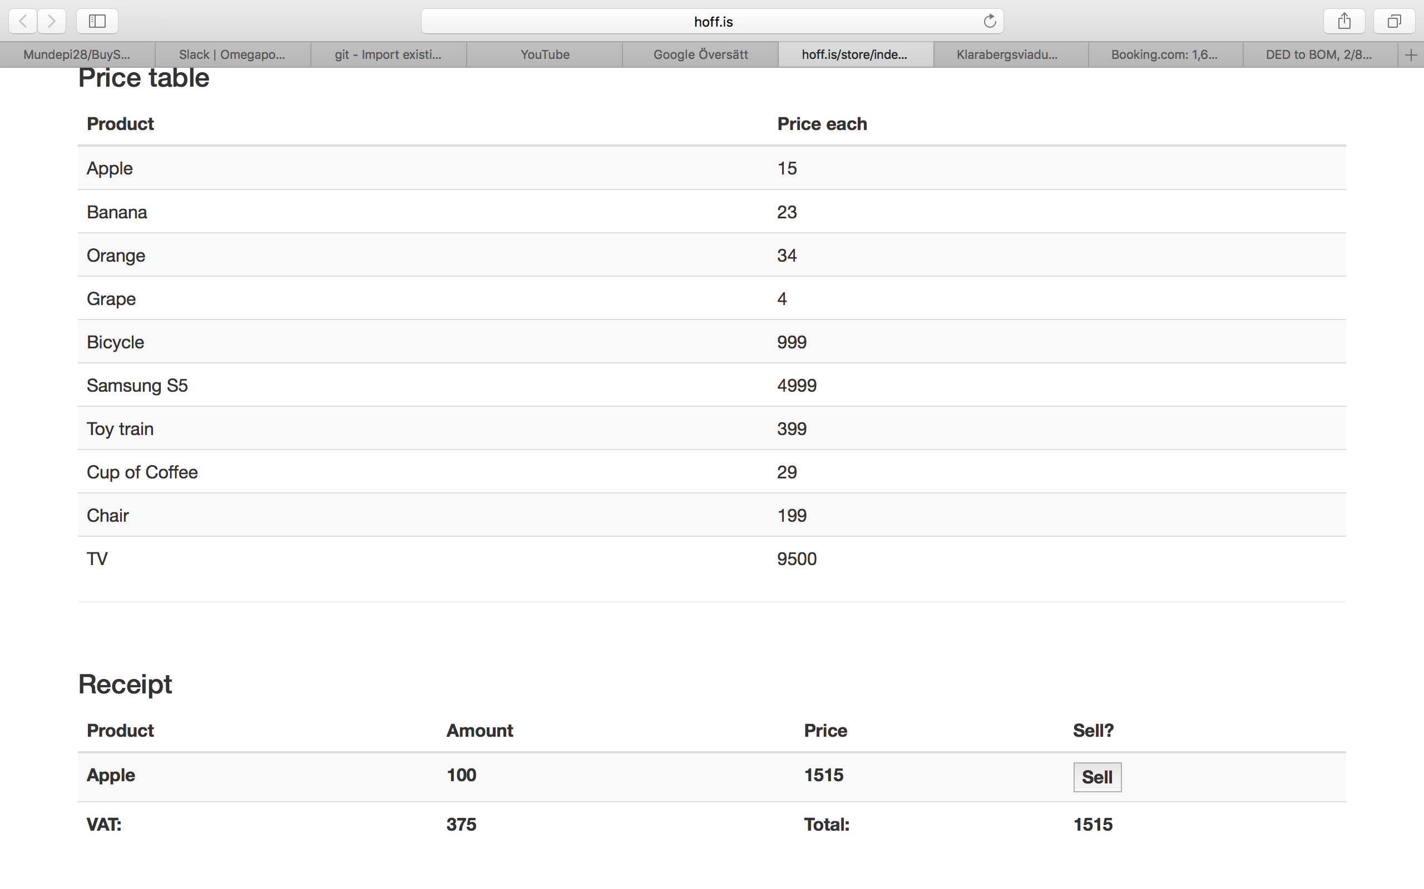

|  |  |
| --- | --- |
| ID number | Defect 6 |
| Name | Incorrect buying price for Grape if Amount is more than 5 |
| Reporter | Prashant Mundepi |
| Submit Date | 30/01/2017 |
| Summary | When more than 5 grapes are bought, incorrect price is calculated |
| URL | http://hoff.is/store/index.html |
| Screenshot | See below |
| Platform | - |
| Operating System | MAC OS |
| Browser | Chrome driver |
| Severity | Major |
| Assigned to |  |
| Priority | High |

**Description**

The calculation of price for Grapes is incorrect if amount is more than 5

**Steps to reproduce**

> Select the product Grape

> Provide the Amount more than 5 till example 7 and click “Buy” button.

> Check message.

**Expected result**

Message: You bought 7 x Grape for a total of 28

**Actual result**

Message: You bought 7 x Grape for a total of 24

**Screenshots**

