**Screenshots**

This document is part of the Module-8 Portfolio from CSC450: Programming III at Colorado State

University Global. It contains the GitHub repository and IDE code source screenshots for the “Thread Counting Synchronization.”

**Figure 1**

*Source Code in GitHub*

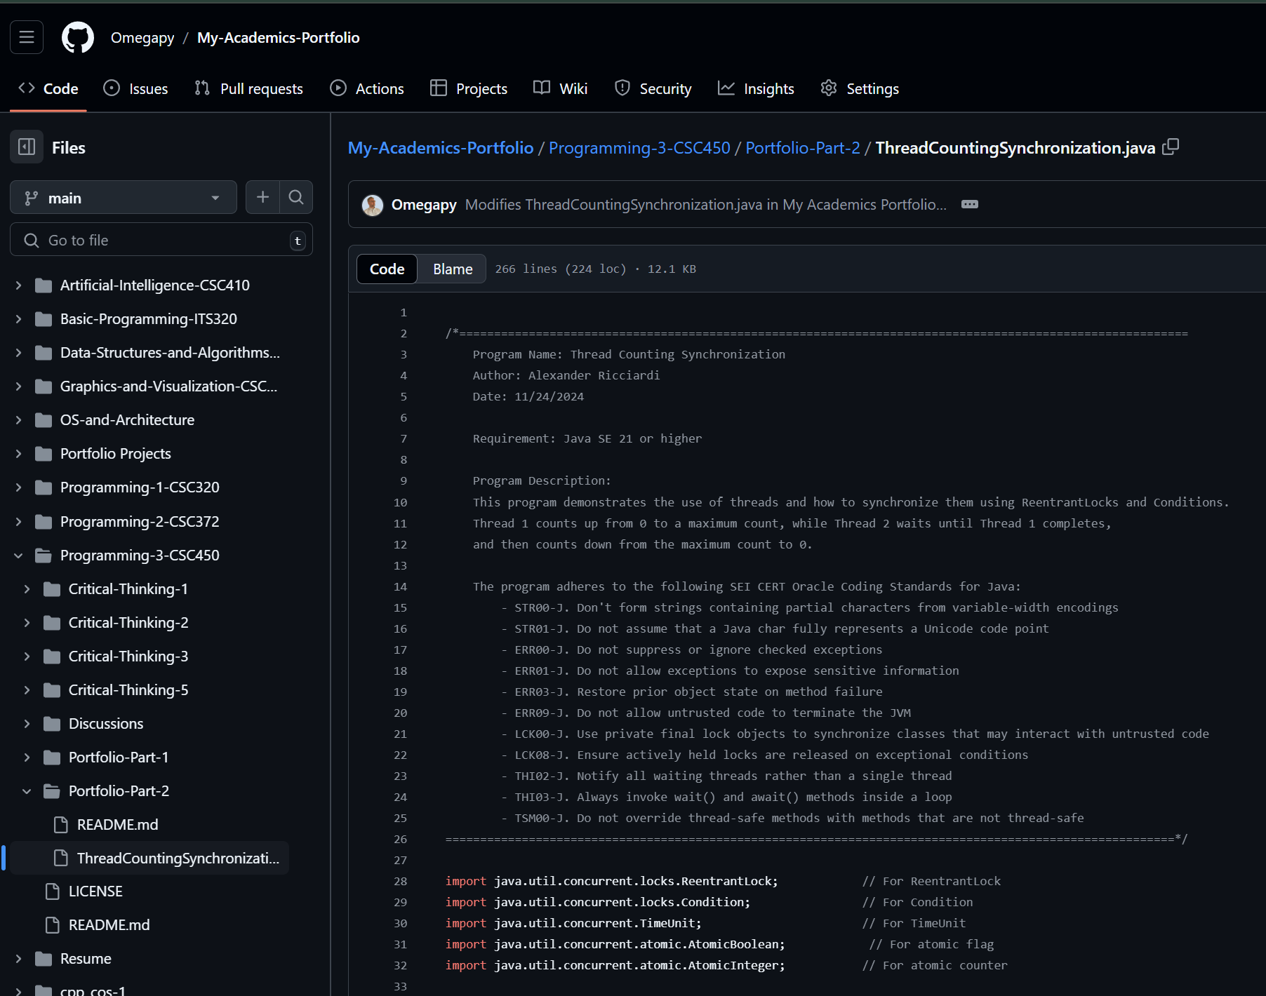

Continue next page

*Continue next page*

*Continue next page*

*Continue next page*

Next page Source Code in IDE

**Figure 2**

*Source Code in IDE*   
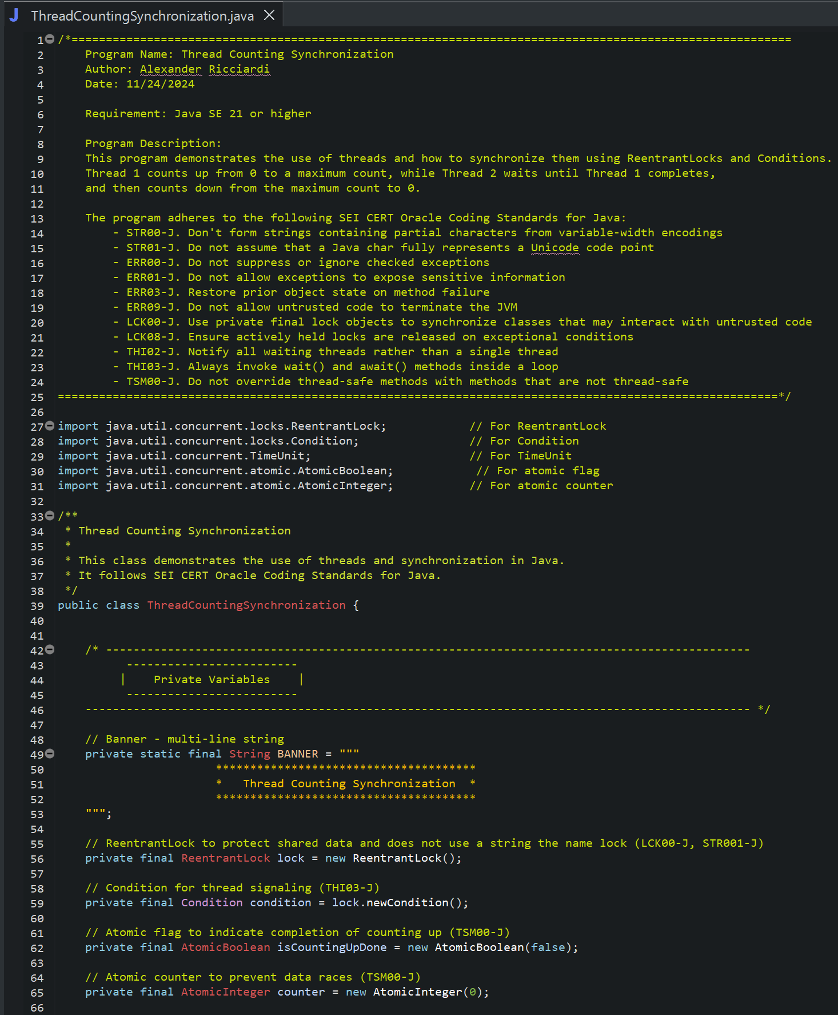

Continue next page

Continue next page

Continue next page

**Figure 3**

*Console Program Output*

As shown in Figure 3 the program runs without any issues displaying the correct outputs as expected.