Recommendation Guide: Choosing the Right Sorting Algorithm
Alexander Ricciardi
Colorado State University Global
CSC506 - Design and Analysis of Algorithms
Professor Dr. Jonathan Vanover
April 05, 2026

Choosing the right sorting algorithm depends on several factors, not on speed only. When choosing a sorting algorithm, it is important to consider the dataset size, input order, stability requirements, and memory constraints. The tool Benchmark Lab feeature benchmarked Bubble Sort, Selection Sort, Insertion Sort, and Merge Sort on random unsorted, sorted, reverse-sorted, and partially sorted datasets. The dataset sizes ranged from 1,000 to 50,000. Based on those benchmark results, this guide recommends when or in which instance each algorithm is best suited.

When to Use Bubble Sort
Bubble Sort is the better choice when:
- If the dataset is already sorted or very close to sorted. Benchmark Lab results show that Bubble Sort is the fastest algorithm on sorted data for all tested dataset sizes. At 1,000 elements it completed in 0.0460 ms, and at 50,000 elements it completed in 2.5783 ms.
- If the goal is teaching algorithm functionality, as it is an easy to understand algorithm. Bubble Sort is the best choice for this purpose. As the algorithm is easy to explain, it compares elements that are next to each other and moves the larger values, one position at a time, toward the end of the list. This makes it one of the best algorithms for showing repeated passes order data.
- If implementation simplicity and low overhead is more important than scalability and performance. For tiny datasets and where reduced overhead and simplicity matter, Bubble Sort is an acceptable choice
- If you want to quickly check if the data is sorted, Bubble Sort is the best choice because it can stop after one pass with no swaps; therefore, the algorithm can act as a simple sortedness tool check.

When to Use Selection Sort
Selection Sort is the better choice when:
- If minimizing swaps or writes is important. Selection Sort has a low swap count because it usually performs only one swap per pass. In the Benchmark Lab, its swap count is far less than Bubble Sort.
- If the dataset is small and a stable sort is not required, that is, the relative order of duplicate elements does not matter. Selection Sort is simple to implement and easy to use, even though it is not the fastest option.
- If the environment has expensive write operations. In hardware-restricted or write-sensitive environments, having a sort algorithm that reduces swaps can matter more than one that reduces comparisons.
- If you want an algorithm that respects the input order is essential. Selection Sort is useful for analysis projects; however, it is not recommended for production projects.
It is important to note that Selection Sort never won a benchmark scenario in the Benchmark Lab, and on sorted data at 50,000 elements, it still required 43,670.5342 ms, and on reverse sorted data at 50,000 elements it required 43,440.3886 ms.

When to Use Insertion Sort
Insertion Sort is the better choice when:
- If low overhead is important and when data is already nearly sorted. Insertion Sort has low overhead and performs very well on smaller datasets, especially when the data is not heavily disordered.
- If stability matters and you still want an in-place algorithm. That is, if the relative order of duplicate elements must be preserved and memory usage is a constraint. Insertion Sort is stable and uses O(1) extra space, which makes it perfect for small data-processing, sorting nearly sorted data, and when memory usage is a constraint.
- If you need to use a hybrid sort. Insertion Sort is commonly used as the small-subarray case inside larger algorithms and when the subarrays are nearly sorted because its overhead is low.
- If data production has been sorted and new and small amounts of values are written after hand, requiring the dataset to be resorted. In other words, Insertion Sort is well suited for this purpose because it works well when a dataset remains mostly ordered, and new values are inserted slowly over time.
It is important to note that Insertion Sort becomes a weaker choice as the dataset scales up and disorder increases in significant amounts. On random unsorted data at 50,000 elements, it required 49,241.7240 ms, which shows how quickly Insertion Sort, a quadratic growth algorithm, becomes impractical at scale and when the data is significantly disordered.

When to Use Merge Sort
Merge Sort is the better choice when:
- If the dataset that needs to be sorted is medium or large, and the input order is unknown. Merge Sort, in the Benchmark Lab, was the fastest algorithm in every random unsorted, reverse-sorted, and partially sorted the benchmark scenario.
- If performance matters, Merge Sort, with its O(n log n) runtime in the best, average, and worst cases, is a good choice.
- If stability is required at scale. Merge Sort is stable, that is, the relative order of duplicate elements is preserved, which makes it useful for record-based sorting where duplicate key values should maintain their original order of appearance.
- If the dataset is large enough that scalability matters more than in-place, that is, memory usage is not a constraint. The Benchmark Lab results show that with a dataset of 50,000 random unsorted elements, Merge Sort completed in 123.0534 ms, while the next-fastest algorithm, Selection Sort, performed 43,440.3886 ms.
- If you are working with applications large unsorted or reverse sorted datasets. Merge sort is the best choice for this purpose because it is the fastest algorithm for these types of datasets. In the Benchmark Lab, Merge Sort was the fastest algorithm in every random unsorted, reverse-sorted, and partially sorted the benchmark scenario.
It is important to note that the algorithm, Merge Sort, is not an in-place sort and has O(n) space complexity, so it is not the best choice when memory is extremely constrained or when a small, nearly sorted dataset can be handled more efficiently by Insertion Sort or Bubble Sort.

Decision Matrx
The following matrix summarizes which algorithm was fastest for each dataset type and size in the Benchmark Lab. Each cell color shows the winning algorithm.
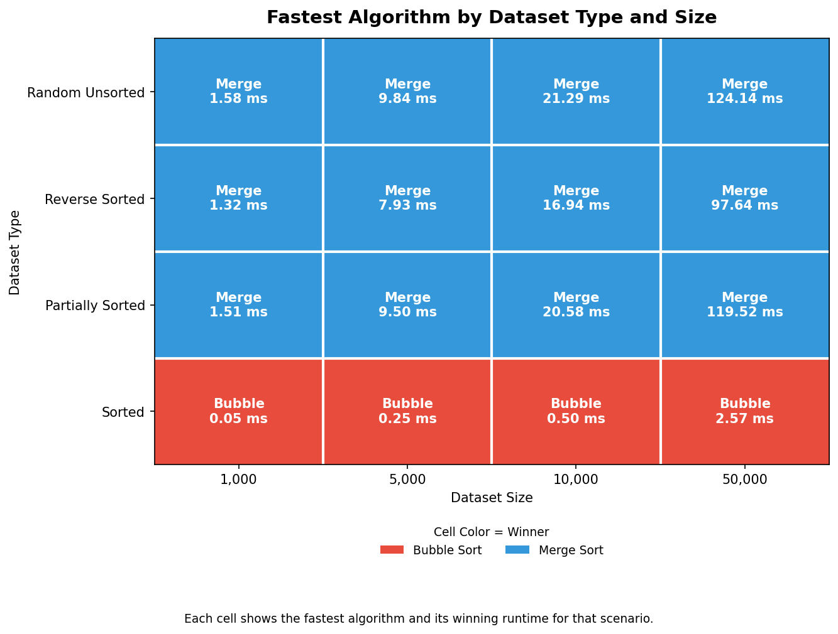
Scenario Winner Heatmap

Practical Summary

Criterion | Bubble Sort | Selection Sort | Insertion Sort | Merge Sort
Best use case | Already sorted data, teaching | Minimizing swaps/writes | Small or nearly sorted data | Large or unpredictable data
Best-case runtime | O(n) | O(n^2) | O(n) | O(n log n)
Average runtime | O(n^2) | O(n^2) | O(n^2) | O(n log n)
Worst-case runtime | O(n^2) | O(n^2) | O(n^2) | O(n log n)
Extra space | O(1) | O(1) | O(1) | O(n)
Stable | Yes | No | Yes | Yes
In-place | Yes | Yes | Yes | No
Strong the benchmark result | Fastest on sorted data | Low swap count | Strong on partially sorted data | Fastest in 12 of 16 scenarios

Key Takeaway
In practice, there is no universally best sorting algorithm for every scenario. If the dataset is large or the input is disordered and is expected to be unknown, Merge Sort is the best choice because it scales efficiently and performed best in nearly every benchmark scenario. If the data is already sorted, Bubble Sort is surprisingly the most effective because of its early-exit behavior. If the data is small or mostly sorted, Insertion Sort is the best choice. Selection Sort is usually the least attractive general-purpose option, but it still has a narrow role when writes need be low and they matter more than comparisons.
Based on Benchmark Lab results, the most practical recommendation is to use Merge Sort when in doubt, use Insertion Sort for nearly sorted small datasets, use Bubble Sort for teaching or when simplicity matters, and finally, use Selection Sort for specialized write-constrained cases.

