Screenshots

This document is part of the Module-8 Portfolio from CSC450: Programming III at Colorado State
University Global. It contains the GitHub repository and IDE code source screenshots for the “Thread Counting Synchronization.”

Figure 1
Source Code in GitHub
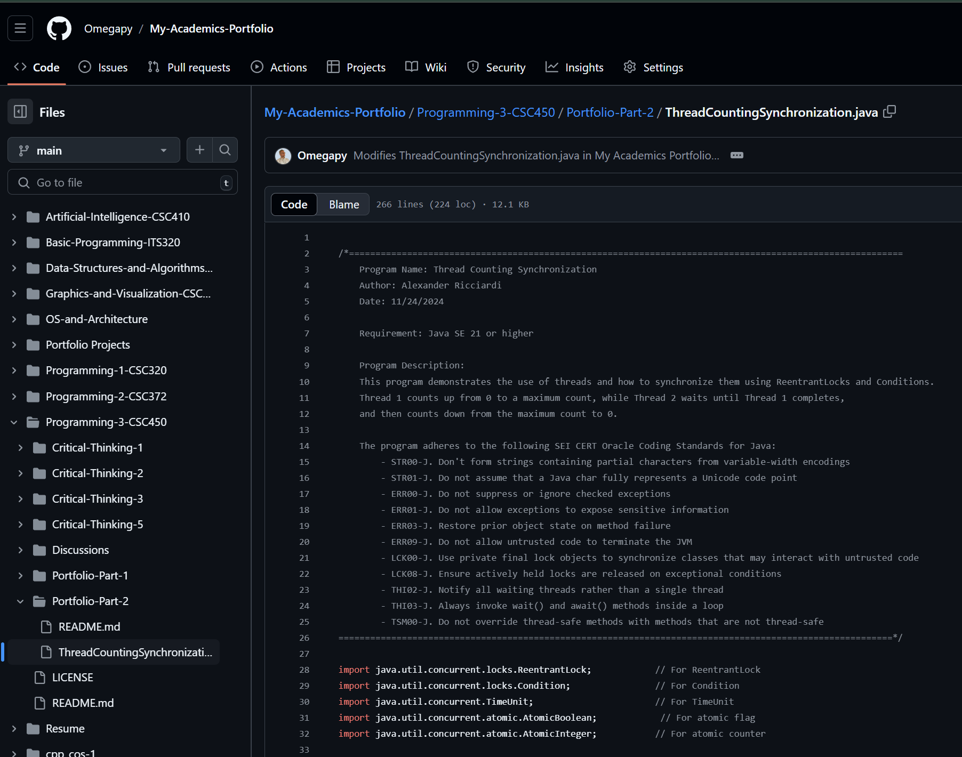

Continue next page

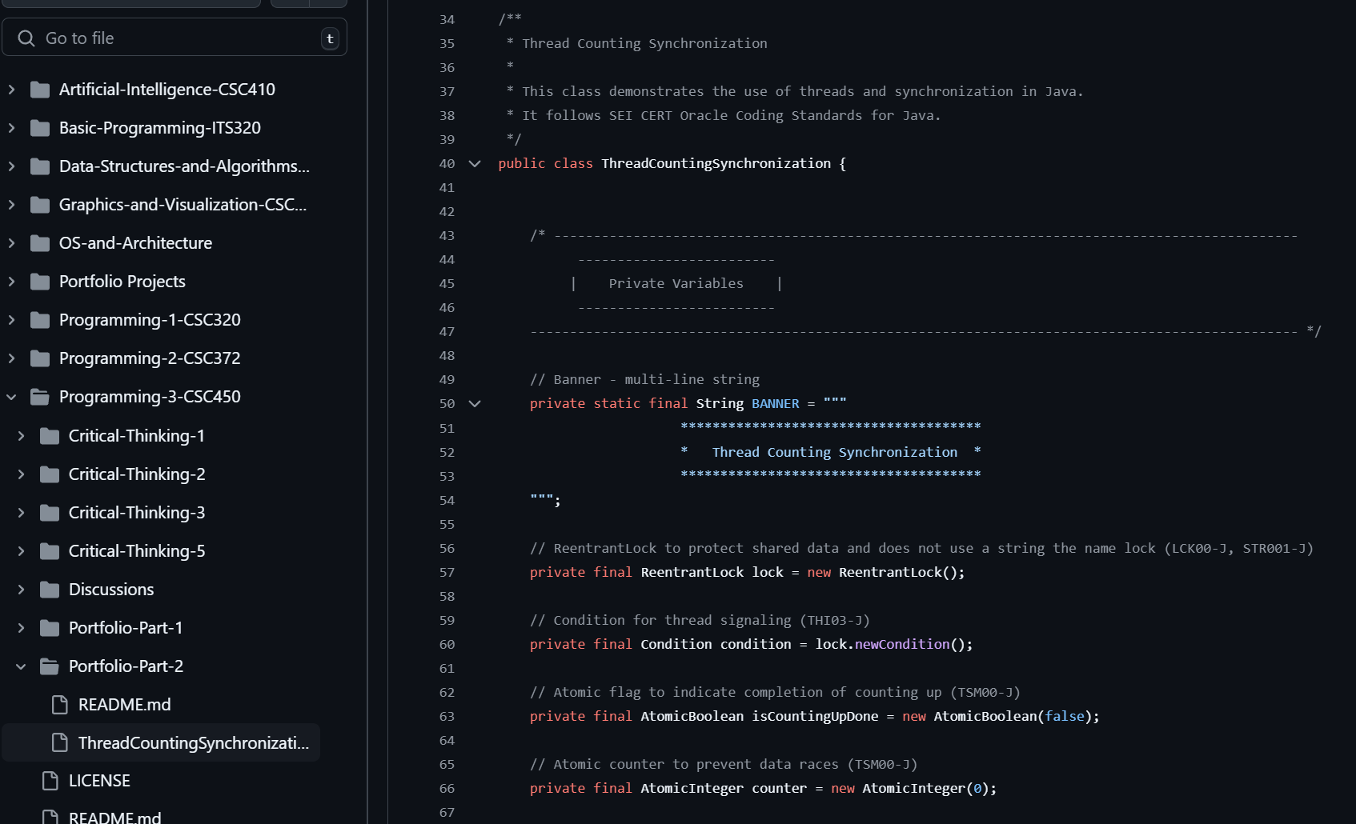

Continue next page

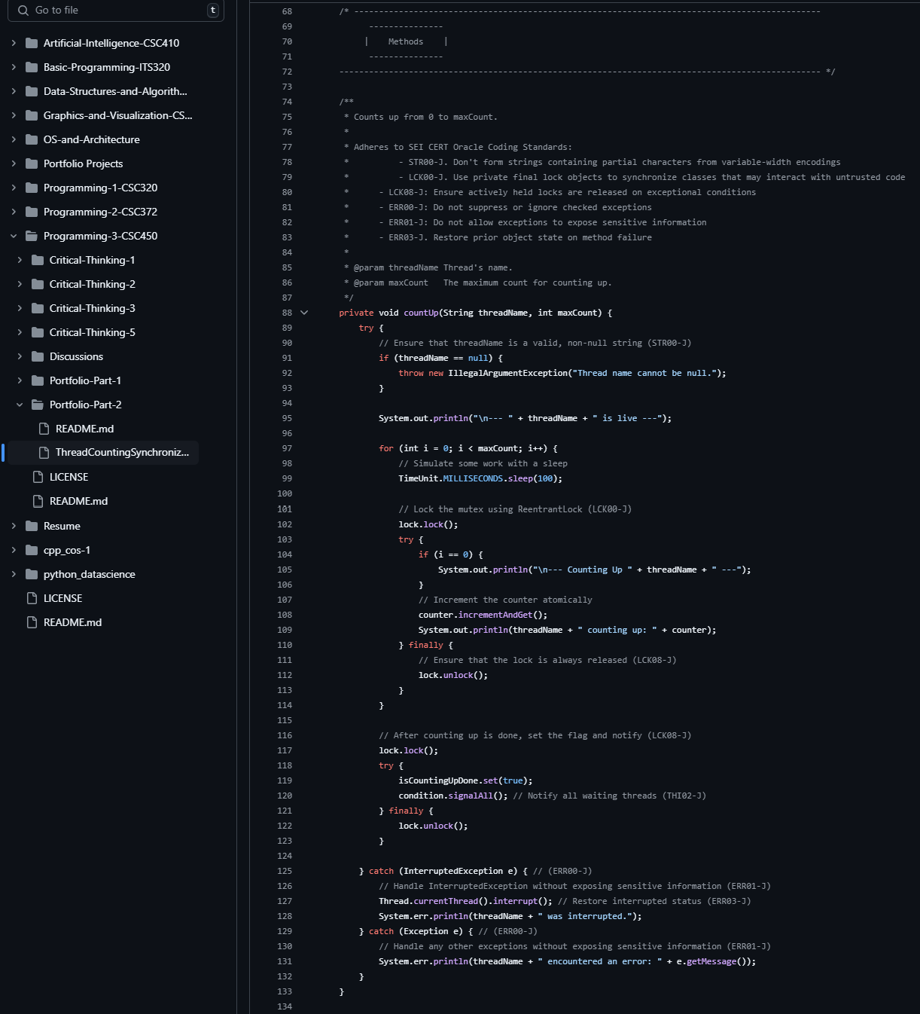

Continue next page
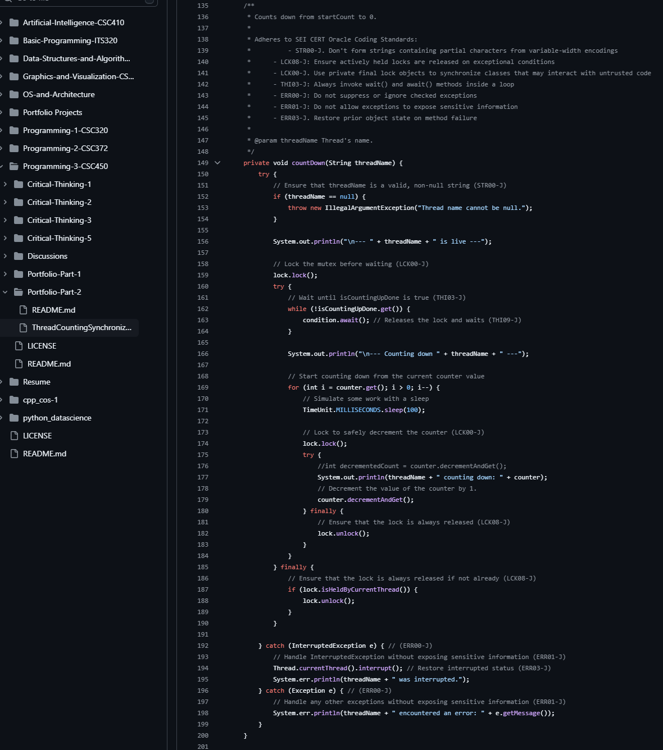

Continue next page
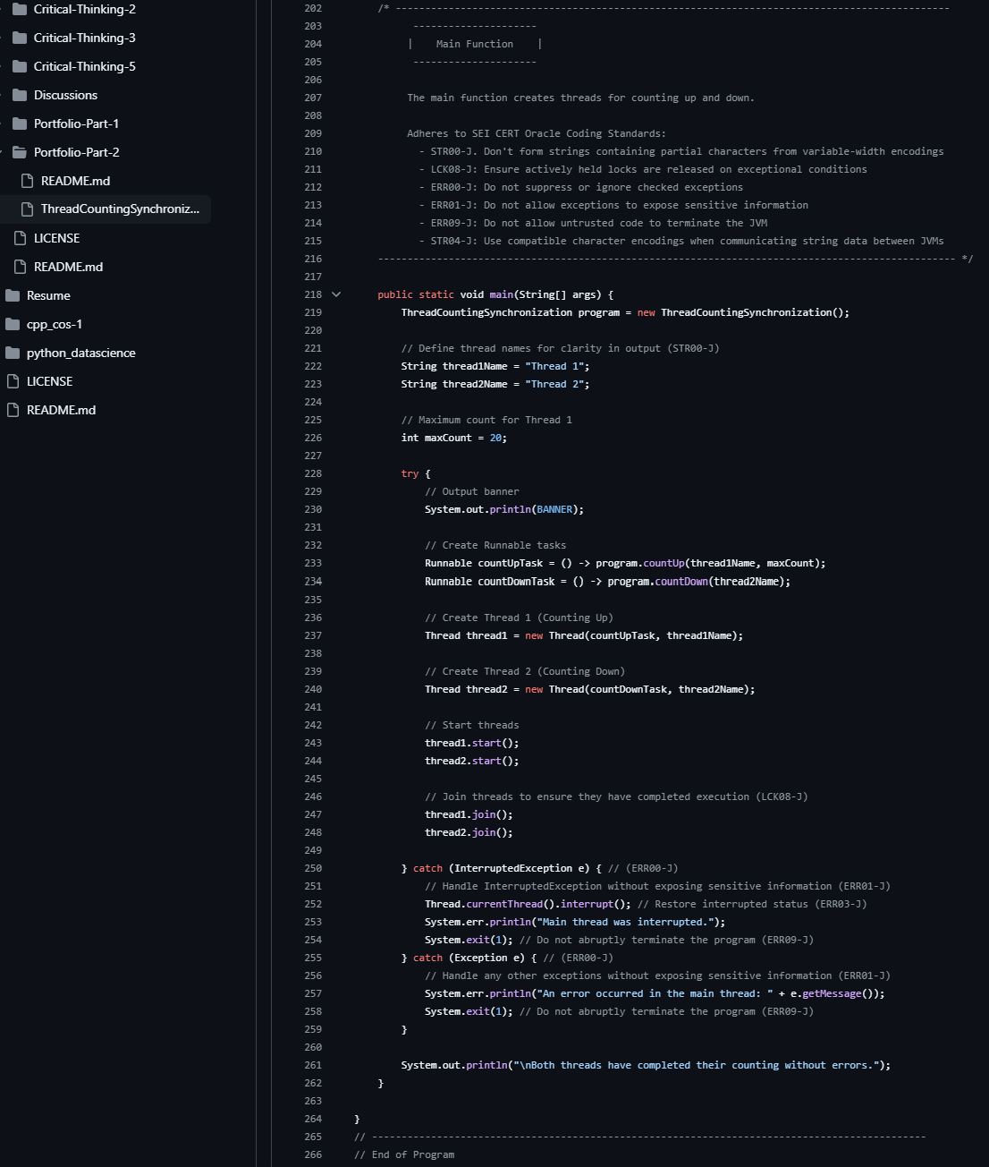

Next page Source Code in IDE
Figure 2
Source Code in IDE
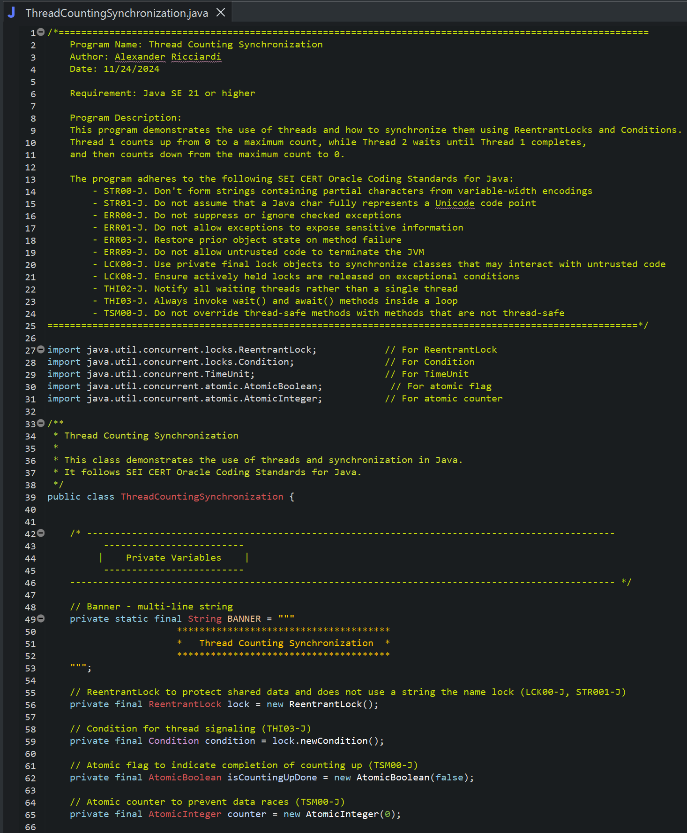

Continue next page
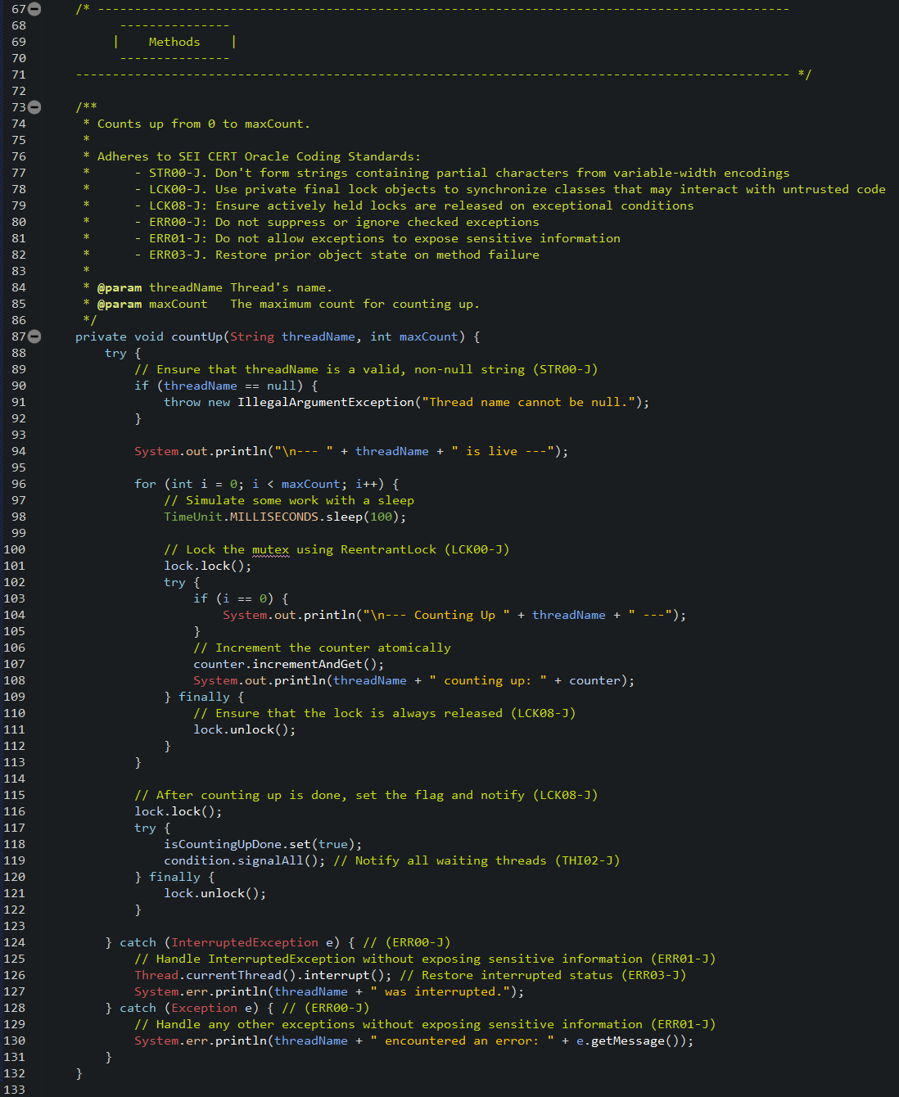
Continue next page
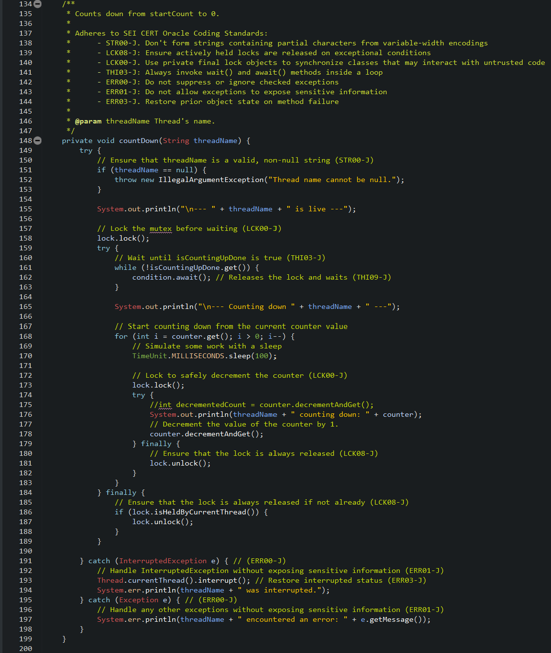

Continue next page
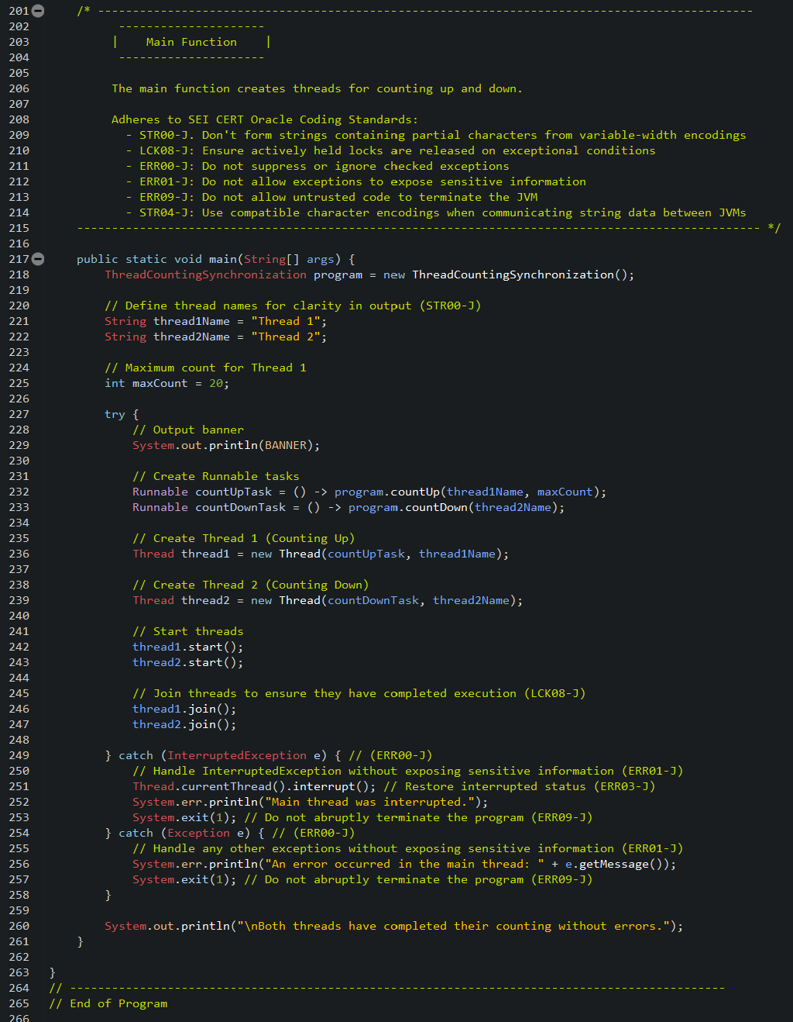
Figure 3
Console Program Output
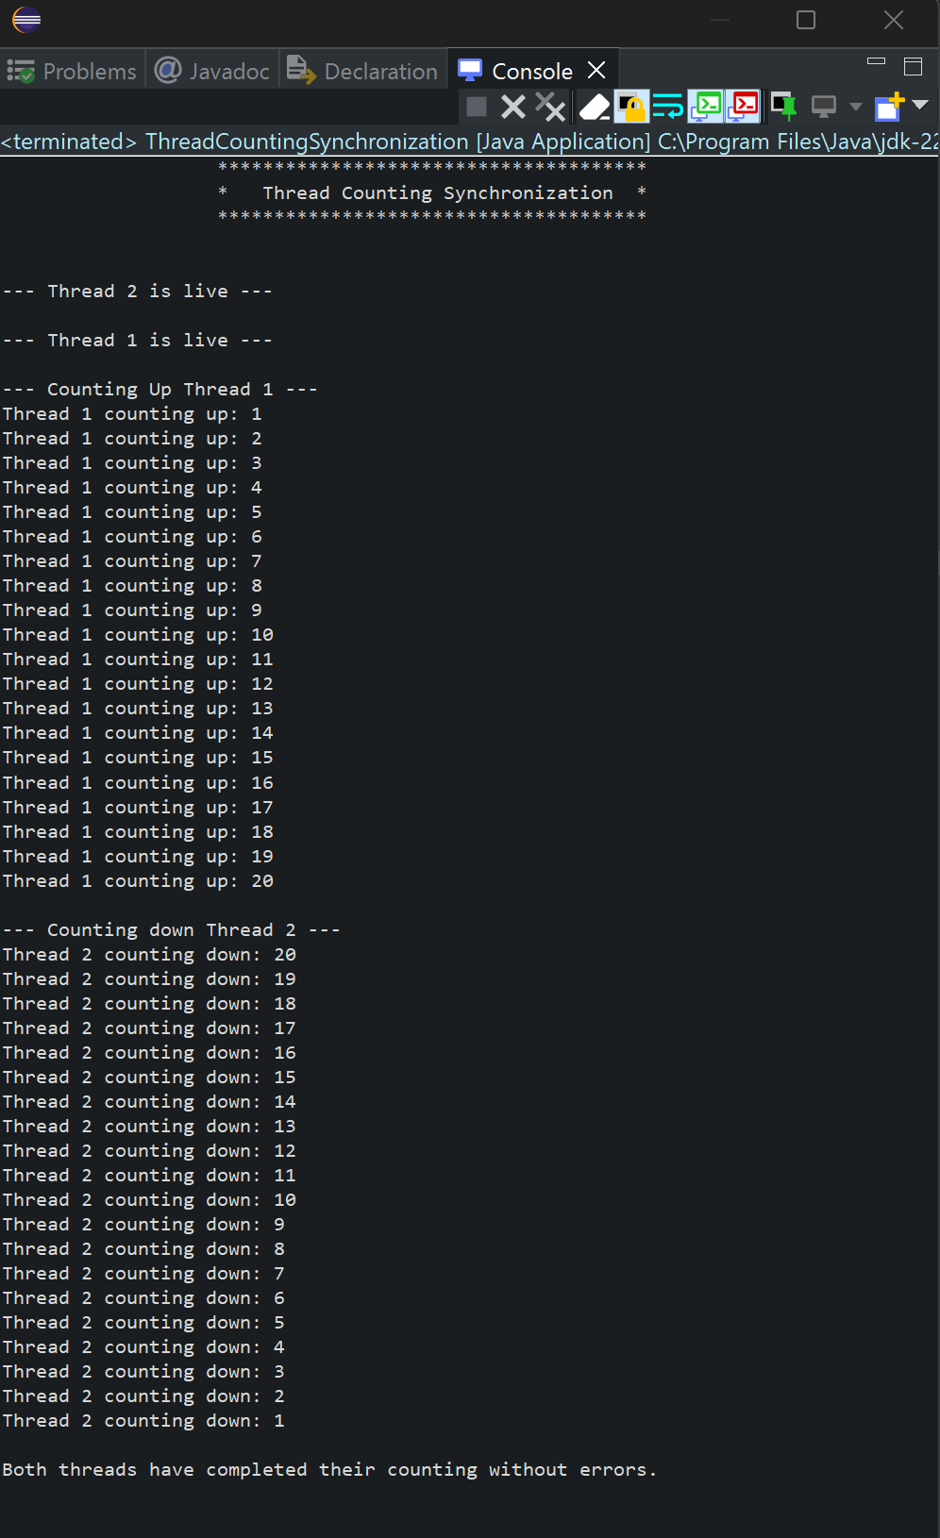

As shown in Figure 3 the program runs without any issues displaying the correct outputs as expected.

