Recommendation Guide: Choosing the Right Sorting Algorithm
Alexander Ricciardi
Colorado State University Global
CSC506 - Design and Analysis of Algorithms
Professor Dr. Jonathan Vanover
April 12, 2026

Choosing the right data structure depends on several factors, not on speed only. When choosing a data structure, it is important to consider the ordering rule, which end of the structure is used most often, whether middle updates are needed, and the cost as the dataset becomes larger. The tool Benchmark Lab benchmarked Stack, Queue, Deque, and LinkedList on common_build, common_drain, peek_front, deque_ends, and linked-list-specific workloads. The Compare Structures feature also provides a side-by-side comparison of ordering behavior, ends used, build cost, what each structure is best at, and typical use case. The dataset sizes ranged from 1,000 to 50,000. Based on those benchmark results and the Compare Structures feature, this guide recommends when or in which instance each structure is best suited.

When to Use Stack
Stack is the better choice when:
- If the workload is last-in, first-out and the most recently added item must be processed first. In the Compare Structures feature, Stack is shown as a LIFO structure with top-only access.
- If the goal is keeping all work on one favorable end of the underlying Python list. Stack is the best choice for this purpose because push, pop, and peek all work from the top only.
- If build speed is important. Benchmark Lab results show that Stack.push was the fastest structure in the common_build group at every tested dataset size. At 1,000 items it completed in 0.0484 ms, and at 50,000 items it completed in 2.3620 ms.
- If the problem fits cases such as undo / redo history, expression evaluation, depth-first search, backtracking, and balanced bracket checking. Stack is well suited for this purpose because each of these problems naturally uses the most recently added item first.
It is important to note that Stack is not the best choice when order of arrival must be preserved or when operations from both ends or from the middle are important.
Example: In customer-support software, a stack can track an agent's most recent actions, such as recently opened case records or undoing the latest change to a ticket. This works well because the most recent action is usually the first one that needs to be reversed or revisited.

When to Use Queue
Queue is the better choice when:
- If the workload is first-in, first-out and order of arrival must equal order of service. In the Compare Structures feature, Queue is shown as a FIFO structure with front and rear behavior.
- If front-only consumption is more important than build speed. In the Benchmark Lab, Queue.dequeue was the fastest structure in the common_drain group at 50,000 items, where it completed in 5.4459 ms.
- If the problem fits cases such as task scheduling, breadth-first search, request queues, service lines, and producer / consumer buffers. Queue is the best choice for this purpose because it preserves the order in which the work arrived.
- If the dataset is small enough or the workload is light enough that the more expensive enqueue cost is acceptable. Queue is still a useful teaching and analysis structure because it makes FIFO behavior easy to understand.
It is important to note that the Compare Structures feature shows that Queue has a build cost of O(n^2) because enqueue uses insert(0). In the Benchmark Lab, at 50,000 items, Queue.enqueue required 351.2580 ms, while Stack.push required 2.3620 ms and LinkedList.insert_rear required 13.4627 ms. This shows how quickly the list-shift cost becomes expensive as the dataset becomes larger.
Example: In customer-support software, a queue can be used by an agent to handle assigned tickets in the same order they were received. This is useful because the first ticket assigned should usually be the first ticket worked.

When to Use Deque
Deque is the better choice when:
- If both ends of the structure are useful and the workload needs front and rear access. In the Compare Structures feature, Deque is shown as a both-ends structure with front and rear behavior.
- If the workload benefits most from the front-end operations. Deque is the best choice for this purpose because the Compare Structures feature identifies its best use as front operations.
- If the problem fits cases such as sliding windows, palindrome checking, double-ended buffers, and work-stealing style tasks. Deque is well suited for these types of problems because both ends can be used.
- If you want one structure that can inspect or remove from either end. In the peek_front group, Deque remained effectively constant time and Deque.peekRear was the recorded winner at every tested size at about 0.0001 ms. In the deque_ends group, Deque.addFront_build also won at every tested size and completed in 1.5538 ms at 50,000 items.
It is important to note that Deque is not equally strong at both ends in this implementation. At 50,000 items, addFront_build completed in 1.5538 ms, while addRear_build required 344.5407 ms. Also, removeFront_drain completed in 4.2062 ms, while removeRear_drain required 155.3099 ms. This means Deque becomes a weaker choice when the rear-end operations are used heavily.
Example: In customer-support software, a deque can manage both urgent and non-urgent incoming tickets, with high-priority tickets inserted at the front and regular tickets added at the back. This is useful when the system must process data from either end instead of following a strict single-direction order.

When to Use LinkedList
LinkedList is the better choice when:
- If you need a doubly linked structure with both head and tail references. In the Compare Structures feature, LinkedList is shown as a doubly linked structure with head and tail access.
- If you need insertions and removals around a node you already know. LinkedList is the best choice for this purpose because the Compare Structures feature identifies it as best at splicing around known nodes.
- If the workload benefits from bidirectional traversal. LinkedList is useful for problems such as playlists, browser history, LRU cache lists, and other cases where moving forward and backward matters.
- If avoiding repeated array shifts is more important than having direct indexed access. In the Benchmark Lab, LinkedList.insert_rear completed in 13.4627 ms at 50,000 items, which is much faster than Queue.enqueue at 351.2580 ms and Deque.addRear at 350.8099 ms.
- If endpoint updates matter most. In the Benchmark Lab, LinkedList.delete_head_single was the fastest linked-list delete case at every tested size, and at 50,000 items it completed in 0.0007 ms.
It is important to note that LinkedList still becomes slower when it must traverse the structure to search or delete by value. At 50,000 items, search_middle required 0.6186 ms, search_missing required 1.2122 ms, delete_middle_single required 0.6257 ms, and delete_tail_single required 1.2615 ms. This shows that LinkedList is strongest when its linked structure is actually being used.
Example: In customer-support software, a doubly linked list can help an agent move forward and backward through related case records or recently viewed tickets. This is useful when the application benefits from next-and-previous navigation rather than repeatedly scanning through a full list from the beginning.

Compare Structures Snapshot
The following chart summarizes the side-by-side structure comparison shown in the Compare Structures feature.
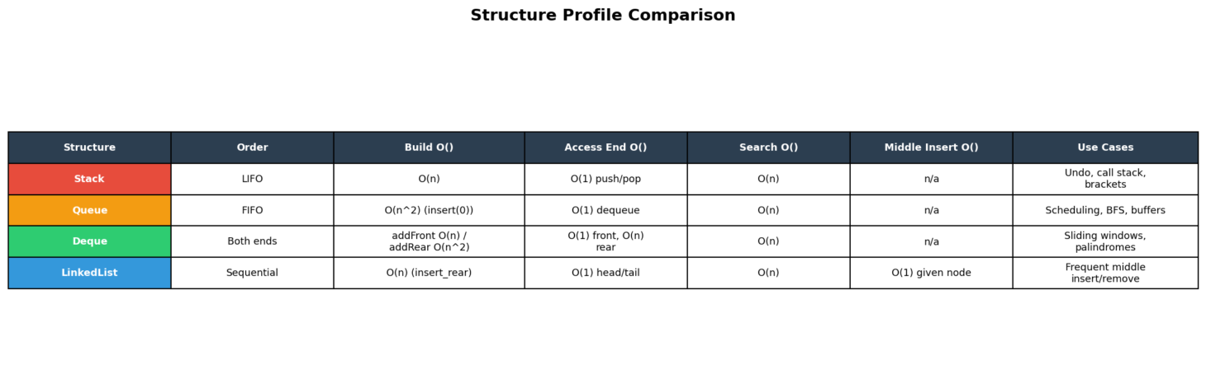
It is important to note that the Compare Structures feature also highlights two practical details. First, every structure returns None on empty-state pop, peek, dequeue, front, and deque-end operations instead of raising an exception, while LinkedList.delete returns False when a value is missing. Second, Queue.enqueue and Deque.addRear deliberately use insert(0), which is why their build cost becomes much more expensive as the dataset grows.

Decision Matrix
The following matrix summarizes which structure was fastest for each operation group and size in the Benchmark Lab. Each cell color shows the winning structure.
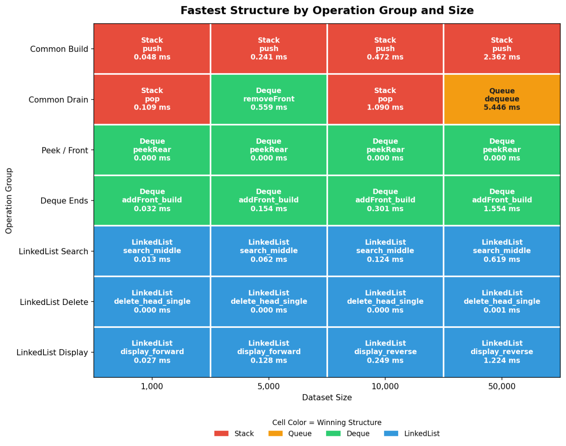

Practical Summary
Criterion | Stack | Queue | Deque | LinkedList
Best use case | LIFO processing, undo, DFS | FIFO processing, scheduling, BFS | Both-end processing, sliding windows | Node-based insertion/deletion, traversal
Best-case runtime pattern | Strong one-end operations | Strong drain/front use | Strong front-end operations | Strong endpoint and known-node updates
Average weakness | Not FIFO | Expensive enqueue build | Rear operations are expensive | Search and delete still traverse
Build cost in this project | O(n) | O(n^2) | addFront O(n) / addRear O(n^2) | O(n)
Productive ends | Top only | Front + rear | Front + rear | Head + tail
Compare Structures profile | LIFO | FIFO | Both ends | Doubly linked
Strong the benchmark result | Fastest in common_build | Fastest in common_drain at 50,000 | Fastest in deque_ends on the favorable end | Strongest in linked-list-specific delete cases

Key Takeaway
In practice, there is no universally best data structure for every scenario. If the workload is LIFO and one-end access is enough, Stack is the best choice because it keeps all work on the favorable end of the list and performed best in the common build benchmark scenario. If the workload is truly FIFO, Queue is the best choice for that purpose, but its list-backed enqueue cost makes it a weaker option as the dataset becomes larger. If both ends matter, Deque is the best choice when the workload mostly uses the front-end operations. If linked insertion, deletion, and bidirectional traversal matter, LinkedList is the best choice.
Based on Benchmark Lab results and the Compare Structures feature, the most practical recommendation is to use Stack when in doubt for one-end workloads, use Queue when arrival order must be preserved, use Deque when both ends matter but the front is used most often, and finally, use LinkedList when linked updates and endpoint access matter more than direct list-style storage.

