Data Structure Performance

Analysis
Alexander Ricciardi
Colorado State University Global
CSC506 - Design and Analysis of Algorithms
Professor Dr. Jonathan Vanover
April 12, 2026

Linear data structures are important in computer science because they determine how data is stored, inserted, removed, and traversed. Stacks, queues, deques, and linked lists are often studied not only as programming exercises, but also as examples of how implementation choices affect runtime, memory usage, and scalability. In this project, four structures were implemented and tested: Stack, Queue, Deque, and a custom doubly linked LinkedList.
The purpose of this analysis is to examine how each structure behaves both theoretically and practically. Theoretical analysis uses Big-O notation to describe how performance grows as input size n increases. Practical analysis uses benchmark results collected from the Benchmark Lab feature across several operation groups, including common build, common drain, peek/front, deque-only operations, and linked-list-only operations. The benchmark sizes used in the generated report are 1,000, 5,000, 10,000, and 50,000 elements, which makes it possible to observe how quickly performance differences widen as the workload becomes larger.
It is important to note that the same abstract data type can behave very differently depending on how it is implemented. The Module 4 materials explain that stacks, queues, deques, and linked lists can be built in more than one way, and the benchmark results in this project support that point clearly (Lysecky & Vahid, 2019). In particular, the results show how strongly list shifting, cached endpoint access, and full traversal influence real performance.

Stack
A stack follows the last-in, first-out (LIFO) rule, which means the most recently inserted value is the first one removed. The stack reference identifies push(), pop(), and peek() as the fundamental stack operations and emphasizes that all activity occurs at the top of the structure (Stack Data Structure, n.d.). In this project, the stack is implemented with a Python list, so those operations stay focused on one favorable end of the underlying structure.
From a Big-O perspective, stack operations are very favorable in this implementation. Repeated push operations produce a linear build workload, repeated pop operations produce a linear drain workload, and peek remains constant time because it only reads the top item. Those are exactly the kinds of operation patterns that stacks are designed to support.
In practice, Stack is the strongest general performer in the common build group. Stack.push is the fastest common build operation at every tested size, increasing from 0.0484 ms at 1,000 items to 2.3620 ms at 50,000 items. Stack.pop also remains highly competitive in the common drain workload, finishing the 50,000-item drain in 5.6118 ms. These results show that Stack is an excellent choice when the workload only needs recent-item access.

Queue
A queue follows the first-in, first-out (FIFO) rule, so the earliest inserted item is the first one removed. The queue reference describes enqueue(), dequeue(), and peek() as the basic operations and explains that data enters at one end and leaves through the other (TutorialsPoint, n.d.-c). Additionally, in an array-based queue, enqueue can be O(N) while dequeue remains O(1) (Lysecky & Vahid, 2019).
From a Big-O perspective, Queue is more mixed in this project than Stack. The common drain workload remains linear because each dequeue removes one item at a time, and front remains constant time because it only reads the next value to be removed. However, the common build workload is much more expensive because each enqueue shifts existing elements in the internal list.
The benchmark results strongly support that description. At 50,000 items, Queue.enqueue requires 351.2580 ms, while Queue.dequeue requires only 5.4459 ms. Compared with the Stack.push common build time of 2.3620 ms, the queue build is 148.7x slower at the largest tested size. This does not mean FIFO is a weak abstraction. It means this specific list-backed implementation pays a large shifting cost as the workload grows.

Deque
A deque, or double-ended queue, allows insertion and removal at both the front and the back. The course materials describe PushFront, PushBack, PopFront, PopBack, PeekFront, and PeekBack as common deque operations and explain that a deque can be implemented with either an array or a linked list (Lysecky & Vahid, 2019). That makes deque more flexible than stack or queue, but it does not guarantee equal performance at both ends.
From a Big-O perspective, Deque is the most asymmetric structure in the project. Some operations stay close to the favorable end of the list and perform well, while others force repeated shifting and become much slower. That difference is especially important because deque exposes both-end operations directly.
The benchmark results show that this asymmetry is very large in practice. At 50,000 items, Deque.addFront_build completes in 1.5538 ms, while Deque.addRear_build takes 344.5407 ms, making the rear build workload 221.7x slower. The same pattern appears in removal: Deque.removeFront_drain completes in 4.2062 ms, but Deque.removeRear_drain requires 155.3099 ms, which is 36.9x slower. These results make it clear that having access to both ends is not the same as getting the same cost at both ends.

LinkedList
A linked list stores data in nodes connected by pointers rather than in contiguous array slots. The linked-list reference explains that nodes are connected through links, that the structure begins at a head node and ends at a tail node, and that linked lists do not require contiguous memory (TutorialsPoint, n.d.-b). The doubly linked list reference adds that each node stores both next and prev links, which makes forward and backward traversal possible (TutorialsPoint, n.d.-a).
From a Big-O perspective, LinkedList is strongest when it can use cached endpoint access and weaker when it has to traverse the structure. insert_rear and delete_head support linear full workloads well, while positional delete and search operations still depend on how far the traversal must travel through the list.
In practice, the custom LinkedList provides the clearest contrast with the list-backed structures because it is the only node-based implementation in the project. LinkedList.insert_rear reaches 13.4627 ms at 50,000 items, which is still far better than the slow front-shifting builds in Queue and Deque. The most dramatic result appears in the single-delete workloads: delete_head_single takes only 0.0007 ms at 50,000 items, while delete_middle_single takes 0.6257 ms and delete_tail_single takes 1.2615 ms. Search results show the same pattern. At 50,000 items, search_middle takes 0.6186 ms, while search_missing takes 1.2122 ms because the missing-value case must walk the full list before failing. These results confirm the main linked-list tradeoff: cached endpoint operations are very efficient, but middle access still requires traversal.

Comparative Big-O Analysis
Big-O notation is useful in this project because it explains why the relative rankings in the benchmark data are not accidental. The course materials emphasize that array-based queue enqueue can be O(N) while dequeue remains O(1), and that search and remove operations in an array-based list have worst-case O(N) behavior because items may need to be scanned or shifted (Lysecky & Vahid, 2019). Those same ideas appear in this project's benchmark results. Operations that stay on a favorable end of the underlying structure behave close to linear or constant time, while operations that trigger repeated shifts or traversals become much more expensive as n grows.
Table 1
Theoretical Complexity Comparison of the Data Structures in This Project
Structure | Common Build | Common Drain | Peek / Front | Search | Key implementation note
Stack | O(n) | O(n) | O(1) | O(n) | Uses list-end append() / pop() for top-only access
Queue | O(n^2) | O(n) | O(1) | O(n) | enqueue inserts at index 0, so every existing item shifts
Deque | O(n) with addFront, O(n^2) with addRear | O(n) with removeFront, O(n^2) with removeRear | O(1) | O(n) | Both ends are available, but the chosen end changes the cost
LinkedList | O(n) with insert_rear | O(n) with delete_head | O(1) at cached ends | O(n) | Cached head / tail help endpoint work; middle work still traverses
Note: The table reflects the course-aligned implementations used in this project, not every possible implementation of the same ADTs.
Table 1 illustrates the scaling patterns imparted from the Benchmark Lab results stored in the benchmark CSV. It shows that when the dataset size grows from 1,000 to 50,000, Stack.push grows by 48.8x, LinkedList.insert_rear by 53.8x, and Deque.addFront_build by 47.9x. This is close to a linear growth behavior for a 50x larger dataset. On the other hand, Queue.enqueue grows by 1,765.5x, Deque.addRear by 1,781.9x, and Deque.addRear_build by 1,888.8x. These larger growth behaviors are what should be expected when a workload has an internal shifting cost, that is, when shifting elements is required for insertion or deletion.

Benchmark Results
The benchmark lab feature measured runtime for every operation group at sizes 1,000, 5,000, 10,000, and 50,000.

Operation Groups
- Common Build is a bulk insertion process that is used to measure how fast each structure can fill itself up from empty using its normal add operation (Stack.push, Queue.enqueue, Deque.addRear, LinkedList.insert_rear).
- Common Drain is bulk removal process that is used to measure how fast each structure can empty itself out using its normal remove operation (Stack.pop, Queue.dequeue, Deque.removeFront, LinkedList.delete_head).
- Peek / Front is an operation that reads the next element to be removed without removing it.
- Deque Ends is an operation that inserts or removes elements from both ends of the deque.
- LinkedList Delete / Search / Display is an operation that deletes, searches, or displays elements in the linked list.
Table 2
Benchmark Results for All Structure Workloads
Structure | Operation | Group | Size | Time (ms) | Big-O | Correct
Deque | addRear | Common Build | 1,000 | 0.1969 | O(n^2) | Yes
LinkedList | insert_rear | Common Build | 1,000 | 0.2504 | O(n) | Yes
Queue | enqueue | Common Build | 1,000 | 0.1990 | O(n^2) | Yes
Stack | push | Common Build | 1,000 | 0.0484 | O(n) | Yes
Deque | removeFront | Common Drain | 1,000 | 0.1293 | O(n) | Yes
LinkedList | delete_head | Common Drain | 1,000 | 0.2638 | O(n) | Yes
Queue | dequeue | Common Drain | 1,000 | 0.1133 | O(n) | Yes
Stack | pop | Common Drain | 1,000 | 0.1089 | O(n) | Yes
Deque | addFront_build | Deque Ends | 1,000 | 0.0325 | O(n) | Yes
Deque | addRear_build | Deque Ends | 1,000 | 0.1824 | O(n^2) | Yes
Deque | removeFront_drain | Deque Ends | 1,000 | 0.0811 | O(n) | Yes
Deque | removeRear_drain | Deque Ends | 1,000 | 0.1281 | O(n^2) | Yes
LinkedList | delete_head_single | LinkedList Delete | 1,000 | 0.0003 | O(1) | Yes
LinkedList | delete_middle_single | LinkedList Delete | 1,000 | 0.0128 | O(n) | Yes
LinkedList | delete_missing_single | LinkedList Delete | 1,000 | 0.0244 | O(n) | Yes
LinkedList | delete_tail_single | LinkedList Delete | 1,000 | 0.0251 | O(n) | Yes
LinkedList | display_forward | LinkedList Display | 1,000 | 0.0265 | O(n) | Yes
LinkedList | display_reverse | LinkedList Display | 1,000 | 0.0268 | O(n) | Yes
LinkedList | search_middle | LinkedList Search | 1,000 | 0.0125 | O(n) | Yes
LinkedList | search_missing | LinkedList Search | 1,000 | 0.0243 | O(n) | Yes
Deque | peekFront | Peek / Front | 1,000 | 0.0001 | O(1) | Yes
Deque | peekRear | Peek / Front | 1,000 | 0.0001 | O(1) | Yes
Queue | front | Peek / Front | 1,000 | 0.0001 | O(1) | Yes
Stack | peek | Peek / Front | 1,000 | 0.0001 | O(1) | Yes
Deque | addRear | Common Build | 5,000 | 3.7225 | O(n^2) | Yes
LinkedList | insert_rear | Common Build | 5,000 | 1.2686 | O(n) | Yes
Queue | enqueue | Common Build | 5,000 | 3.7020 | O(n^2) | Yes
Stack | push | Common Build | 5,000 | 0.2410 | O(n) | Yes
Deque | removeFront | Common Drain | 5,000 | 0.5594 | O(n) | Yes
LinkedList | delete_head | Common Drain | 5,000 | 1.3070 | O(n) | Yes
Queue | dequeue | Common Drain | 5,000 | 0.5635 | O(n) | Yes
Stack | pop | Common Drain | 5,000 | 0.5602 | O(n) | Yes
Deque | addFront_build | Deque Ends | 5,000 | 0.1540 | O(n) | Yes
Deque | addRear_build | Deque Ends | 5,000 | 3.7006 | O(n^2) | Yes
Deque | removeFront_drain | Deque Ends | 5,000 | 0.4141 | O(n) | Yes
Deque | removeRear_drain | Deque Ends | 5,000 | 1.5046 | O(n^2) | Yes
LinkedList | delete_head_single | LinkedList Delete | 5,000 | 0.0004 | O(1) | Yes
LinkedList | delete_middle_single | LinkedList Delete | 5,000 | 0.0629 | O(n) | Yes
LinkedList | delete_missing_single | LinkedList Delete | 5,000 | 0.1191 | O(n) | Yes
LinkedList | delete_tail_single | LinkedList Delete | 5,000 | 0.1237 | O(n) | Yes
LinkedList | display_forward | LinkedList Display | 5,000 | 0.1277 | O(n) | Yes
LinkedList | display_reverse | LinkedList Display | 5,000 | 0.1283 | O(n) | Yes
LinkedList | search_middle | LinkedList Search | 5,000 | 0.0616 | O(n) | Yes
LinkedList | search_missing | LinkedList Search | 5,000 | 0.1205 | O(n) | Yes
Deque | peekFront | Peek / Front | 5,000 | 0.0001 | O(1) | Yes
Deque | peekRear | Peek / Front | 5,000 | 0.0001 | O(1) | Yes
Queue | front | Peek / Front | 5,000 | 0.0001 | O(1) | Yes
Stack | peek | Peek / Front | 5,000 | 0.0001 | O(1) | Yes
Deque | addRear | Common Build | 10,000 | 14.3594 | O(n^2) | Yes
LinkedList | insert_rear | Common Build | 10,000 | 2.6037 | O(n) | Yes
Queue | enqueue | Common Build | 10,000 | 14.2810 | O(n^2) | Yes
Stack | push | Common Build | 10,000 | 0.4721 | O(n) | Yes
Deque | removeFront | Common Drain | 10,000 | 1.1057 | O(n) | Yes
LinkedList | delete_head | Common Drain | 10,000 | 2.6531 | O(n) | Yes
Queue | dequeue | Common Drain | 10,000 | 1.1008 | O(n) | Yes
Stack | pop | Common Drain | 10,000 | 1.0898 | O(n) | Yes
Deque | addFront_build | Deque Ends | 10,000 | 0.3013 | O(n) | Yes
Deque | addRear_build | Deque Ends | 10,000 | 14.0763 | O(n^2) | Yes
Deque | removeFront_drain | Deque Ends | 10,000 | 0.8363 | O(n) | Yes
Deque | removeRear_drain | Deque Ends | 10,000 | 5.2333 | O(n^2) | Yes
LinkedList | delete_head_single | LinkedList Delete | 10,000 | 0.0003 | O(1) | Yes
LinkedList | delete_middle_single | LinkedList Delete | 10,000 | 0.1217 | O(n) | Yes
LinkedList | delete_missing_single | LinkedList Delete | 10,000 | 0.2393 | O(n) | Yes
LinkedList | delete_tail_single | LinkedList Delete | 10,000 | 0.2468 | O(n) | Yes
LinkedList | display_forward | LinkedList Display | 10,000 | 0.2504 | O(n) | Yes
LinkedList | display_reverse | LinkedList Display | 10,000 | 0.2495 | O(n) | Yes
LinkedList | search_middle | LinkedList Search | 10,000 | 0.1235 | O(n) | Yes
LinkedList | search_missing | LinkedList Search | 10,000 | 0.2385 | O(n) | Yes
Deque | peekFront | Peek / Front | 10,000 | 0.0001 | O(1) | Yes
Deque | peekRear | Peek / Front | 10,000 | 0.0001 | O(1) | Yes
Queue | front | Peek / Front | 10,000 | 0.0001 | O(1) | Yes
Stack | peek | Peek / Front | 10,000 | 0.0001 | O(1) | Yes
Deque | addRear | Common Build | 50,000 | 350.8099 | O(n^2) | Yes
LinkedList | insert_rear | Common Build | 50,000 | 13.4627 | O(n) | Yes
Queue | enqueue | Common Build | 50,000 | 351.2580 | O(n^2) | Yes
Stack | push | Common Build | 50,000 | 2.3620 | O(n) | Yes
Deque | removeFront | Common Drain | 50,000 | 5.5740 | O(n) | Yes
LinkedList | delete_head | Common Drain | 50,000 | 12.6559 | O(n) | Yes
Queue | dequeue | Common Drain | 50,000 | 5.4459 | O(n) | Yes
Stack | pop | Common Drain | 50,000 | 5.6118 | O(n) | Yes
Deque | addFront_build | Deque Ends | 50,000 | 1.5538 | O(n) | Yes
Deque | addRear_build | Deque Ends | 50,000 | 344.5407 | O(n^2) | Yes
Deque | removeFront_drain | Deque Ends | 50,000 | 4.2062 | O(n) | Yes
Deque | removeRear_drain | Deque Ends | 50,000 | 155.3099 | O(n^2) | Yes
LinkedList | delete_head_single | LinkedList Delete | 50,000 | 0.0007 | O(1) | Yes
LinkedList | delete_middle_single | LinkedList Delete | 50,000 | 0.6257 | O(n) | Yes
LinkedList | delete_missing_single | LinkedList Delete | 50,000 | 1.2009 | O(n) | Yes
LinkedList | delete_tail_single | LinkedList Delete | 50,000 | 1.2615 | O(n) | Yes
LinkedList | display_forward | LinkedList Display | 50,000 | 1.2252 | O(n) | Yes
LinkedList | display_reverse | LinkedList Display | 50,000 | 1.2238 | O(n) | Yes
LinkedList | search_middle | LinkedList Search | 50,000 | 0.6186 | O(n) | Yes
LinkedList | search_missing | LinkedList Search | 50,000 | 1.2122 | O(n) | Yes
Deque | peekFront | Peek / Front | 50,000 | 0.0001 | O(1) | Yes
Deque | peekRear | Peek / Front | 50,000 | 0.0001 | O(1) | Yes
Queue | front | Peek / Front | 50,000 | 0.0001 | O(1) | Yes
Stack | peek | Peek / Front | 50,000 | 0.0001 | O(1) | Yes
Note: The table is generated from analysis/benchmark_results.csv, which stores one row per (structure, operation, size) workload.
Table 3
Fastest Structure by Operation Group and Size
Operation Group | Size | Fastest Structure | Fastest Operation | Time (ms) | Runner-Up
Common Build | 1,000 | Stack | push | 0.0484 | Deque.addRear
Common Drain | 1,000 | Stack | pop | 0.1089 | Queue.dequeue
Deque Ends | 1,000 | Deque | addFront_build | 0.0325 | Deque.removeFront_drain
LinkedList Delete | 1,000 | LinkedList | delete_head_single | 0.0003 | LinkedList.delete_middle_single
LinkedList Display | 1,000 | LinkedList | display_forward | 0.0265 | LinkedList.display_reverse
LinkedList Search | 1,000 | LinkedList | search_middle | 0.0125 | LinkedList.search_missing
Peek / Front | 1,000 | Deque | peekRear | 0.0001 | Deque.peekFront
Common Build | 5,000 | Stack | push | 0.2410 | LinkedList.insert_rear
Common Drain | 5,000 | Deque | removeFront | 0.5594 | Stack.pop
Deque Ends | 5,000 | Deque | addFront_build | 0.1540 | Deque.removeFront_drain
LinkedList Delete | 5,000 | LinkedList | delete_head_single | 0.0004 | LinkedList.delete_middle_single
LinkedList Display | 5,000 | LinkedList | display_forward | 0.1277 | LinkedList.display_reverse
LinkedList Search | 5,000 | LinkedList | search_middle | 0.0616 | LinkedList.search_missing
Peek / Front | 5,000 | Deque | peekRear | 0.0001 | Stack.peek
Common Build | 10,000 | Stack | push | 0.4721 | LinkedList.insert_rear
Common Drain | 10,000 | Stack | pop | 1.0898 | Queue.dequeue
Deque Ends | 10,000 | Deque | addFront_build | 0.3013 | Deque.removeFront_drain
LinkedList Delete | 10,000 | LinkedList | delete_head_single | 0.0003 | LinkedList.delete_middle_single
LinkedList Display | 10,000 | LinkedList | display_reverse | 0.2495 | LinkedList.display_forward
LinkedList Search | 10,000 | LinkedList | search_middle | 0.1235 | LinkedList.search_missing
Peek / Front | 10,000 | Deque | peekRear | 0.0001 | Stack.peek
Common Build | 50,000 | Stack | push | 2.3620 | LinkedList.insert_rear
Common Drain | 50,000 | Queue | dequeue | 5.4459 | Deque.removeFront
Deque Ends | 50,000 | Deque | addFront_build | 1.5538 | Deque.removeFront_drain
LinkedList Delete | 50,000 | LinkedList | delete_head_single | 0.0007 | LinkedList.delete_middle_single
LinkedList Display | 50,000 | LinkedList | display_reverse | 1.2238 | LinkedList.display_forward
LinkedList Search | 50,000 | LinkedList | search_middle | 0.6186 | LinkedList.search_missing
Peek / Front | 50,000 | Deque | peekRear | 0.0001 | Stack.peek
Note: The table is generated from analysis/operation_winners.csv, which ranks the fastest recorded structure per operation group and dataset size.
Figure 1
Common operation runtime
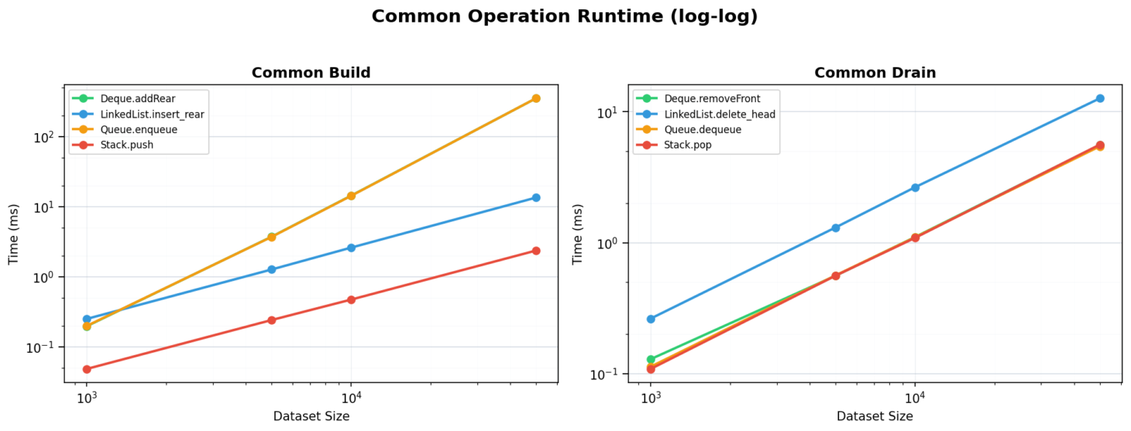

Note: The common build and common drain chart makes the largest scaling gap in the project easy to see. Stack.push and LinkedList.insert_rear remain far below Queue.enqueue and Deque.addRear as size increases.

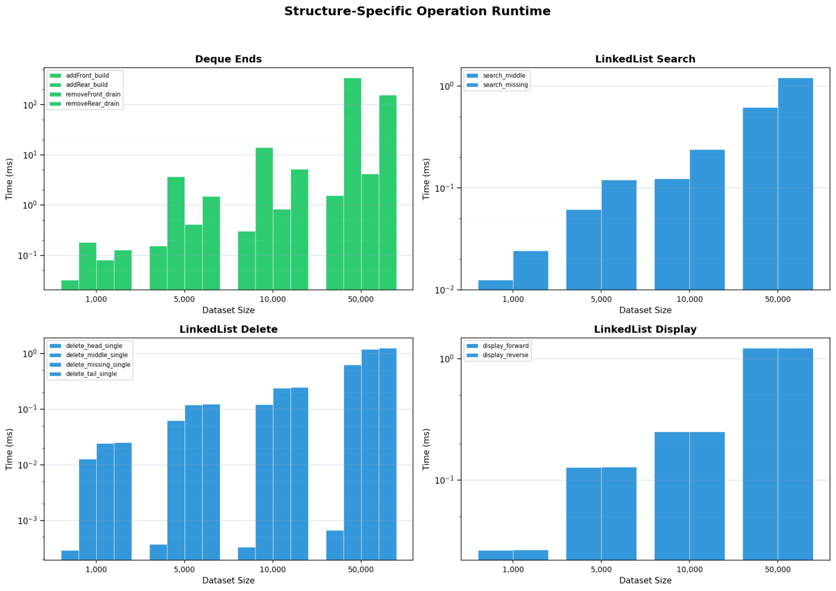
Figure 2
Structure-specific runtime

Note: The structure-specific runtime chart highlights the internal asymmetry within Deque and the traversal-driven cost of LinkedList search, delete, and display workloads.

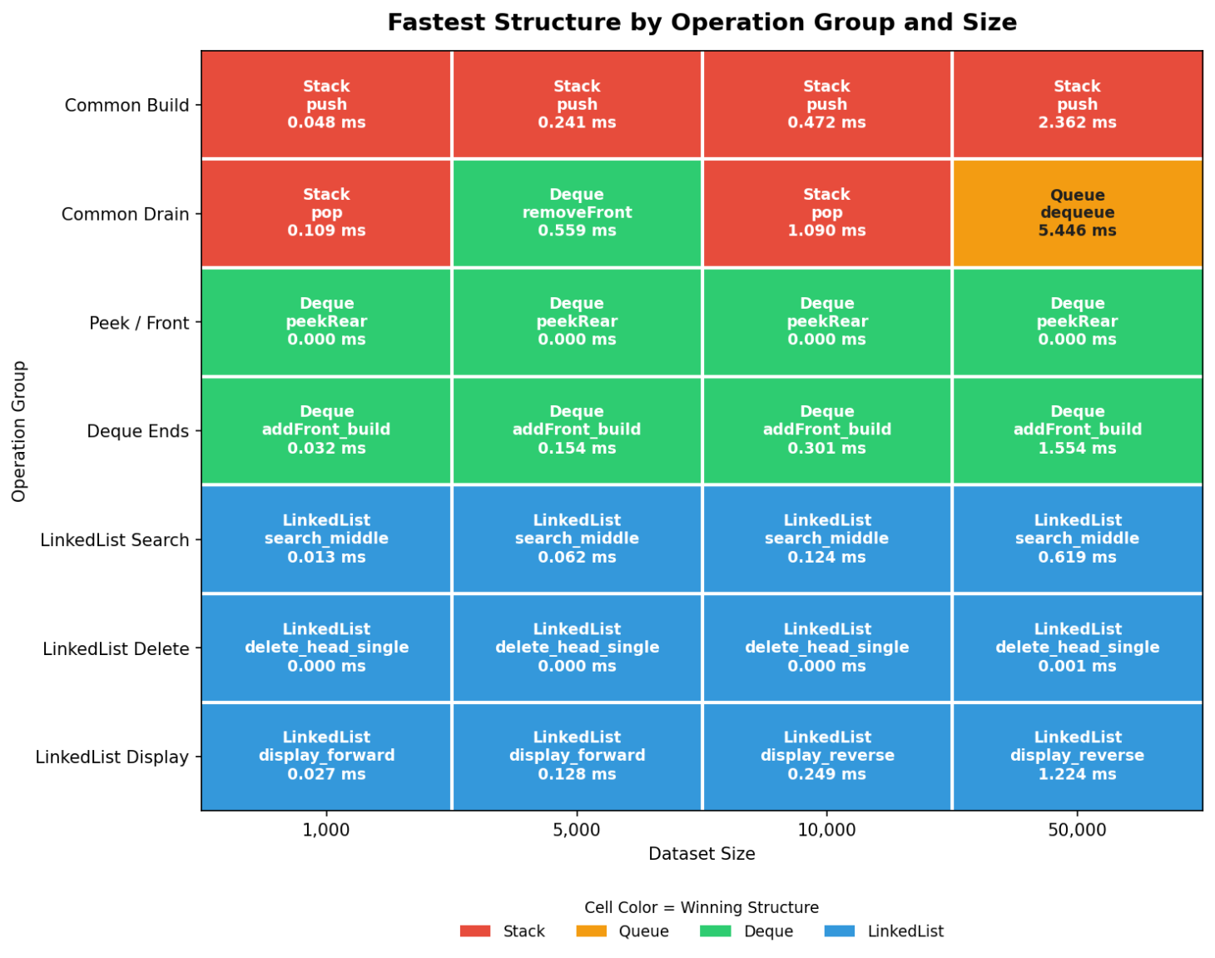
Figure 3
Fastest structure by operation group and size

Note: The heatmap confirms that Stack dominates common build, Deque dominates two-ended favorable-end workloads, and LinkedList dominates its own cached-head delete and related traversal scenarios.

Figure 4
Structure profile comparison
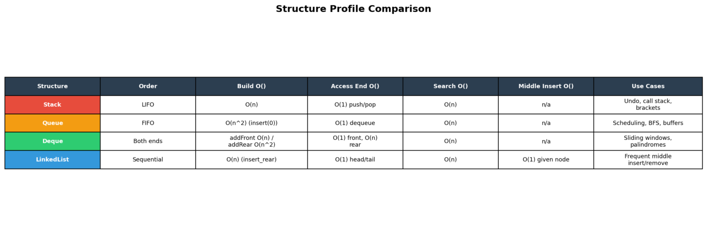

Note: This figure summarizes the practical tradeoffs among the four structures and complements Table 1 by presenting the same ideas in a more visual comparison format.
The benchmark results show that Stack is the best general-purpose data structure in the common build group because all work is done on one end of the list. The Queue with its FIFO behavior, makes large build times expensive. Deque, on the other hand, makes operation choice matter, as one end, the front, performs very well, while the other, the rear, becomes much slower. Finally, LinkedList is most effective for endpoint access, avoids shifting all the elements when deleting or inserting, and uses node-based traversal for searching.
The common build results show that at 50,000 items, Stack.push finishes in 2.3620 ms, LinkedList.insert_rear in 13.4627 ms, Deque.addRear in 350.8099 ms, and Queue.enqueue in 351.2580 ms. This means the two shift-heavy builds are roughly 148x slower than Stack at the largest tested size. That widening gap is exactly what Big-O analysis predicts.
On the other hand, the common drain results show that Stack.pop, Queue.dequeue, and Deque.removeFront have the same time range at 50,000 items, from 5.4459 ms to 5.6118 ms, while LinkedList.delete_head is slower at 12.6559 ms. For peek operations, every structure stays constant, as times are clustered around 0.0001 ms. These means that the structures can reach the needed value without needing to perform a full traversal or a large shifting of elements.
The linked-list-specific cases are especially useful because they separate endpoint, and from having to perform traversal-heavy work when the middle or tail of the list is accessed. delete_head_single is effectively constant at every size, but delete_middle_single, delete_tail_single, search_middle, and search_missing all grow with list size. This shows that theoretical complexity, Big-O notation analysis, gives expectations, while benchmark data shows explicitly where or when traversal times become significant.

Conclusion
The analysis shows that choosing the best data structure depends on both theory and context, that is, the specific operations that will be performed on the data structure, and the requirements of a specific data application. Stack is the strongest option when access is limited to the most recently inserted item, the front. Queue is best suited for arrival-order processing matters; however, the benchmark results show that this list-backed front insertion approach scales poorly. Deque is highly flexible, but its benchmark results show that this both-end access does not eliminate the cost asymmetry, that is, the front of the deque is much faster to access than the rear. LinkedList is most useful when work happens at cached endpoints or when insertion and deletion matter more than direct indexed access, as it avoids the cost of shifting elements.
In practical terms, the Benchmark Lab results show that if the workload requires a LIFO (Last-In, First-Out) approach, choose Stack. If the workload is FIFO (First-In, First-Out), choose Queue. If both ends matter, Deque can be very effective, but only when the cheaper end, the front (if using a Python list as the underlying structure), is used consistently. If endpoint insertion, deletion, and traversal behavior (for searches) matter more than contiguous storage, LinkedList is a strong choice. Overall, Big-O analysis and benchmark testing work best together as theory explains the pattern, and measurement shows how large the difference becomes in real use.
An important note is that LinkedList can be used singly and doubly as an underlying structure for Queue and Deque Abstract Data Types, and they are often used in that manner in practice, as they are more efficient than using a Python list.

References
Lysecky, R., & Vahid, F. (2019). Module 4: Lists, stacks, and queues. Data structures essentials: Pseudocode with Python examples. zyBooks
TutorialsPoint. (n.d.-a). Doubly Linked List Data Structure. TutorialsPoint. https://www.tutorialspoint.com/data_structures_algorithms/doubly_linked_list_algorithm.htm
TutorialsPoint. (n.d.-b). Linked List Data Structure. TutorialsPoint. https://www.tutorialspoint.com/data_structures_algorithms/linked_list_algorithms.htm
TutorialsPoint. (n.d.-c). Queue Data Structure. TutorialsPoint. https://www.tutorialspoint.com/data_structures_algorithms/dsa_queue.htm
TutorialsPoint. (n.d.-d). Stack Data Structure. TutorialsPoint. https://www.tutorialspoint.com/data_structures_algorithms/stack_algorithm.htm
nvas.

