Recommendation Guide: Choosing Graph Representations and Algorithms
Alexander Ricciardi
Colorado State University Global
CSC506 - Design and Analysis of Algorithms
Professor Dr. Jonathan Vanover
May 3, 2026

Choosing the right graph representation and algorithm depends on several factors, not on speed only. When choosing between an adjacency-list graph and an adjacency-matrix graph, it is important to consider whether the graph is sparse or dense, whether repeated neighbor scans matter, whether direct edge checks are common, whether the vertex set will remain stable, and whether the shortest-path workload uses positive or negative edge weights. The Benchmark Lab compared AdjacencyListGraph and AdjacencyMatrixGraph across sparse and dense scenarios with dataset sizes from 25 to 100 vertices. Based on those benchmark results and the traversal and shortest-path features in this module, this guide recommends when or in which instance each representation and algorithm is the better practical fit.

When to Use an Adjacency List
A list-based graph is the better choice when:
- If the graph is sparse. An adjacency list is the better choice for this purpose because it stores real edges rather than reserving space for every possible vertex pair.
- If the workload performs repeated neighbor scans, traversals, or route searches. AdjacencyListGraph is useful for this purpose because BFS, DFS, Dijkstra, and Bellman-Ford can move through stored neighbors directly.
- If memory efficiency matters. In this kind of case, the list-based representation is preferable because its space cost follows O(V + E) rather than O(V^2).
- If the graph changes over time. A list-based graph is useful for this kind of problem because it organizes work around stored connections instead of a full square table.
It is important to note that the saved benchmark lab results strongly support this recommendation under sparse workloads. In the saved sparse scenarios, the adjacency list won all 24 operation-size buckets. At 100 vertices, it was still faster for build, adjacency checks, neighbor scans, BFS, DFS, Dijkstra, Bellman-Ford, and edge removal.
Example: Suppose a program models course prerequisites or road connections in which each vertex links to only a small number of other vertices. An adjacency list is useful for this kind of problem because the program can store only the real connections and traverse those connections directly.

When to Use an Adjacency Matrix Instead of an Adjacency List
A matrix-based graph is the better choice when:
- If many possible connections are present and the vertex set is relatively stable. In this kind of case, the row-column structure becomes more reasonable because many of the O(V^2) cells represent real edges.
- If the program performs many direct edge-existence checks. An adjacency matrix works well for this purpose because it is designed around direct source-target lookup once row and column positions are known.
- If the workload resembles the dense benchmark cases where the matrix becomes more competitive. In the benchmark lab, AdjacencyMatrixGraph earned selected wins in dense adjacency checks, DFS, Dijkstra, Bellman-Ford, and edge removal.
- If a full table view makes the graph easier to inspect, explain, or teach. The matrix works well for this purpose because every possible vertex pair is visible in one structured layout.
It is important to note that an adjacency matrix is not automatically the best choice for every dense graph. In the saved dense scenarios, the matrix won 6 of 24 operation-size buckets, and the adjacency list still won 18. These results show that the matrix is a specialized choice rather than a general replacement for the list-based model.
Example: Suppose a classroom demonstration needs to show whether many possible vertex pairs are linked and the graph stays mostly fixed. An adjacency matrix is useful for this kind of problem because the full connection table is easy to inspect directly.

When an Adjacency List Is the Stronger Default Choice
The list-based representation is the stronger default choice when:
- If the graph contains far fewer real edges than possible vertex pairs. In this kind of case, the list avoids paying matrix cost for absent edges.
- If the workload includes repeated traversal and neighbor scanning. The adjacency list is useful for this purpose because those operations follow stored connections instead of scanning absent-edge cells.
- If the program needs one representation that remains competitive across build, mutation, traversal, and shortest-path work. AdjacencyListGraph is the better practical fit here because it remains broadly competitive across most saved benchmark categories.
- If practical scalability matters more than direct-table symmetry. The list is useful for this purpose because its performance follows the real graph structure more closely.
It is important to note that saved benchmark results support this recommendation very strongly under sparse workloads. At the largest saved sparse size of 100 vertices, AdjacencyListGraph completed neighbor scan in 0.0211 ms versus 0.1793 ms for the matrix, Dijkstra in 0.5930 ms versus 0.9978 ms, and edge removal in 0.0763 ms versus 0.2282 ms. These results show that the list-backed representation is the better practical default when the graph stores relatively few real connections.
Example: In a routing or prerequisite system, a list-based graph is the better choice when the program must repeatedly move through and inspect the same sparse graph structure. This is useful because the same representation supports those operations without reserving a large table of absent edges.

When an Adjacency Matrix Becomes More Competitive Than the List
A matrix-based graph becomes more competitive when:
- If enough matrix cells represent real edges. Under that condition, the cost of the square table is easier to justify.
- If direct pair-based access matters more than neighbor iteration. The matrix works well for this purpose because its design favors source-target lookup.
- If the dense shortest-path or dense traversal workload follows the same pattern as the saved benchmark wins. In benchmark lab, the matrix won dense Dijkstra at 25 and 100 vertices, dense Bellman-Ford at 100 vertices, and dense DFS at 100 vertices.
- If a fixed row-column view matters more than storage efficiency, the matrix can be the better practical fit even though it requires more storage.
It is important to note that the matrix becomes more competitive without becoming dominant. At dense 100, the matrix was faster for adjacency checks (0.0368 ms versus 0.0413 ms), DFS (1.2629 ms versus 1.4653 ms), Dijkstra (16.2586 ms versus 17.3360 ms), and Bellman-Ford (5.8276 ms versus 5.8555 ms). However, the list-based representation still remained faster for build, neighbor scan, BFS, and edge removal at the same size. These results show that dense workloads narrow the gap, but they do not remove the list-based model's broader practical advantage.
Example: Suppose a program analyzes a dense scheduling or communication graph where many vertex pairs are linked and repeated pair lookup matters. In this kind of case, a matrix-based graph may be the better choice because the workload matches the structure's main strength more closely.

When BFS Is the Better Choice
BFS fits best when:
- If the problem cares about layers beginning at one start vertex. BFS is useful for this purpose because it moves outward one level at a time.
- If an unweighted graph needs the fewest number of edges from one start vertex. In this kind of case, BFS is usually the better fit because it reaches nearer vertices before farther ones.
- If the goal is to show layered reachability. Social-network levels, router hop counts, and dependency distance are all good fits for BFS.
It is important to note that, on sparse workloads, BFS is usually paired well with a list-based graph. In the benchmark lab, the sparse 100-vertex BFS benchmark favored the adjacency list at 0.4673 ms compared with 0.5863 ms for the matrix. That result reflects the advantage of traversing stored neighbors directly.
Example: Suppose a network tool needs to show which devices are one hop, two hops, and three hops away from a starting router. BFS is useful for this kind of problem because its traversal order naturally matches those layers.

When DFS Is the Better Choice
DFS is the better choice when:
- If the problem benefits from branch-by-branch exploration before backtracking. DFS is useful for this purpose because it follows one path as far as possible before returning to another path.
- If the program needs connected-component style exploration or exhaustive path following. In this kind of case, DFS is useful because its stack-like behavior supports backtracking naturally.
- If the problem involves dependency exploration, cycle-oriented reasoning, or branch-by-branch inspection. DFS is well suited for this purpose because it keeps attention on one path until that path is exhausted.
It is important to note that DFS and BFS can produce different visit orders on the same graph. The better choice depends on the goal of the traversal, not only on which runtime is smaller in one benchmark bucket. In dense 100, AdjacencyMatrixGraph did outperform the list for DFS, which shows that graph density can change the representation result even when the traversal purpose stays the same.
Example: Suppose a program explores task dependencies and needs to follow one dependency chain deeply before returning to another branch. DFS is useful for this kind of problem because it naturally supports deep branch exploration.

When Dijkstra Is the Better Choice
Dijkstra is the better choice when:
- If every edge weight is non-negative. Dijkstra is the better choice for this purpose because it assumes path costs do not decrease through negative edges.
- If the graph represents distance, travel time, latency, or another positive cost. In this kind of case, Dijkstra is useful because it provides the practical shortest-path default for positive-weight graphs.
- If the workload performs repeated shortest-path searches on positive-cost graphs. Dijkstra is the better practical fit here because it avoids the extra work of Bellman-Ford when negative-weight cases are not part of the problem.
It is important to note that Dijkstra should not be used on graphs with negative edge weights. A faster Dijkstra benchmark is not useful if the graph violates the algorithm's correctness rules. In labs, the positive weighted demo and the dense benchmark comparisons are appropriate uses of Dijkstra because those cases use non-negative costs.
Example: Suppose a route planner needs the shortest driving distance between Denver and Vail, and every road distance is positive. Dijkstra is useful for this kind of problem because the graph follows the non-negative weight rule.

When Bellman-Ford Is the Better Choice
Bellman-Ford is the better choice when:
- If negative-weight edges can appear. Bellman-Ford is the better choice for this purpose because it can handle cases that Dijkstra must reject.
- If the program must detect reachable negative cycles. In this kind of case, Bellman-Ford is useful because it includes a correctness check that Dijkstra does not provide.
- If the graph models discounts, credits, penalties, refunds, or reductions that can lower the running path cost. Bellman-Ford is useful for this kind of problem because those situations can create negative-weight edges.
It is important to note that Bellman-Ford is slower in Big-O terms, but that additional cost becomes necessary when correctness requires support for negative-weight edges or negative-cycle detection. Overall, Bellman-Ford is the best-suited when the negative edge values are present; the negative-cost demo in the lab is one such case.
Example: Suppose an order-processing graph includes discounts and credits that reduce the total cost of a path. Bellman-Ford is useful for this kind of problem because it can evaluate negative-cost edges safely.

Representation Comparison Snapshot
The following table summarizes the adjacency-list-versus-adjacency-matrix comparison shown in the CTA-7 Benchmark Lab.
Criterion | List-Based Graph | Matrix-Based Graph
Best use case | Sparse or changing connection data | Dense, stable, pair-heavy graphs
Best practical condition | Traversal, neighbor scans, and memory matter | Direct edge checks or selected dense workloads
Main strength | Stores only real edges with O(V + E) space | Organized for direct row-column pair lookup
Main weakness | Not the theoretical first choice for full-table use | Requires O(V^2) space even for absent edges
CTA-7 role | Main default graph representation | Specialized comparison representation
Strong benchmark result | Won all 24 saved sparse buckets | Won 6 dense buckets, including dense Dijkstra
It is important to note that the practical recommendation changes based on the density of the graph, dense or sparse, and the operations performed on it. For sparse graphs, the list-based representation is the clear default. For dense graphs, the matrix-based representation is better suited, and yet the list still wins most saved operation buckets overall.

Algorithm Choice Snapshot
The following table summarizes the best practical fit for each graph algorithm.
Algorithm | Best use case | Main condition or warning
BFS | Layered reachability | Best for unweighted fewest-edge paths
DFS | Deep path following and backtracking | Visit order differs from BFS
Dijkstra | Positive weighted shortest paths | Do not use when negative-weight edges can occur
Bellman-Ford | Negative-weight paths or cycle detection | Slower, but handles cases Dijkstra cannot handle
It is important to note that representation choice and algorithm choice are separate decisions. The representation should fit the graph's shape and dominant operations, and the algorithm should fit the practical goal and the edge-weight rules.

Recommendation Figures
The following figures summarize the main recommendation results from the CTA-7 Benchmark Lab.
Figure 1
Representation profile comparison
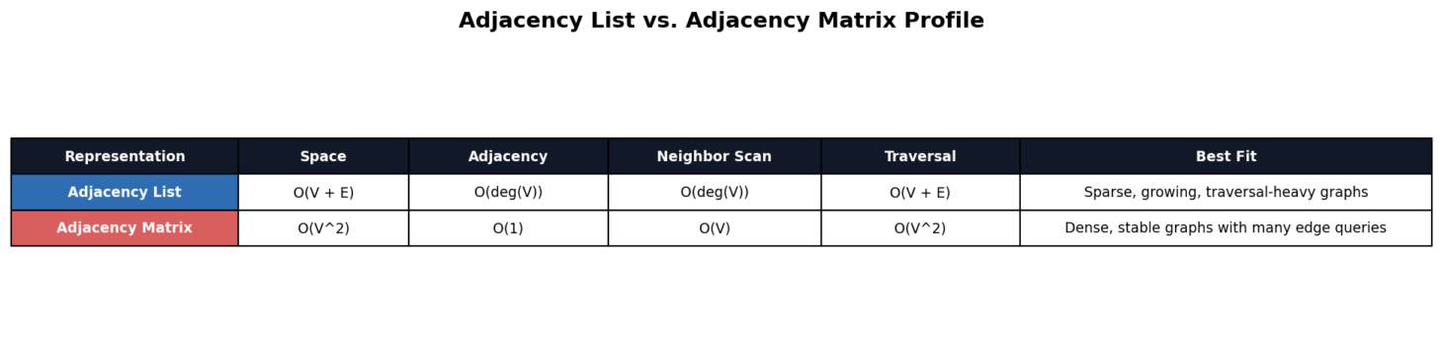
Representation profile comparison
Note: The representation profile chart shows that the list-based representation is the stronger general default, while the matrix-based representation remains useful in selected dense workloads.
Figure 2
Sparse and dense runtime comparison
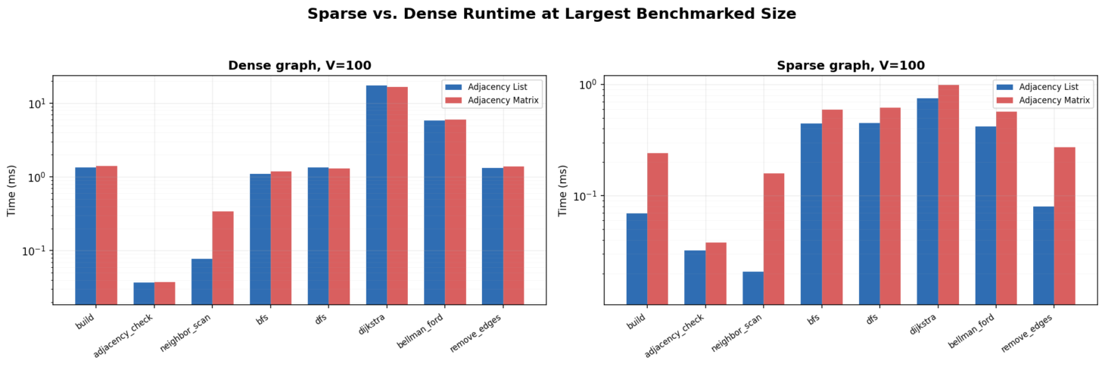
Sparse and dense runtime comparison
Note: The sparse and dense comparison chart shows how graph density changes the practical gap between the two representations.
Figure 3
Operation winner heatmap
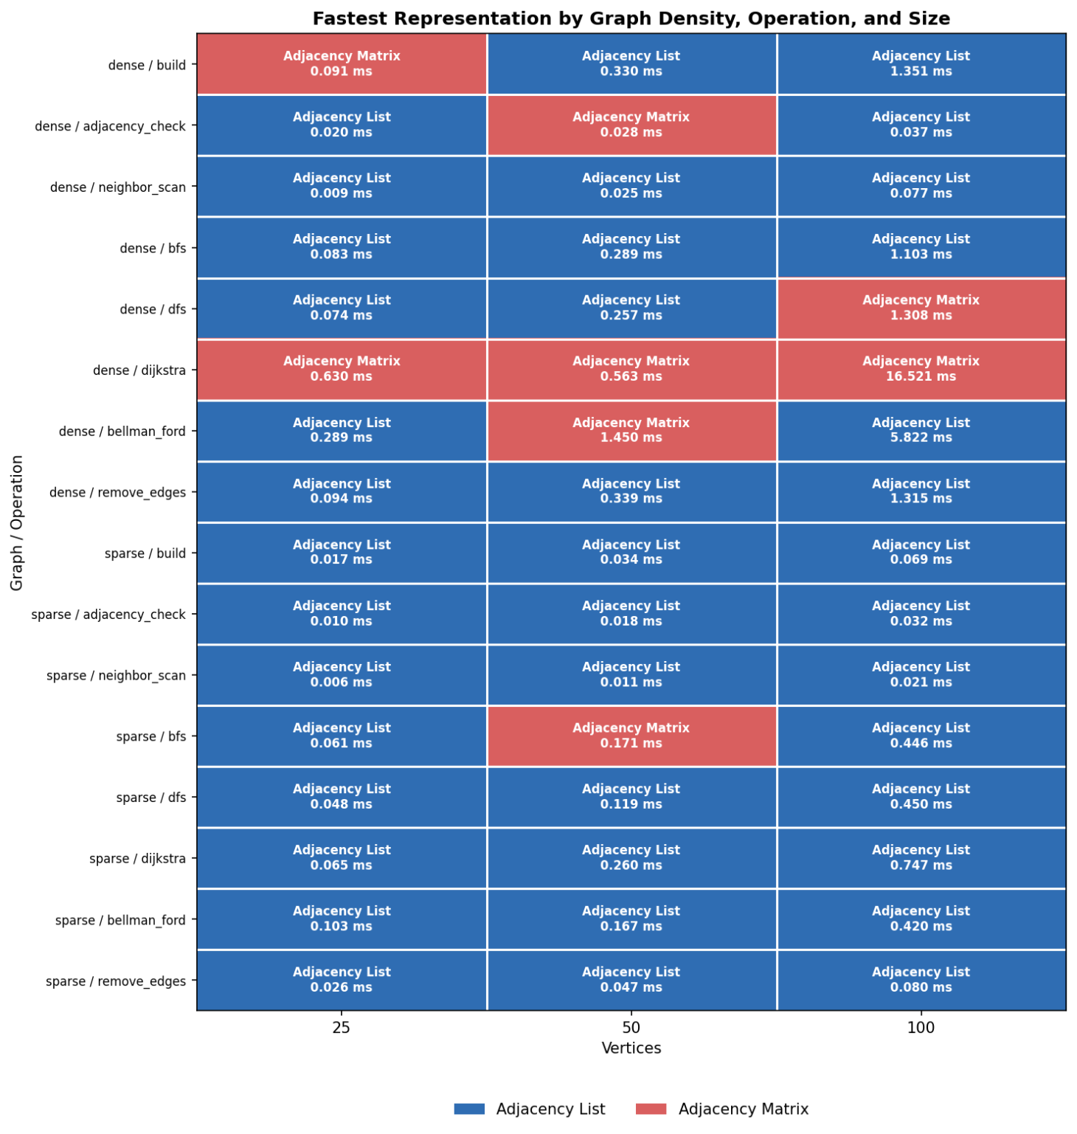
Operation winner heatmap
Note: The heatmap shows the adjacency list winning all saved sparse buckets and most saved dense buckets, while the matrix-based representation still earns selected wins in pair-heavy and dense shortest-path cases.

Practical Summary
Decision area | Better choice | Main reason
Sparse graph storage | List-Based Graph | Stores only real edges and wins the saved sparse benchmarks
Dense stable graph view | Matrix-Based Graph | More competitive when direct pair lookup and table layout matter
Layered reachability | BFS | Moves outward one level at a time
Deep path exploration | DFS | Follows one branch until it must backtrack
Positive weighted routes | Dijkstra | Best choice when edge weights are non-negative
Negative weighted routes | Bellman-Ford | Best choice when negative-weight edges or cycle detection are necessary

Practical Recommendation
The analysis in this report shows that there is no single best graph choice. If the graph is sparse, is updated over time, or traversal and neighbor-based operations are performed often, the list-based representation is the better choice. On the other hand, if the graph is dense, stable, and edge-pair operations are the most frequent operation, the matrix-based representation is best suited.
For algorithms, the main recommendation is to choose correctness first and performance second. Use BFS for layered reachability, and DFS for deep path following. Use Dijkstra for non-negative weighted shortest paths, and Bellman-Ford when negative-weight edges or negative-cycle detection are part of the problem.

